Truth to Nature: The Art of Iridescence
Exhibition by Franziska Schenk
31 Jan – 25 Feb
The Hive, 43-47 Vittoria Street, Jewellery Quarter, Birmingham, B1 3PE
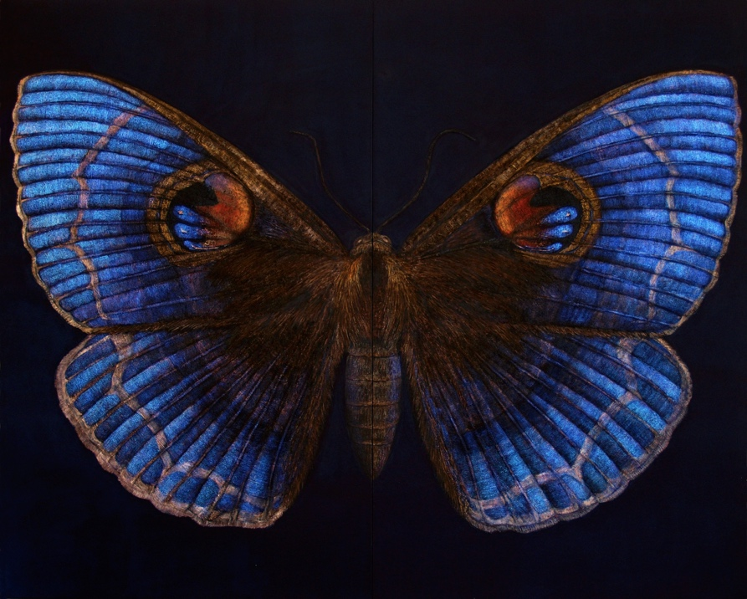
Contemporary artist Franziska Schenk uses nano-pigment technology to depict the iridescent colour of Nature. This exhibition takes its theme from John Ruskin’s call for artists to ‘go to Nature, rejecting nothing, selecting nothing and scorning nothing’ and his attack on Darwin’s theory of evolution. Alongside this exhibition there is an events programme to mark Ruskin’s 201st birthday and the end of his bicentennial celebrations. #Ruskin200
To find out more about the exhibition theme and the artist please visit: https://www.rmlt.org.uk/event/truth-to-nature

‘If I had him [Darwin] here in Oxford for a week, and could force him to try to copy a feather…, his notions of feathers… would be changed for all the rest of his life. But his ignorance of good art is not excuse for the accurately illogical simplicity of the rest of his talk of colour in the Descent of Man’.

Ruskin, LE 25. 263-264
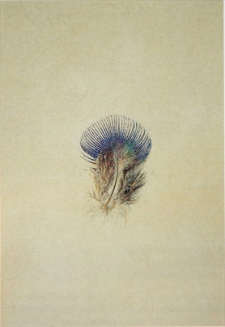
Franziska Schenk’s work on nature’s iridescent hues and millennia-old colour optics, complemented by scientific study, have led her to adapt and adopt new nano-materials for painting. The resulting artwork, like iridescent creatures, fluctuates in perceived colour and pattern, depending on the light and vantage.

About the Artist
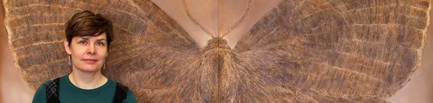
Franziska Schenk is an artist and lecturer in Fine Art at Birmingham City University. Her work has been shown in venues across England and in Germany. And, in tandem, she has conceived, initiated and led a number of funded Art and Science projects, focusing on the conversion of nature’s iridescent colour to the painter’s palette – introducing flow, dynamism, transience and an evolutionary element into painting. Her work, From Mimesis to Biomimetics: Towards Smarter Art, has most recently been presented at Max Planck Institute, Dresden (June 19).

