Birmingham City University

English Proficiency Test

Listening

- Do not open this booklet until the recording tells you to turn to Section One.
- Listen carefully to the instructions.
- The recording will be played once only.
- You will have 10 minutes to transfer your answers to the answer sheet at the end of the test.
- Write in pen or pencil.

Name: …………………………………………………………………………..
ID Number: …………………………………………………………………………..
Test Centre: …………………………………………………………………………..
Date: …………………………………………………………………………..

Birmingham City University
International Centre for English
BCU Listening Test – Section 1

You will hear a recruitment agent talking to a woman who is looking for a job.
First you have 30 seconds to look at questions 1 – 6.
Questions 1 – 6
Choose the correct letter A, B or C.
- What is Azni’s email address?

A midldeaz@gmail.com
B middleaz@gmail.com
C middleza@gmail.com

- Azni is from

A Indonesia.
B Russia.
C Malaysia.

- In the Caledonian Hotel Azni was employed as a

A bartender.
B receptionist.
C line manager.

- Tayo Ollotu

A is letting out his flat to Azni.
B is Azni’s former employer.
C worked with Azni in a shop.

- Azni did a training course in health and safety when she was

A working at the Caledonian hotel.
B working in a local pub.
C studying in a college.

- Azni says that she loves studying languages and that she is good at
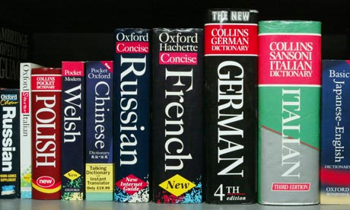
A German.
B French.
C Russian.

Before you hear the rest of the conversation, you have 30 seconds to look at questions 7 – 10.
Questions 7 – 10
Complete the table below.
Write NO MORE THAN THREE WORDS for each answer.
Agency Central

Name | Location | Position | Salary | Special requirements
Britannia Hotel | - close to the agency’s office  - located in the city centre  - near the Bull Ring | - receptionist | - from £18,000 to £23,000 | - flexibility  - exceptional  7 …………………..…  - basic IT skills
Ramada  Hotel | - countryside near Bristol | - housekeeping supervisor | - maximum pay of  8 £………..... | - previous experience  - strong organisational skills
Apollo  Hotel | - Wolverhampton  - half an hour drive | - 9 ..………..………  - assistant chef | - £24,000 | - 10 …………………..
You now have 30 seconds to check your answers.
BCU Listening Test – Section 2
You will hear a radio interview in which an expert gives some tips to college students on what to wear to a job interview.
First you have 30 seconds to look at questions 11 – 15.
Questions 11 – 15
Write ONE WORD ONLY for each answer.
The radio interview starts by introducing Nicole 11 ………………………………, a career expert for LinkedIn and founder of DOIT. Nicole’s task is to tell you how to choose the best outfit for a job interview.

Nicole starts by saying that it is important to research the company before attending an interview. She says that this can be done by doing 12 ……………………………… research, telephoning the company, contacting company’s staff, or requesting information about the company’s dress code.

Nicole believes that the way people dress for a job interview can differ from one place to another. This can be influenced by factors such as country,
13 ……………………………… and industry. Therefore, if you are not sure of what to wear, the best option is to go for something conservative. Men, for example, should dress formally and wear a suit, dress shoes, tie, 14 ……………………………… shirt and black socks. They should choose colours which are subtle and solid.

Nicole also says that most companies have their own appearance guidelines on shaving and hairstyles. In general, a candidate with a beard may keep it if it’s presentable. Also people who are not in contact with the 15 ……………………………… and who do not work in an office can keep their hair long. However, she advises men with medium length hair to cut it short for the interview and grow it back out later.
Before you hear the rest of the conversation, you have 30 seconds to look at questions 16 – 20.
Questions 16 – 20
Complete the notes in the table below. Write NO MORE THAN TWO WORDS for each answer.
DRESS CODE FOR WOMEN

Interview attire | Pieces of advice
Suit | - choose a neutral colour, for example navy, 16…………………………………... or black
Shirt or blouse | - colour that goes with the suit  - not too bright or patterned  - not low cut
Makeup | - keep it 17……………………………………  - no time to experiment  - if you wear a lipstick on a daily basis, then put it on for the interview too.
Hairstyle | - choose the one that you feel confident in  - keep it neat and 18………………………………

DO’S and DON’TS

Nervous habits | - do a mock interview with a friend  - examine your 19…..…………….………  - don’t play with hair  - learn how to keep your hands busy
Other DO’s and DON’Ts | - avoid wearing plenty of perfume  - try to match what other employees are wearing  - study employees profile 20 .…………………..………  - do not wear too much jewellery
You now have 30 seconds to check your answers.
BCU Listening Test – Section 3
You will hear a guest speaker talking to prospective BCU students.
First you have 30 seconds to read questions 21 – 25.

Questions 21 – 25

Complete the sentences below. Write ONE WORD ONLY for each answer.

- Christine obtained a degree in Jewellery and Silversmithing at the Birmingham Institute of Art and Design. She says that she did a lot of ………………………………………… before applying for her course.

- Christine was pleased to live in the Jewellery Quarter. She could find there replacement for her broken tools and ………………………………………… polished gems for her work.

- According to Christine, her design are inspired by ………………………………………… .

- After graduation Christine was helped by her jewellery mentor who offered her fifteen hours of work. She could also attend some of the ………………………………………… in return for lecturing.

- The same ………………………………………… and methods that were used in the past are still being used when making jewellery.

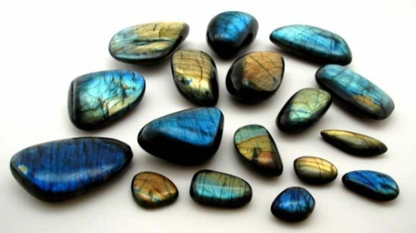

Before you hear the rest of the discussion, you have 30 seconds to look at questions 26 – 30.
Questions 26 – 30
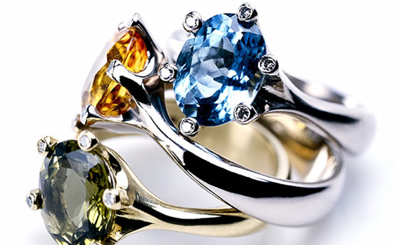
Choose the correct letter A, B or C.

- Christine buys silver and most of her jewels

A online.
B from a local supplier.
C from a gemstone polisher.

- HS Walsh & Sons

A offers discounts on jewellery making tools.
B was established nearly a decade ago.
C is the only place where students can purchase tools for jewellery making.

- Christine’s jewellery is tested and hallmarked

A out of the Jewellery Quarter.
B at the School of Jewellery.
C at Birmingham Assay Office.

- According to the most up-to-date figures ……………..…………. of British jewellery is still made in the Jewellery Quarter.

A 90%
B 60%
C 40%

- Christine’s work is mainly sold

A to the local shop.
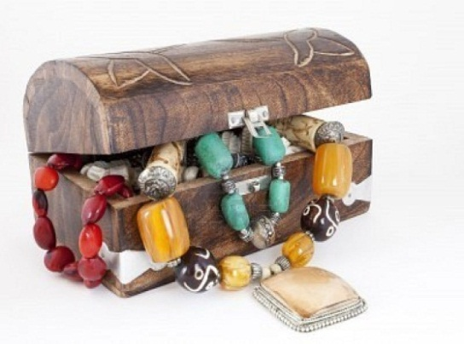
B on the internet.
C to international customers.

You now have 30 seconds to check your answers.
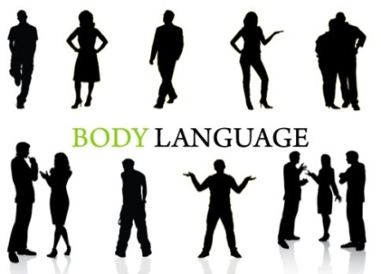
BCU Listening Test – Section 4
You will listen to a university lecture on body language.
First you have one minute to look at questions 31 – 40.

Questions 31 – 35
Complete the notes below. Write ONE WORD ONLY for each answer.
- Eye movements:

- Can provide information about one’s 31 ….……………………………… and untruthfulness
- Example:
- the mind of a person looking to the right is ‘creating’ something
- Used to tell if someone is frustrated or excited

- Mouth movements:

- A person with a tight-lipped smile:
- may have a 32 ….………………………………
- may lack trust in others
- Show feelings of self-comfort, tension or frustration

- Arm movements:

- Associated with feelings of nervousness or insecurity
- Imply 33 ….……………………………… when hands and arms are kept behind a person's back
- Examples of defensive arm movements:
- folding arms
- keeping things in front of the chest
- playing with bracelets or 34 ….………………………………

- Hand movements:

- The most researched aspect of non-verbal communication
- Suggests an array of emotional states
- Examples:
- pulling one’s ear indicates indecision
- cracking knuckles signal the need for 35 ….………………………………
- open palms can imply openness
BODY LANGUAGE

Questions 36 – 40

Complete the sentences below. Write ONE WORD ONLY for each answer.

- In his research Borg argued that ……………………………….. percent of human interaction is done by words.

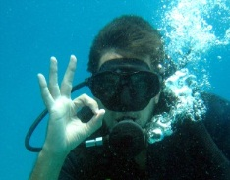
- Nowadays it’s easier for people from different countries to understand non-verbal communication not because of the internet or ……………………………….. , but due to the effects of television.

- The 'OK' sign often used by scuba divers can be interpreted as rude in a country such as ……………………………….. .

- According to the speaker, the way in which people ……………………………….. each other is hugely influenced by factors such as gender and culture.

- In order to feel more secure, people tend to create artificial barriers. For example, many of us tend to keep our hands close to our face which can be an indication of ……………………………….. .

Thank you. That is the end of the test.
You now have 10 minutes to transfer your answers to the answer sheet.

