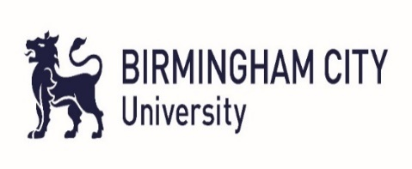
Birmingham City University
English Proficiency Test

Reading 2 - Answer Key
 | Reading Passage 1 |  | Reading Passage 2 Continued
1 | F | 21 | C / London-Bristol railway
2 | T | 22 | B / Clifton Suspension Bridge
3 | NG | 23 | F / The Great Eastern
4 | F | 24 | A / Thames Tunnel
5 | NG | 25 | G / Renkioi Hospital
6 | (increased) testing/ pressure | 26 | C / London-Bristol railway
7 | (through) play | 27 | B / Clifton Suspension Bridge
8 | bad behaviour |  | Reading Passage 3
9 | greater influence | 28 | demand
10 | A / Marta Drew | 29 | harmful gases/ (harmful) greenhouse gases (ANSWER MUST CONTAIN GASES)
11 | D / Arun Gill | 30 | lifestyles
12 | E / Helen Lees | 31 | businesses/ corporations/ firms/ companies
13 | B / Simon Drew | 32 | sustainability/ environmentally-friendly processes/ environmental policies/ environmental practices/ sustainable practices
 | Reading Passage 2 | 33 | A
14 | (his) (engineer) father | 34 | B
15 | 1842 | 35 | D
16 | landmark/ attraction | 36 | C
17 | (the) River Avon | 37 | NG
18 | (the) journey (time) | 38 | F
19 | (The) Great Western/  (The) SS Great Britain | 39 | F
20 | (The) SS Great Britain/  (The) Great Western | 40 | T

