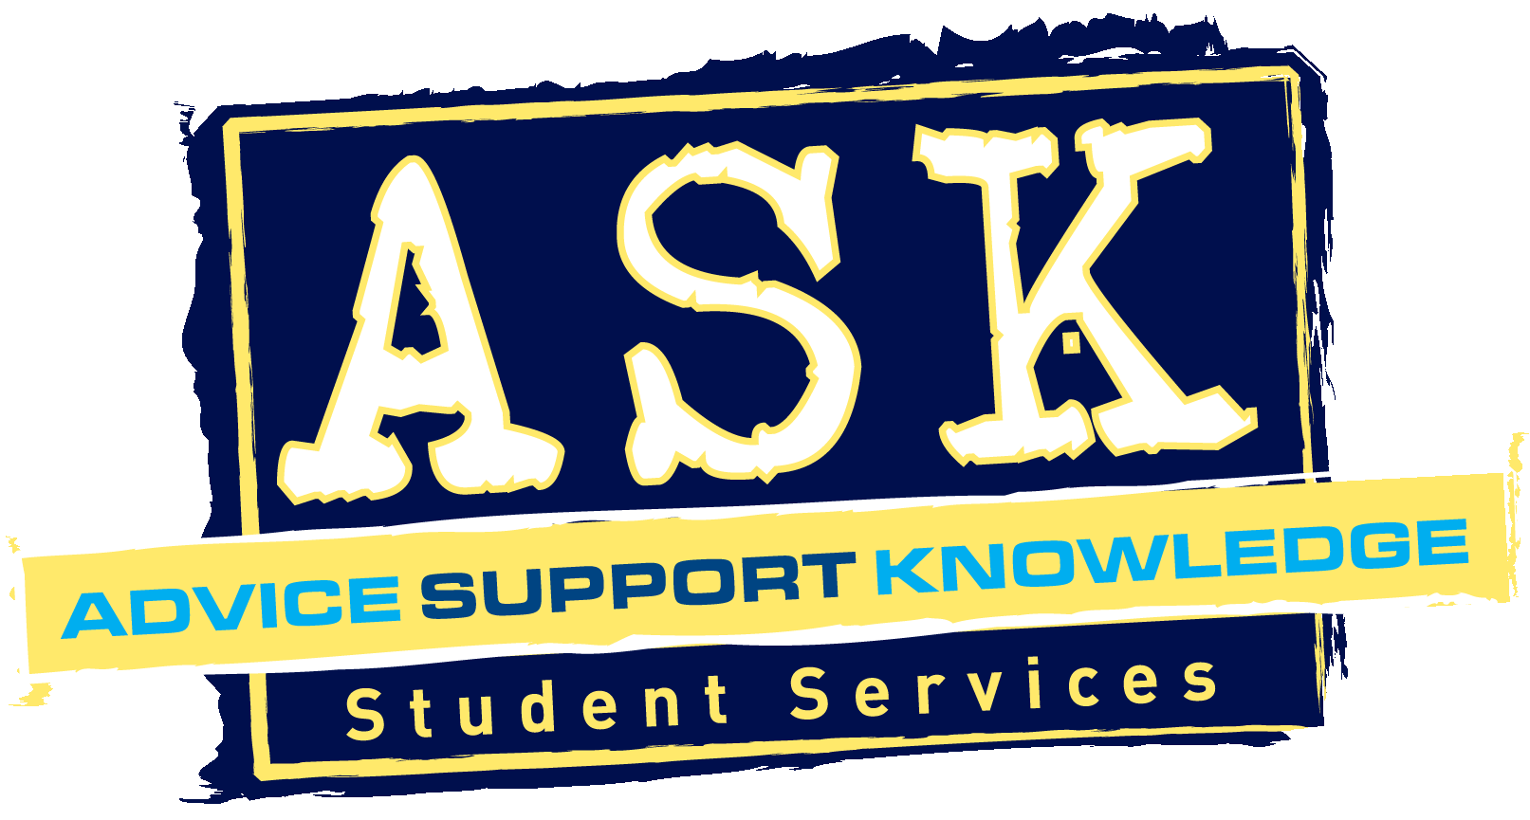CV Guidance Checklist

**Is the CV....?**

No more than two pages long

Well laid out, making good use of space, and not too cluttered

In a readable and clear font (usually Arial 11 or 12)

Double checked for spelling and grammar

Focussed toward the role being applied for e.g. graduate/part-time/placement

**This structure below is for guidance purposes. The actual order and structure of your CV may vary according to your experience and what type of role you are applying for.**

|  |  |
| --- | --- |
| **Personal Details:**   * Located at the top of the page, including name, address, contact details and a professional email address. * No information relating to age, sex, nationality, marital status or health, unless specifically requested in the job description. |  |

|  |  |
| --- | --- |
| **Personal/Career Profile:**   * A profile which is a brief (three or four lines maximum) summary of current situation and career objectives, and perhaps evidence of two or three main strengths. |  |

|  |  |
| --- | --- |
| **Key Skills:**   * A short bullet pointed summary of key skills developed (no more than 5 or 6) through work, study or extra-curricular activity, along with a relevant example to illustrate each. * If adopting a skills-based CV, this section should be longer and more detailed, with several examples provided for each skill. |  |

|  |  |
| --- | --- |
| **Education:**   * Includes subject studied, dates, the name of the institution, and town. * Is in reverse chronological order, with the most recent experiences first, going back to relevant secondary level education (these can be summarised e.g. 5 GCSE’s grades A-C). * (Optional and only if relevant) Lists relevant modules studied at University and information about dissertations and projects. |  |

|  |  |
| --- | --- |
| **Employment History:**   * Details of all work experience, including paid, voluntary and shadowing. * Each role has examples of key responsibilities and achievements (max 6 bullet points for each job). * Highlights any skills gained during work (unless CV has a separate skills section). * Is in reverse chronological order, with most recent experience first. |  |

|  |  |
| --- | --- |
| **Interests and Achievements:**   * Lists of any extra-curricular achievements or successes * Details of (relevant) personal interests with a focus on contributions made and skills gained |  |

|  |  |
| --- | --- |
| **References:**   * Two referees (either both employment or one academic and one employment) or stating “References available on request” if short of room |  |

**Further resources and Advice**

**You and your CV are individual and it is important that you choose a style that clearly reflects your skills and experience, is relevant for the job and industry you are applying for and makes you stand out in a positive way.**

**Student Services Resources:**

“Applications, CVs and Covering Letters” booklet from AGCAS and Graduate Prospects, available in Student Services

“Folder 8.1/2 CVs and Cover letters” – contains sample CVs and lots of CV writing tips

“Creating the perfect CV” book Bright and Earl

**Online**

[www.bcu.ac.uk/studentservices/careers](http://www.bcu.ac.uk/studentservices/careers) - BCU’s downloadable CV handout

[www.prospects.ac.uk/cvs](http://www.prospects.ac.uk/cvs) - contains sample CVs and more advice about CV content

<http://careers.guardian.co.uk/cv> - includes advice, clinics and industry specific CVs

[www.nextstep.direct.gov.uk/GETTINGAJOB/CVSANDCOVERINGLETTERS](http://www.nextstep.direct.gov.uk/GETTINGAJOB/CVSANDCOVERINGLETTERS)

[www.grb.uk.com](http://www.grb.uk.com/) - Graduate Recruitment Bureau- click on Job Advice