Centre for Critical Social Research Seminar Series
Revisiting the Campaign to Stop Heathrow Third Runway
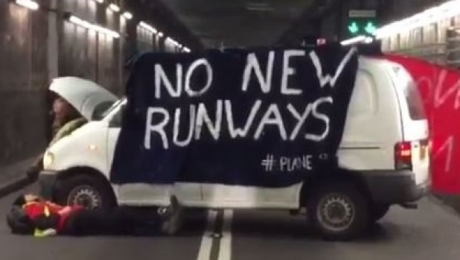

Dr Eugene Nulman

Wednesday 24th February
2-3.30pm
Curzon, 319

Event is free and refreshments provided

After a long campaign to stop the expansion of Revisiting the Campaign to Stop Heathrow Third Runway
Heathrow Airport residents and climate activists are once again placed in a precarious position regarding a third runway. How were activists able to thwart the threat of expansion at UK's hub airport previously and will they be able to do it again? Dr. Eugene Nulman will utilise a range of analytical tools developed within social movement studies to help answer these questions.
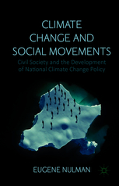

Dr Eugene Nulman is author of Climate change and social movements: civil society and the development of national climate change policy published by Palgrave Macmillan in 2015.

