The Rufopoly Resource Kit Proposed version 1 May 2015.
RATIONALE
- Following three workshops in April 2015 (Birmingham, Aberystwyth and Edinburgh) the core team (Scott, Carter, Adams and Gibbs) have synergised the various ideas and intelligence emerging into a proposed resource kit for your comment and approval.
- The diagram below shows in original form (complete with my awful writing!), the summary chart emerging from our team meeting on 29th April 2015.
- There was a clear consensus from each workshop stressing the importance of the resource kit having maximum flexibility and adaptability for possible users as part of a ‘learning tool’ that guides people into their own potential uses and applications drawing on lessons learnt from previous case studies.
- The diagram below is a brain dump of the key ingredients of the resource kit. These are briefly unpacked below. The order and sequence of headings is not significant and one goal for us all is to think about how we translate this complexity into an easily navigated web interface.
- We would appreciate your feedback and support on the resource kit as proposed and also your input into some of the resources section (see comments in text). Proposed actions are highlighted within a comments box.
- We are keen to identify and formalise procedures for the testing phase. Thus if you see any opportunities between late May and September please let us know asap.
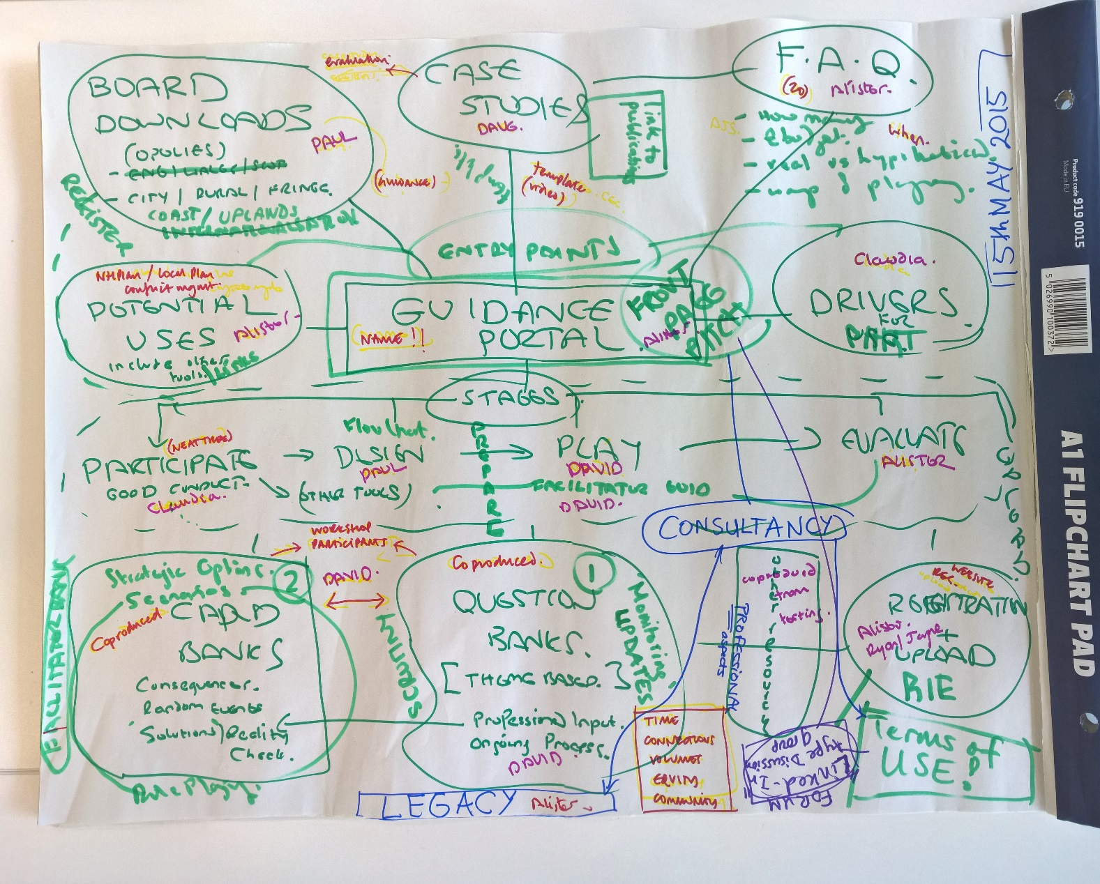
Figure 1: Proposed Rufopoly Resource kit
UNPACKING THE DIAGRAM
GUIDANCE
- The resource kit is constructed as a web portal within which there is clear and concise guidance. The web portal will be a complete one stop shop that provides well signposted and managed user navigation to the key resources they need to understand how to build, design, execute and evaluate their own successful ‘Rufopoly’ experience. Thus all the boxes in the diagram are proposed points of contact that potential users will encounter somewhere in their journey.
- The guidance therefore requires text to be built into each box in the diagram and these will be written up by the core project team in a draft form by May 15th. Some of these boxes will require your input : Question banks and Card banks in particular.
Stages of the game
BEST PRACTICE ------------------DESIGN------------ PLAY -------------------EVALUATE
- For each phase there will be a series of concise statements and prompts linked to other resources and logistics across the diagram. We are writing material to appeal to public and international audiences.
- Best practice - converts generic guidance and lessons on how to plan and manage participation successfully. People need to understand how to manage participation properly at the outset as it is here that many key mistakes are made.
- Design: This covers the full range of design applications; from those that want to design their whole Rufopoly board and questions to others who want to pick something already made off the shelf. It covers the particular exercise that is being done to include purpose; type of board requirement; questions required or designed and venue. We will tailor guidance that enables all groups to use software that is open source and available. This becomes important if people want to design their own boards.
- Play covers rules, numbers and logistics. Importantly we need the resource kit to be compatible with mobile phone and ipad use so that people can use the kit whilst an event is ongoing.
- Evaluate covers the assessment by participants and organisers related to how successful a particular event is. By using a set template, users will be able to upload and share their evaluation on our web portal for the benefit of other users.
- Facilitator Guidance covers guidance and briefings on the role(s) of a facilitator together with a register of approved facilitators who have been trained in the use of the resource kit.
REGISTRATION
- Whilst the Rufopoly Resource Kit is freely available, there will be a registration process after an initial home page which then grants access to the full set of resources. This is so we are able to ‘capture’ users and also then be in a position to encourage/facilitate uploads of evaluation, case studies, questions, boards and promote use of discussion forums. Crucially it enables users to understand the limitations of use (copyright issues) and to sign up to these formally.
- Registration would enable users to choose their own user name and password for ease of access and regular use.
DRIVERS FOR PARTICIPATION
- The drivers and potential uses (see next title) are inextricably linked. There are a series of drivers which have a particular bent for using the Rufopoly Resource Kit. So for example forthcoming Planning Legislation (Wales); Institutional changes, Localism and Local Plan initial consultations all featured in our workshop discussions.
POTENTIAL USES
- One major theme from the workshops was the need to understand where this type of resource was valuable and created additionality to extant tools including WHEN and for what PURPOSE. This section helps people appreciate the powers and limitations and also signposts other participatory resources to help where relevant. Here use in schools, communities and organisational change were commonly discussed in the workshops.
BOARD DOWNLOADS
- It was important to provide a set of hypothetical board resources as downloadable documents for printing. The boards will be developed using open source software so that if people want to design their own board from scratch they can. Equally they can download different landscapes. This section needs to be pick and mix style.
- So there are boards to be downloaded; with or without question grids with or without questions with or without Chance cards.
- Initially we will produce up to 5 generic boards based on different landscape characters. One would be urban/city based; one would be urban fringe; one would be rural; 2 other multifunctional boards will be produced.
QUESTION BANKS
- For both banks (question and Cards) they will be designed to ensure that they can be easily printed out as cards for a board game version but equally could be used in game on mobile or ipad applications.
- The questions on the current Rufopoly board are too restrictive and thus boards need to be used with questions located separately (See Plainsopoly presentation). This then enables a question bank to be built up. This bank will be built in part from past questions following a scrutiny process, but it was felt equally important to enrich this resource with questions designed by workshop participants and your networks.
- However it was important to use real scenarios for any question in the resource kit. All questions would be vetted by a scrutiny committee across the project team.
- We want to raise the profile and importance of our coloured themes and thus these would relate to question categories. At present we propose Strategic; Contested Values ; Long Termism ; Connectivity; Community and Equity
- By building these banks we can then offer users a board with a preset set of questions that cover the full range of issues/themes or we can enable a pick and mix selection so people can actually select the questions they want from the themes they want and/or create their own questions or themes.
- Ultimately we would like people who have built their own question set or new themes to upload these. This will enrich and build the question bank resource.
CARD BANKS
- The card banks are a pick and mix of resources that might be useful for a particular exercise. Guidance will help expose organisers to the pros and cons of using various options
- A common concern encountered was the need to introduce a chance or random event into the game. We see the need to set up a set of cards that change the nature of the game and can be used if people wish these include:
- Role play cards. Here we would like people to paint pen profiles of real people so that these roles can then be used in a game situation. We need more than a role so we are looking for a 100 words to define the person and their values. Eg Farmer, Planner, Developer, Landowner, Ecologist, Archaeologist, Small Business, Supermarket
- Random events cards: these cards would throw into the mix an unexpected event or crisis that the players then have to respond to and also possibly rethink earlier choices.
- Consequences Cards; there was common support for trying to make people more accountable for their decisions as they journey around a board. These cards might be available for some multiple choice questions (question bank) where a set of consequences might be defined according to particular answers. More simply we will also have instructions to reflect on your previous answers
- Reality Check cards: these are cards which link with the question banks above where for some questions there is actually the real answer of what happened in the scenario. This can be used to help promote debate and comparison with the answer given.
- Strategic Option cards. These are cards that can be used from the outset or during the game within a scenario how a player or players might approach the questions. Options for growth for example.
CASE STUDIES
- These will capture the different experiences and uses of Rufopoly using a set template whereby our existing case studies can be uploaded. This would cover: purpose of the exercise, what was done, what happened and lessons learnt but with an update section also added.
- This section was seen to have both a review of past studies up to NOW but also a section whereby new experiences with the Resource Kit could be uploaded to so that it grows as a resource base.
FAQ FREQUENTLY ASKED QUESTIONS
- This section was seen to be an important add on to the central guidance that dealt with commonly occurring questions and problems. For the most part these would be key concerns from the workshops (eg size, numbers, real vs hypothetical), past experiences and also problems actually encountered with the testing of this resource kit itself. We have limited this to 20 priority issues.
FORUM DISCUSSIONS
- There was a need to enable registered users to share their experiences and ask questions. This would be monitored as many discussion form do fail to take off.
LEGACY
- The project finishes officially in November 2015. However, it is vital that we build a legacy component in. We have secured access to a hosting via David Jarvis Associates and we will create a simple web design that will enable us (the core team) to upload at least 2 times a year resources that external users have submitted after the project end (eg boards, questions, case study and evaluations). However the site will be regularly monitored for problems as part of our own requirement for research assessment exercise 2020 and impact studies.
INTERACTION AND FUNCTIONALITY
- The initial resource kit (late May) will be a simple functional web portal that will take you to the various stages above without the design or interactivity. As we go through the testing phase we will start to augment the design and interactivity in conjunction with feedback. Pragmatically we need to get you something you can use and test. All the preliminary resources will be available for downloads but the question banks, case studies and card banks do depend on your support.
- The latter changes to the web portal will enable discussion and uploads of material but clearly this is not a priority for us just now.

