BCU ITE Secondary

PGCE Secondary Education with QTS

&

BA & BSc (Hons) Secondary Education with QTS

School Based Training

Mentor Handbook

Contents

- Key dates
  - PGCE Secondary SBT dates and core expectations for Associate Teachers during SBT
  - BA & BSc (Hons) Secondary Education with QTS SBT dates
- BCU ITE Core Curriculum
- Further guidance to support School Based Training (SBT) Placements
  - Planning and Preparation Guidance
  - PRE-PLACEMENT TASKS
- REPORTING ABSENCE
- WORKLOAD
- SCHOOL BASED TRAINING PLACEMENT INFORMATION
  - Formal observations of Associate Teachers
  - WEEKLY TASKS
- School Based Visits
  - PGCE Secondary Tutor Visit Mapping
  - For BA & BSc (Hons) with QTS Secondary Education
- BCU Weekly Mentor & Associate Teacher Meeting Record
- Learning Observation Record
- Critical incident Discussion Form
- Mid and End Point Assessments (informed by the Assessment Tracker and to capture progress)
- BCU ITE Curriculum Themes and links with Teachers’ Standards and ITT Core Content framework
- RAPID IMPROVEMENT TARGETS (RIT) PROCEDURE 2023-2024
- Placement Review Process
- The Role of Mentors
- Course Team contact details:
- Mentor CPD Events 2023/24
- BCU Associate Teacher Code of Conduct
- Enrichment Placements

Key dates

PGCE Secondary SBT dates and core expectations for Associate Teachers during SBT.

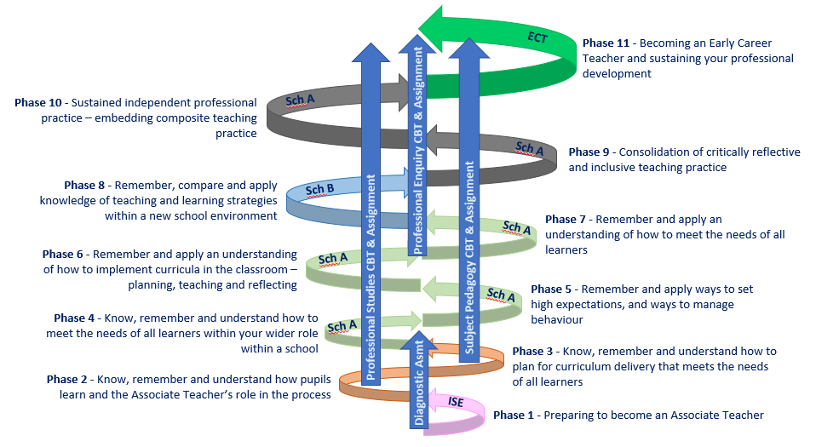

School A: Phases 5-7
Start - Thursday 5th October 2023
End – Friday 9th February 2024
Associate Teachers will:
- Be in SBT Thursday and Friday from Thursday 5th October to Friday 28th October.
- Be in SBT Tuesday to Friday from 7th November to Friday 9th February
- Build towards solo teaching of 5 hours per week across Key Stage 3 and Key Stage 4 in phases 5 & 6 (up to the school Christmas break). This then increases to 7 hours per week in phase 7 (January-February)
- Plan 2 lessons weekly on the BCU lesson plan template (other taught lessons can use other lesson planning templates as negotiated with the Subject Mentor)
- Support teaching for 7 hours a week in their specialist subject across Key Stage 3 and Key Stage 4
School B: Phase 8 - 10
Start – Tuesday 20th February 2024
End – Friday 28th June 2024
In Phase 8 Associate Teachers will:
- Be in SBT Tuesday to Friday each week for Phase 8
- Build towards solo teaching of 9 hours per week across Key Stage 3 and Key Stage 4 (including Key Stage 5 where possible)
- Plan 2 lessons weekly on the BCU lesson plan template (other taught lessons can use other lesson planning templates as negotiated with the Subject Mentor)
- Support teaching in 7 hours a week in their specialist subject across Key Stage 3 and Key Stage 4
In Phase 9 Associate Teachers will:
- Tuesday to Friday each week for 9.
- build towards 11 hours solo teaching per week across Key Stage 3 and Key Stage 4 (including Key Stage 5 where possible) throughout Phase 9.
- Plan 2 lessons weekly on the BCU lesson plan template (other taught lessons can use other lesson planning templates as negotiated with the Subject Mentor) - until directed to adapt to school planning format.
In Phase 10 Associate Teachers will:
- Be in SBT 5 days a week for Phase 10 from Monday 20th June 2023.
- Build towards solo teaching of 14 hours per week from the start of Phase 10.
- Plan 2 lessons weekly on the BCU lesson plan template (other taught lessons can use other lesson planning templates as negotiated with the Subject Mentor) - until directed to adapt to school planning format.

BA & BSc (Hons) Secondary Education with QTS SBT dates:

Year 1 Associate Teachers:
Part 1 - Start – Monday 20th November 2023 End –Friday 19th January 2024
Part 2 - Start – Monday 8th April 2024 End – Friday 3rd May 2024
Associate Teachers will:
- Have a timetable that follows the minimum teaching expectations below, using the BCU lesson plan template.
- Additional lessons can be added on agreement between the associate teacher and mentor.

Placement Days | Placement Expectations
3 Monday only placement days:  Monday 20th November to Monday 4th December 2023 | Teaching:  Aim to support (through team teaching or teaching episodes) in at least 2 lessons during these three days.  Observing:  The main objective of these three days is to observe as much as possible and to gather all relevant policies and student data for your taught lessons.  The AT must complete the placement induction tasks and have a timetable set up by the mentor.
5-day block A:  Monday 11th – Friday 15th December 2023 | Teaching:  Have one lesson/hour per day timetabled to individually teach (or build up to teaching) per day.  Observing:  Observe/support in 2 lessons in their specialist subject per day  The remainder of time can be allocated to admin or observing as the mentor sees fit.
10-day block A:  Monday 8th January to Friday 19th Jan 2024 | Teaching:  Have one lesson/hour per day timetabled to individually teach (or build up to teaching) per day. Progress should be seen from the 5 day block in either effectiveness of teaching and/or building to being individually taught lessons.  Observing:  Observe/support in 2 lessons in their specialist subject per day
12-day Block B  *two consecutive Mondays followed by two-week block*  Monday 8th April to Friday 3rd May 2024 | Teaching:  Build on from Block A to having as much of your one lesson per day as individually taught as possible.  Observing:  Observe/support in 2 lessons in their specialist subject per day

Year 2 Associate Teachers:
Start – Tuesday 7th May 2024 - End – Friday 5th July 2023
Associate Teachers will:
- Have a timetable that follows the planned teaching expectations below, using the BCU lesson plan template.

Placement Days | Placement Expectations
First four weeks:  Tuesday 7th May – Friday 7th June 2024 | The placement induction tasks should be completed in their first week.  Teaching:  Build on from Year One to teaching towards individually taught lessons.  The AT should have a timetable of 10 lessons/hours a week, with the aim to be teaching 7 of those (minimum) in the first four weeks.  Observing:  Observe/support in at least 10 lessons in their specialist subject across the week.  The remainder of time can be allocated to admin/observing.
Second four weeks:  Monday 10th June – Friday 5th July 2024 | Teaching:  Build on from the first four weeks, to teaching the 10 planned lessons/hours a week individually.  Observing:  Observe/support in at least 10 lessons in their specialist subject across the week.  The remainder of time can be allocated to admin/observing.

Year 3 Associate Teachers:
Start – Monday 11th December 2023 - End – Friday 24th May 2024
Associate Teachers will:
- Have a timetable that follows the planned teaching expectations below, using the BCU lesson plan template.

Placement Days | Placement Expectations
Five-day Induction Block:  Monday 11th December 2023 - Friday 15th December 2023 | The placement induction tasks should be completed in their first week.  Gather all necessary documentation and create your placement timetable.  Observe and support in around 3-4 hours of lessons each day, or as the department timetable sees fit.
Two-week block:  Monday 8th – Friday 19t^{h} Jan 2024 | Teaching:  Plan and deliver 10 individual lessons/hours each week of the two-week block.  Observe and support as needed
3-day placement: (Monday, Thursday and Friday)  Monday 22nd January – Friday 22nd March 2024 | Plan and deliver 7-10 individual lessons/hours across the three days.  Observe and support as needed.
3-day placement: (Monday, Thursday and Friday)  Monday 8th April – Friday 24th May 2024 | Plan and deliver 10 individual lessons/hours across the three days.  Observe and support as needed

Assessment points:

 | Formative Assessment Point  (Mid-Placement Review) | Summative Assessment Point  (End-Placement Progress)
BA / BSc (Hons) with QTS Year 1 | 19th January 2024 | 5th May 2024
BA / BSc (Hons) with QTS Year 2 | 7th June 2024 | 7th July 2024
BA / BSc (Hons) with QTS Year 3 | 1st March 2024 | 26th May 2024
PGCE Secondary  School A (Phases 5 to 7) | 22nd December 2023 | 9th February 2024
PGCE Secondary  School B (Phases 8 – 10) | 22nd March 2024 | 24th May 2024

The BCU Assessment Tracker
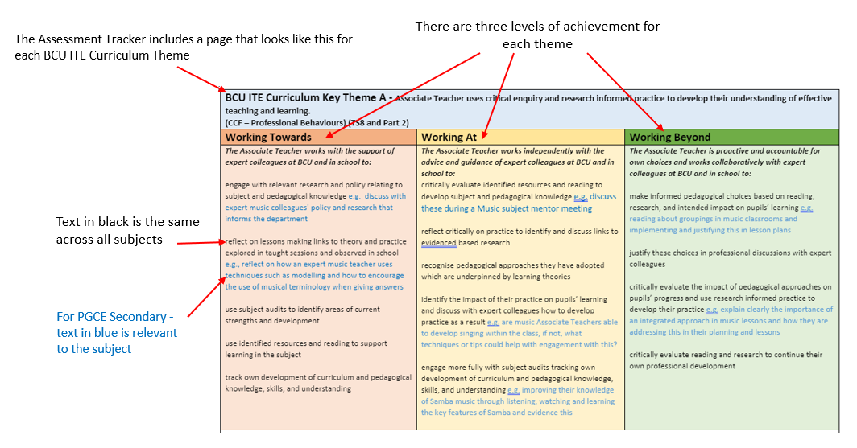
- Statements on the tracker will be highlighted as the Associate Teacher (AT) progresses through the course to show which formative descriptors within the ‘Working Towards’ / ‘Working At’ the AT is achieving for each theme.
- This is a way of capturing the AT’s progress at key points throughout the course.

Use of the Assessment Tracker for PGCE Secondary:
- By the end of Phase 6 (December) the AT needs to achieve ‘Working Towards’ for at least 3 of the Curriculum Themes (and this must include Theme F) to be considered on track for achieving QTS.
- By the end of Phase 7 (February) the AT needs to achieve ‘Working Towards’ for all the Curriculum Themes to be considered on track for achieving QTS. This is also a pass point for School A. Failure to achieve ‘Working Towards’ in all themes will result in a failed placement.
- By the end of Phase 8 (April) the AT needs to achieve ‘Working At’ for at least 3 Curriculum Themes (and this must include Theme F) to be considered on track for achieving QTS.
- By the end of Phase 9 (May) the AT needs to achieve at least ‘Working At’ for all the Curriculum Themes to be considered on track for achieving QTS.
- In Phase 10 the AT is then assessed against the Teachers’ Standards to be awarded QTS.
- The assessment points at the stages outlined above are to ensure that the AT is ‘on track’ for achieving QTS by the end of the PGCE. Any ATs not on track at these assessment points will be placed on a RIT to support their progress.
- All the above points are mapped out in the diagram below as relevant to PGCE Secondary Associate Teachers:

Use of the Assessment Tracker for BA/BSc Secondary:
There are minimum expectations against the assessment tracker, to ensure that ATs are showing effective progress. These can be seen below and are noted on the review and progress check documents:
 | Review  Meeting 1 | Progress  Meeting 1 | Review  Meeting 2 | Progress  Meeting 2 | Review  Meeting 3 | Progress  Meeting 3
Days in School | 15 days | 30 days | 50 days | 70 days | 100 days | 130 days
Assessment Minimum:  Areas completed of the BCU Curriculum | 2/6 in Towards* | 4/6 in Towards* | 5/6 in Towards* | 5/6 in Towards* | 5/6 in Towards* | 6/6 in Towards
 |  |  | 1/6 in At | 3/6 in At | 4/6 in At | 6/6 in At

* Must include theme F
- The numbers relate to the BCU Curriculum theme areas. For example, in review meeting 1, all associate teachers would be expected to show that they have met ‘working towards’ in theme F and one other (for example Theme D).
- The assessment points at the stages outlined above are to ensure that the AT is ‘on track’ for achieving QTS by the end of the course. Any ATs not on track at these assessment points will be placed on a RIT in order to support their progress and steer them back on track towards QTS.

BCU ITE Core Curriculum
- How Associate Teachers use critical enquiry and research informed practice to develop their understanding of effective teaching and learning.
- How classroom practice establishes effective behaviour management through the use of high expectations and awareness of pupil wellbeing.
- How Associate Teacher’s knowledge and understanding of the curriculum, subject knowledge, pedagogy and how pupils learn impact on pupils’ progress and wellbeing.
- How Associate Teachers plan and assess learning to ensure that all pupils make progress.
- How Associate Teachers implement effective adaptive teaching approaches to support all learners, including SEND and EAL learners.
- How Associate Teachers have developed professional behaviours and contribute effectively to the wider life of the school.

The BCU ITE Curriculum aligns with the DfE (2019) ITT Core Content Framework. Our ambitious curriculum is designed within a spiral curriculum model, which deepens knowledge and understanding through an iterative revisiting of identified topics, subjects, and themes throughout all BCU Secondary QTS courses.

Further guidance to support School Based Training (SBT) Placements:

Planning and Preparation Guidance

School Induction procedures should include:

- Information about the context and ethos of the school. An overview of the school’s priorities for teaching and learning and arrangements for the Associate Teacher’s placement.

- A tour of the school and the school’s facilities.

- Safeguarding:
    - Prior to the placement the Associate Teacher is required to complete Level One Safeguarding training, plus an online Safeguarding Quiz and the Home Office (online) Prevent training. Please discuss this with the Associate Teacher.
    - Provide the Associate Teacher with access to, and discuss, the school’s Child Protection and Safeguarding Policy and Procedures, including local safeguarding priorities that are currently impacting on the school.
    - Ensure the Associate Teacher is familiar with the DSL and their deputies, including how they can be contacted.
    - Discuss the school’s record-keeping procedures and the Associate Teacher’s role in this.
    - Discuss and ensure Associate Teacher understanding of the school’s procedures for dealing with peer-on-peer abuse.
    - Have a discussion regarding how to ensure victims of abuse will be supported and what staff need to do to ensure children/pupils know they will be taken seriously.
    - Discuss procedures to ensure data protection and safety – what do Associate Teachers need to do routinely in their professional practice?

- Health and Safety:
    - Explain to Associate Teacher all related risk assessment requirements in line with all staff in school.
    - Health and Safety Induction information gathering from the relevant H&S Policies.

- Policies:
    - Access to relevant policies including: Behaviour Management; SEND; Assessment, Marking and Feedback; Teaching and Learning; any specific policies relating to their specialist Curriculum Subjects

- Staffing:
    - Overview of staff including roles and responsibilities.

- School’s expectations:
    - Outline of the school’s expectations including: time keeping, dress code, online safety, GDPR, use of social media, engaging with parents/carers.

- Confirm arrangements for any meetings
    - Outline all opportunities in school for Associate Teachers to build experience during SBT, e.g. as applicable; involvement in an extra-curricular activity, CPD etc.
    - Identify staff meetings/training that Associate Teacher should attend during the School Based Training. Unless advised otherwise by the school, Associate Teachers should attend ALL whole school/phase meetings and training.

- Observing colleagues
    - Discuss protocol when observing/shadowing teachers. When observing a teacher, Associate Teachers will complete an observation form (a copy is provided in their One Drive folder), making notes to inform their own practice.

- Confirm arrangements for lunchtimes, breaks, start and end of day
    - Information about the school day, including pupil’s arrival times, lunchtime, moving around the school and leaving school at the end of the day.
    - Expected time of arrival in school and departure of staff and Associate Teachers, including any phased timings.

*

During the preliminary visits, Associate Teachers gather a range of information about the school and classes as well as getting to know the pupils. They will be asking a variety of questions about the following aspects:

- Expectations for Planning:
- Identification of Units of Learning to be taught during the placement and access to school Schemes of Learning to guide their planning
- Discuss the school’s medium/weekly term planning for the lessons the Associate Teacher will be teaching
- Identify resources to support learning and teaching in the relevant lessons on the Associate Teacher’s timetable
- The Associate Teacher must complete lesson planning for the lessons being taught weekly – with two of these lessons being recorded and evaluated on the BCU Formal Lesson Plan Template
- Negotiating the timetable to be taught between teacher and Associate Teacher: e.g., team teaching, teaching of small groups, 1:1 intervention etc
- Discuss the BCU ITE Curriculum in your specialist subject and identify the Associate Teacher’s subject/pedagogical development needs
- Adult support in the any lessons on the Associate Teacher’s timetable - how it is used to support learning and when it is available
- Identification of all vulnerable learners in their classes – e.g., Pupil Premium learners, CLA, EAL learners, etc.
- Identification of and provision for learners with Special Educational Needs and Disabilities
- Behaviour Management – policy/practical approaches and general classroom routines
- Assessment: please discuss assessment for learning strategies and summative and statutory assessment procedures. Provide meaningful opportunities for the Associate Teachers to use and become fully conversant with assessment tracking software and to use this as part of their practice.
- Facilitate opportunities for the Associate Teacher to observe teaching to develop their understanding of good practice
- Associate Teachers would benefit from getting to know their classes by teaching small groups, introducing a lesson, leading on plenaries etc. before they transition to full class teaching

PLACEMENT INDUCTION TASKS
BA / BSc Secondary only: Three tasks based on Safeguarding, health and safety and an observation of an expert colleague around behaviour/SEND. This should be completed within the first 5 days of placement.

Before each Placement begins
The Professional Mentor will:
- Develop an appropriate teaching timetable for the Associate Teacher for the placement, based on the teaching expectations. Discuss any arrangements for teaching, e.g. team teaching, teaching of small groups, 1:1 intervention.
- Identify a schedule for Weekly Professional Development Meetings with the Subject Mentor (for BA/BSc associate teachers, these should take place according to the curriculum map dates).
- Discuss, with the Associate Teacher, relevant staff meetings that should be attended, as applicable, including any online meetings or training.

The Subject Mentor will:
- Discuss Associate Teacher’s development and identified targets and generate strategies for in-school support.
- Support planning as appropriate and confirm that they are happy with the Associate Teacher’s planning/preparation before the Associate Teacher is ready to start their School Based Training.
- Map out observation dates/ times across the placement.

REPORTING ABSENCE
It is the professional responsibility for all Associate Teachers to report each day of absence using the BCU absence process, set out below (3 processes):
- Contact the SBT provider to formally report their absence and provide the SBT with sufficient information about the duties/lessons they were due to perform to ensure the SBT are not unduly impacted by the absence. Follow the school procedure set out below to complete this.
- Notify your absence on the MySRS portal by 08:30am at the very latest on each day of absence.
- Email the details of the absence to ESWPlacementAbsences@bcu.ac.uk and CC your UT/PDT into that email. Associate Teachers should provide the following information.
- Full Name
- Student ID Number
- Course Name
- Year of Course
- First Date of Absence
- Last Date of Absence
- Total Hours Absent from Placement
- Name of the Placement Provider (e.g. School name)
- Absence Type (Sickness/Authorised Absence/or another reason)

University Associate Teachers must make calls in person except in extreme circumstances.

- Agreed School procedure for the Associate Teacher to report their absence to the SBT provider:

Who does the associate teacher contact? | [Name of person]
How would you like to be contacted? | [Method of contact]  Please leave the number/s or email addresses here also.
What time does the contact need to have been made by? | [Time (e.g., 8.15am)]
By what time do you need to let the school know if you are going to be in, or not, by the next day? | [Time (e.g., 3.15pm day prior)]

WORKLOAD

Associate Teacher Workload
The university are committed to reducing the workload of ITE Associate Teachers and are following the advice of the DfE.

https://www.gov.uk/government/publications/addressing-workload-in-initial-teacher-education-ite

Based on the DfE advice and in line with school policy, in order to support our Associate Teachers in school consideration should be given to the following:

- Associate Teachers are undertaking tasks which contribute directly to pupil outcomes and their own development
- In line with school’s guidance, protected non-contact time (For example: Associate Teacher planning alongside colleagues, support from subject leaders)
- In line with school’s guidance, planned professional development opportunities
- The Associate Teacher must complete short-term planning for all sessions taught in a format agreed with the school (formally observed lessons must use the BCU formal lesson plan template). Providing opportunity for Associate Teachers to use existing high-quality resources, such as schemes of work, textbooks, to enable them to plan a sequence of lessons. The focus should be on planning a series of lessons, but specific circumstances may mean that Associate Teachers have to plan a one-off lesson
- Provide planning support. This may be from the class teacher/year group colleagues or another designated staff member
- If Associate Teachers are using existing school planning, this will need to be annotated and adapted to meet the needs of the learners the Associate Teachers are teaching, in order to demonstrate how they are developing and adding their own ideas and approaches.

SCHOOL-BASED TRAINING PLACEMENT INFORMATION

Details relating to timings of each SBT block and related teaching load expectations are identified at the start of this document.

Formal observations of Associate Teachers

- Ideally, Associate Teachers will have two observations over every 4-5 days. Learning observations will cover a range of classes within their scheduled teaching timetable.

- Joint observation – a joint observation will be completed once per block by the University Tutor and the Subject Mentor. Please note: Joint observations count as one observation only. This forms part of the internal moderation process (see Internal Moderation document).

- In consultation with the Associate Teacher, Subject mentors will identify when formal lesson observations will take place. Observations may be delegated to other class teachers within whose lessons the Associate Teacher is working.

- The Subject Mentor should, ideally, undertake the first observation, within 7 working days of the block placement starting. The observation should be focused on the impact of the Associate Teacher’s teaching on pupil’s behaviour for learning, learning and progress.

- Observations should ideally be on a weekly basis with sufficient time in between for Associate Teachers to address any targets they need to focus on.

- For lesson observations, a BCU lesson plan should be available for the observer.

- Formal observations should be recorded on the university’s Learning Observation Record (LOR) – this is available electronically and can be downloaded and stored into the Associate Teacher’s OneDrive after completion.

- Verbal feedback from the observation should be shared within 24 hours of the observation taking place.

- The written feedback should be discussed to identify strengths, areas for development and suggest strategies and relevant research the Associate Teacher may use to enhance their professional practice. Please be as detailed and clear as possible. Typically, this should be within 48 hours (maximum of 5 working days).

- Targets should be negotiated with the Associate Teacher and clearly recorded on the Mentor and Associate Teacher Weekly Meeting Record - and reviewed as appropriate. As much informal feedback as possible will also be beneficial to the Associate Teacher.

- The Associate Teacher should email copies of the lesson observation feedback to the University Tutor.

- Any Rapid Improvement Target (RIT) should be clearly identified on the observation form against the relevant BCU Curriculum Key Themes. It should be completed in partnership with the University Tutor.

WEEKLY TASKS

PGCE
- Associate Teachers on the PGCE course will complete a weekly reflection on the Curriculum document that supports the weekly BCU Weekly Mentor & Associate Teacher Meeting Record. Their reflections should focus on the impact of their teaching on the pupils’ learning and progress considering key aspects of their professional practice and linked to the BCU ITE Core Curriculum. Following discussion with the class teacher, subject specific and targets for the week ahead will be set. Clear areas of strength and development should be identified.

BA/BSc
- Using the Curriculum Mapping document for their subject, Associate Teachers, with the support of their mentor, will complete the column titled: Mentor supports the associate teacher's knowledge in school by, in preparation for the BCU Mentor Meeting. The comments left here should reflect the knowledge learnt and applied in the mentoring meeting window. In the mentor meeting, discussion will be centred around the associate teacher’s strengths and carefully selecting SMART targets for the next week ahead.

Associate Teachers must engage in Weekly Professional Development Discussions with the Subject Mentor to review progress, whereby they discuss issues and identify the targets for the following week. Associate Teachers should record outcomes in the Weekly Mentor Associate Teacher Meeting Records and collect evidence that they can use in their Critical Incident Professional Discussions during review and Progress Meetings.

The Subject Mentor should record the Associate Teacher’s progress by underlining appropriate statements from the BCU Assessment Tracker in the Associate Teacher’s School Based Training shared One Drive folder.

BA/BSC One-Drive
Associate Teachers will be responsible for the organisation and content of their electronic, ONLINE School Based Training File (OneDrive) as follows:
- Curriculum Maps – This is where your curriculum map for your subject should be stored and updated.
- Placement Induction – This is where your placement induction tasks and any documents you need to store when being inducted into the school at the start of the SBT placement.
- Lesson Planning Resources – This is where you will store all lesson planning documents and resources
- Observation Records – This is where you will store all lesson observation documents
- ​Assessment, Review & Progress – This folder is where your Assessment Tracker, Mid-Placement Review form and End-Placement Progress form will be kept and updated.
- Mentor Meeting Records – All records using the mentoring meeting agenda will be stored in this folder.
- Your Timetable – Keep a copy of your timetable here (including teaching, observation, and PPA time).
- *Yr3 QTS Reflection* - This is where you will store the QTS reflection document. It is for the end of Yr3 use only.

PGCE One drive
Associate Teachers will be responsible for the organisation and content of their electronic, ONLINE School Based Training File (OneDrive) as follows:

Folder 1: PGCE Curriculum / Mentor Meetings
  - Curriculum Map
  - Assessment Tracker
  - Subject tracker
  - Weekly Mentor Meeting Records (have a separate folder for these to be stored in within this first folder)

Folder 2: School-based experience
  - Pen portrait
  - Timetable
  - Teaching Practice Register
  - Planning documents (have a separate folder for these within this second folder)
  - Planning and resourcing of taught lessons (have a separate folder for these within this second folder)
  - LORs (have a separate folder for these within this second folder)

Folder 3: Centre-based work
  - Completed assignments and feedback (with any academic action plans)
  - Notes and downloads relevant to module

School Based Visits

The Associate Teacher, University Tutor and the Subject Mentor will attend these meetings. The University Tutor will normally visit the school in person once during the placement and will carry out a joint observation of the Associate Teacher with the class teacher or mentor. The University Tutor will attend the Review and Progress Meetings online unless arranged at the same time as the in-person visit.

For PGCE Secondary Education

PGCE Secondary Tutor Visit Mapping
All tutor visits will be aligned to the curriculum phases. These are visits intended to be completed by an Associate’s Teacher’s tutor who will be a subject specialist. Any visits conducted by PLTs will be in addition to these visits and will focus on Professional Mentor support.
Phase / Visit Number | Phase Focus | School Placement | Assessment Focus | Additional Notes
Visit 1 – Phases 3-5  2nd Oct – 17th November | “Remember and apply ways to set high expectations, and ways to manage behaviour” | School A | Settling in review  Review Assessment  (Themes B, C & F to be achieved at ‘Working Towards’ to be on track) | This is an in person visit within the first few weeks of the placement starting. The meeting will focus on how the Associate Teacher has settled into placement with a specific focus on setting high expectations and behaviour management. Information about the first formative assessment provided which is due in on 22nd December.
Visit 2 - Phase 6 – 7  20th Nov – 9th Feb | “Remember and apply an understanding of how to meet the needs of all learners” | School A | Progress Assessment  (all themes at ‘Working Towards’ to be on track) | This is an in-person visit to jointly observe the AT teaching WITH the subject mentor. If the mentor is experienced then the mentor takes the lead with writing the lesson observation feedback, QA’d by the tutor. If the mentor is new to the role, the tutor will complete the observation record and targets to model the process for the mentor. In line with the curriculum phase part of this visit will focus on planning, teaching and reflecting in preparation for the Phase 7 Review due in on 9th February.
Visit 3 – Phase 8  19th Feb – 18th Mar | “Remember, compare and apply knowledge of teaching and learning strategies within a new school environment” | School B | Review Assessment  (Themes B, C & F to be achieved at ‘Working At’ to be on track) | This is an in person visit within the first few weeks of the second placement starting. The meeting will focus on how the Associate Teacher has settled into placement with a specific focus on adjusting to a contrasting placement. Information about the first formative assessment provided which is due in on 22nd March.
Visit 4 – Phase 9  8th Apr – 24th May | “Consolidation of critically reflective and inclusive teaching practice” | School B (return to School A for some School Direct routes) | Progress Assessment (all themes at least ‘Working At’ to be on track for QTS) | This is an in-person visit to jointly observe the AT teaching WITH the subject mentor. If the mentor is experienced then the mentor takes the lead with writing the lesson observation feedback, QA’d by the tutor. If the mentor is new to the role, the tutor will complete the observation record and targets to model the process for the mentor. In line with the curriculum phase part of this visit will focus on consolidation of critically reflective and inclusive teaching practice for the Phase 9 Review due in on 24th May.
Visit 5 – Additional Visit if needed – Phase 10  3rd June – 28th June | “Sustained independent professional practice - embedding composite teaching practice” | School B | Final QTS assessment | This is an optional visit for any ATs who were not on track at Phase 9 for achieving QTS (all themes assessed as ‘Working At’).

For BA/BSc (Hons) with QTS Secondary Education

Secondary Undergraduate Tutor Visit Plan

 | First Visit  (online) |  | Additional Visit  (In-person) | Mid Placement  Review Meeting: | Final Visit  (In-person) | End Placement  Progress Meeting
Y1 Placement 30 days | *QA Email check*  Days 2-4  21st Nov – 5th Dec | Days 6-13  9th Jan – 30th Jan | If required:  Days 16-19 of placement | Day 15  13th Feb 2023 | Days 21-30  24th April – 5th May | Day 30  5th May 2023
Y2 Placement 40 days | Days 6-15  15th May – 26th May |  | If required:  Days 16-30 of placement | Day 20  9th June 2023 | Days 31-40  26th June – 7th July | Day 40  7th July 2023
Y3 Placement 60 days | Days 6-12  3rd Jan – 13th Jan |  | Days 19-30  6th Feb – 10th March | Day 30  3rd March 2023 | Days 34-45  13th March – 21st April | Day 60  26th May 2023  (*QTS Reflection*)

RAPID IMPROVEMENT TARGETS (RIT) PROCESS 2023 24

Aims of the Rapid Improvement Targets Process

The Rapid Improvement Targets Process is initiated after a discussion between a mentor/tutor and the associate teacher. A RIT will ensure that all associate teachers are supported and offered intervention where necessary to make satisfactory progress on the course.

Rapid Improvement Targets can be initiated at any stage of the ITE programme and:
- Can relate to an associate teacher’s engagement with, and attendance, at the taught elements of the programme
- Can be initiated if an associate teacher fails to demonstrate high standards of personal or professional conduct. (See Appendix 1 for examples)
- Can relate to specific aspects of the associate teacher’s teaching and be characterised by a lack of expected progress by the pupils (See Appendix 1 for examples)
- Can identify gaps in performance aligned against the BCU ITE Assessment Tracker and/ or the ITT Core Content Framework (DfE, 2019)
- Can be initiated if associate teacher’s teaching, for any reason, is not developing as expected; for example, if an associate teacher ‘plateaus’ and there is no evidence of further progress or development in the impact of their teaching
- Can be initiated if associate teacher has not received the necessary support from the placement school, at which point the university will intervene and offer additional support
- Can be initiated if an associate teacher needs support with well-being or workload management.

Rapid Improvement Targets can only be initiated by a BCU tutor. Subject and Professional Mentors can and should raise concerns aligned to the process with the link tutor and will share specific areas of weakness ahead of any formal meeting.

Rapid Improvement Targets will:
- outline the concerns,
- set clearly articulated and precise targets aligned to the BCU ITE Curriculum,
- outline concrete actions for the associate teacher to achieve,
- identify which stakeholder is responsible for monitoring each target,
- identify intervention strategies,
- signpost training needs,
- explain existing support strategies, and
- agree review deadlines.

In Rapid Improvement Target meetings:
- the associate teacher must attend
- the SBT subject and/or professional mentor will attend
- targets will be monitored by the BCU tutor responsible for quality assuring the associate teacher’s progress
- be overseen by BCU Senior Tutor on the associate teacher’s course

The Rapid Improvement Target Process is an intervention strategy and will result in an agreed increase in school and / or university support and monitoring to ensure the associate teacher has an opportunity to address the targets requiring immediate action.

If a placement breaks down within a RIT period the lead mentor will be required to complete the RIT review and the Placement Review Process.

Rapid Improvement Target Process

The Rapid Improvement Target Process (RIT) has been simplified into a flow chart and can be found on the following page:
Issues or areas to be discussed by subject/professional mentor and tutor.
Have these issues or areas been discussed with the associate teacher to correct the identified issue?
Yes
No
Issue of RIT1: Associate teacher is placed on a RIT for up to 10 working days * to provide opportunity to demonstrate progress/change in performance. RIT is written and implemented by tutor, with subject/professional mentor supporting the monitoring of progress. RIT should be discussed during weekly review meeting in school.
No
Yes
No
Successful completion of RIT—normal training resumes.
No
Yes
Issue of RIT2: Associate teacher is placed on a RIT for up to 5 working days* to provide opportunity to demonstrate progress/change in performance. RIT is written and implemented by tutor, with subject/professional mentor supporting the monitoring of progress.
Yes
Successful completion of RIT—normal training resumes.
No
Contact Course Leadership to refer
associate teacher to the Placement Review Process (PRP)
No
No
Successful completion of RIT—normal training resumes.

Discussion to take place to ensure the associate teacher is aware of the issues or areas for development.

Has the associate teacher been on a RIT for this issue/area before?
Has the associate teacher demonstrated satisfactory progress within the timeframe?

Yes

Is the associate teacher at risk of failing the placement or the placement terminated ?

Has the associate teacher demonstrated satisfactory progress within the timeframe?

Is the associate teacher at risk of failing the placement or the placement terminated ?

Contact Course Leadership to refer
associate teacher to the Placement Review Process (PRP)
Issue of RIT3: Associate teacher is placed on a RIT for up to 5 working* days to provide opportunity to demonstrate progress/change in performance. RIT targets should be overseen by a senior tutor before RIT is implemented. Associate teacher should be informed of the risk of failed placement.
Yes

Is the associate teacher at risk of failing the placement or the placement terminated?

Contact Course Leadership
to refer associate teacher to the Placement Review Process (PRP)

Yes

Appendix 1- RIT form

Examples:
Rapid Improvement Targets will be issued when:
- An associate teacher does not make the expected progress – e.g.:
  - Not establishing purposeful learning relationships with pupils
  - Not using Behaviour for Learning policy appropriately
  - Inadequate subject knowledge
  - Inadequate pedagogical knowledge
  - Inadequate lesson planning practices
  - Inadequate resource creation within teaching contexts
  - Poor pace within a lesson
  - Inadequate assessment practices
  - Failure to use pupil data appropriately to plan lessons
  - Failure to adapt school lesson plans to meet the needs of pupils in their classroom
  - Insufficient knowledge of adaptive teaching strategies

- An associate teacher fails to demonstrate high standards of personal and professional conduct -e.g.:
  - Poor punctuality
  - Poor attendance
  - Inability to use identified absence procedures appropriately
  - Unprofessional dress
  - Failure to engage in set independent learning tasks
  - Plagiarism
  - Inability to meet deadlines aligned to BCU ITE expectations – such as submitting lesson plans 48 working hours ahead of lessons to be observed
  - Failure to complete set tasks within the course – such as Progress Journal completion and meeting assignment deadlines
  - Failure to respond to feedback from expert colleagues
  - Dis-respectful behaviour in any training context
  - Discriminatory comments in any training context
  - Poor email communication etiquette
  - Poor organisation which impacts on personal and pupils’ progress

* number of days as specified by professional judgement depending on target area

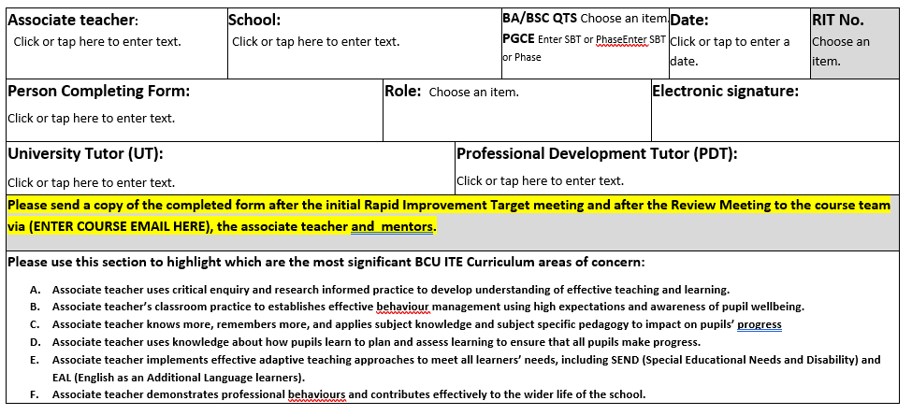
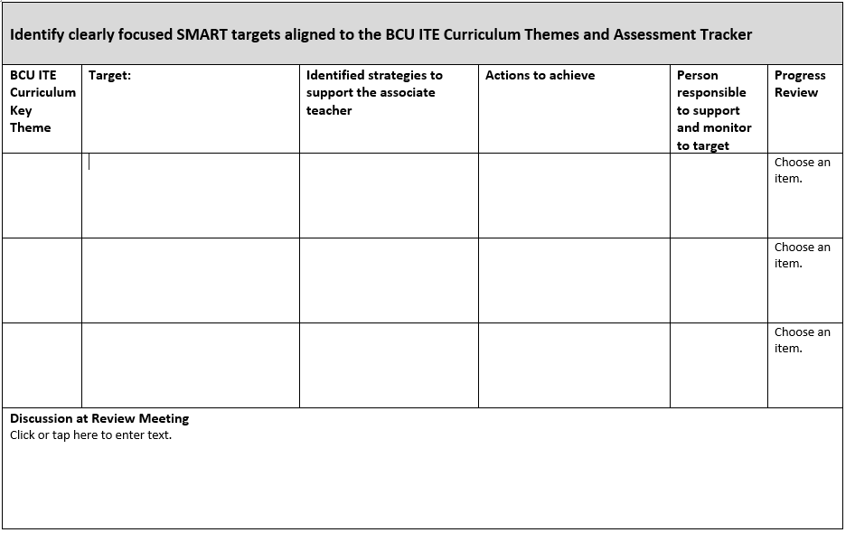
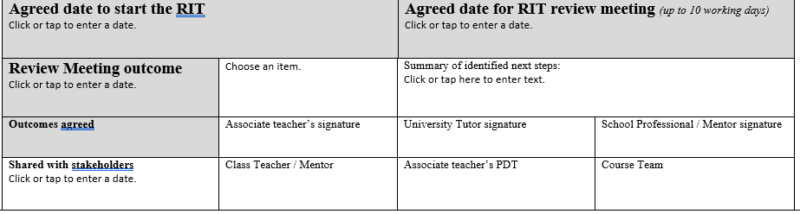

BCU Weekly Mentor & Associate Teacher Meeting Record
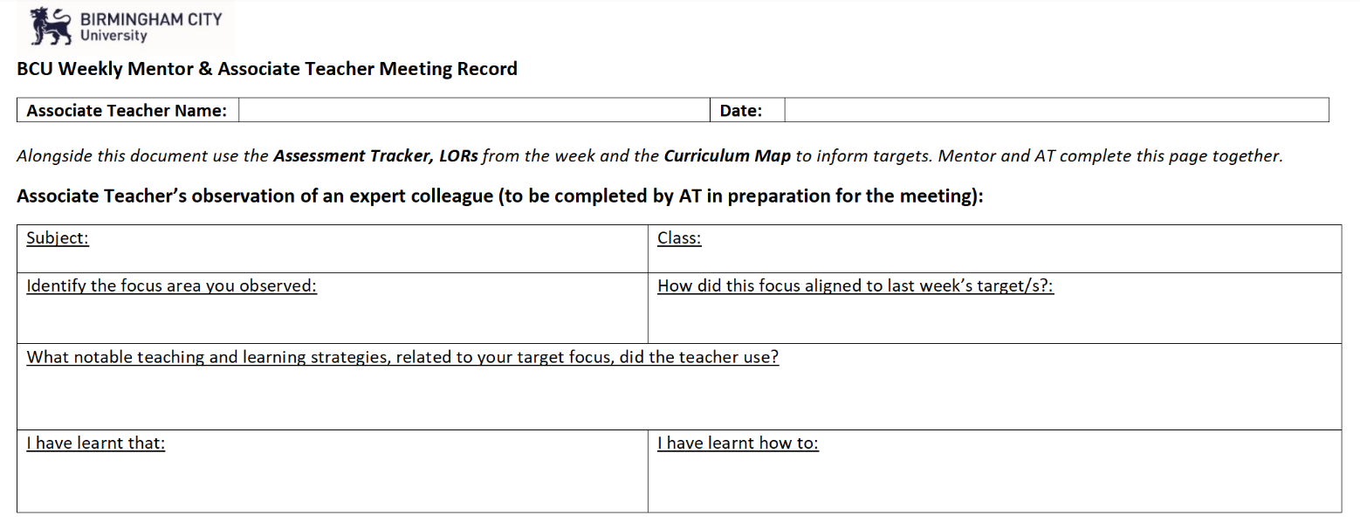

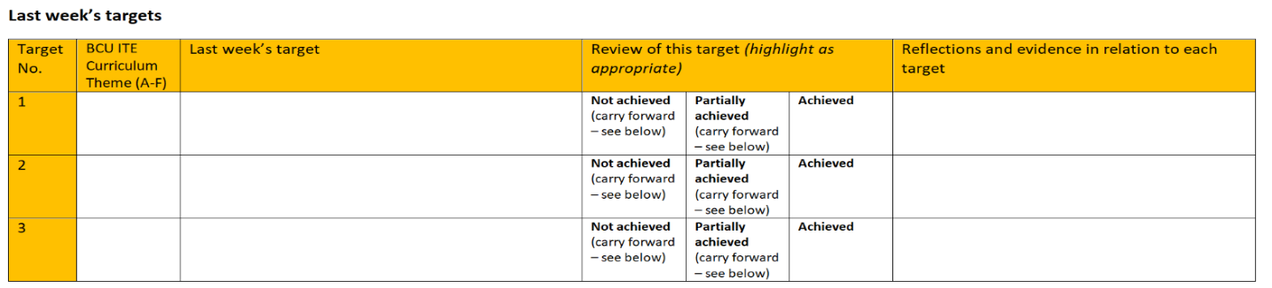

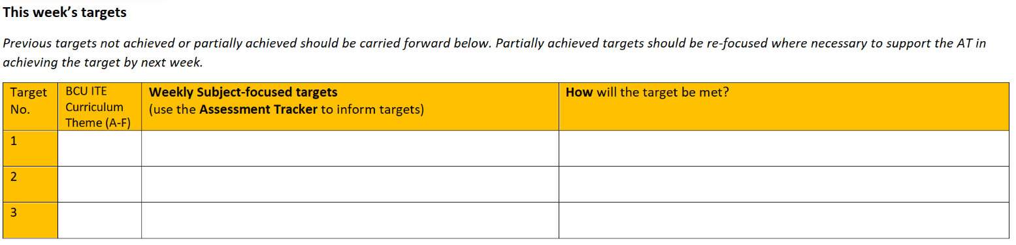

Learning Observation Record
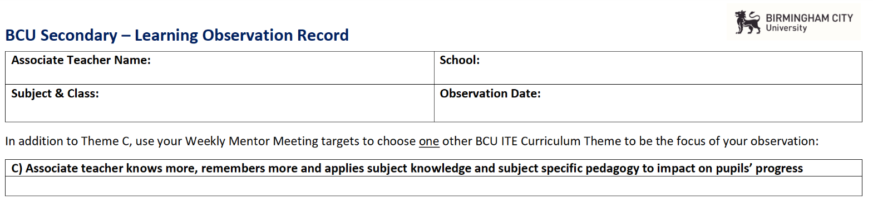

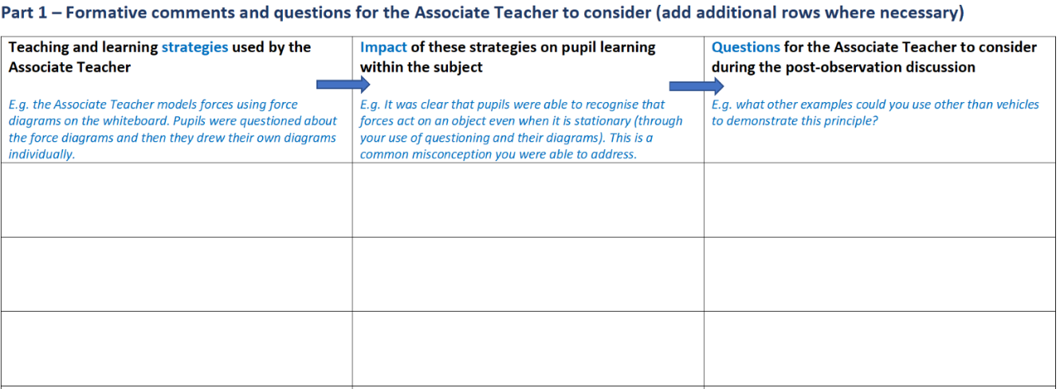

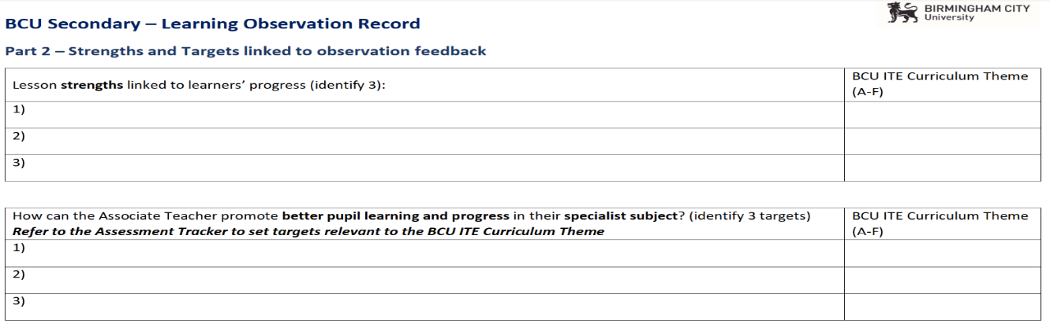

Critical incident Discussion Form (PGCE only)
To be completed before Review Meetings
Date: Click or tap to enter a date.

1. Briefly describe the Critical Incident which stimulated your critical reflection and led to your professional growth at this point in your training.
Click or tap here to enter text.

2. In response to this ‘Critical Incident’ identify the research-informed professional actions taken that demonstrated your intention.
Click or tap here to enter text.

3. What steps did you take to secure the implementation of these actions?
Click or tap here to enter text.

4. Identify the impact your practices had in terms of securing a) pupil progress and b) your understanding of your professional responsibilities.
Click or tap here to enter text. | Click or tap here to enter text.

5. Identify the evidence you will share with your tutor.
Click or tap here to enter text.

Mid and End Point Assessments (informed by the Assessment Tracker and to capture progress)

Below is an example of the document that will be used at mid- and end-point assessments throughout SBT to capture the progress of the AT in relation to the BCU ITE Curriculum Themes. The use of these documents will identify areas of strength, areas of development/targets and action points for each theme. The example below is specific to the Phase 6 Midpoint Assessment for PGCE Secondary and is similar to the documentation used for assessment points throughout the BSc and PGCE courses.

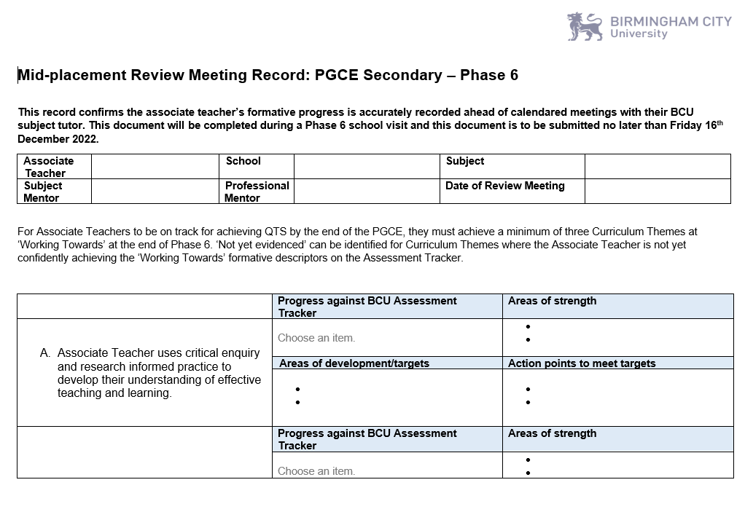

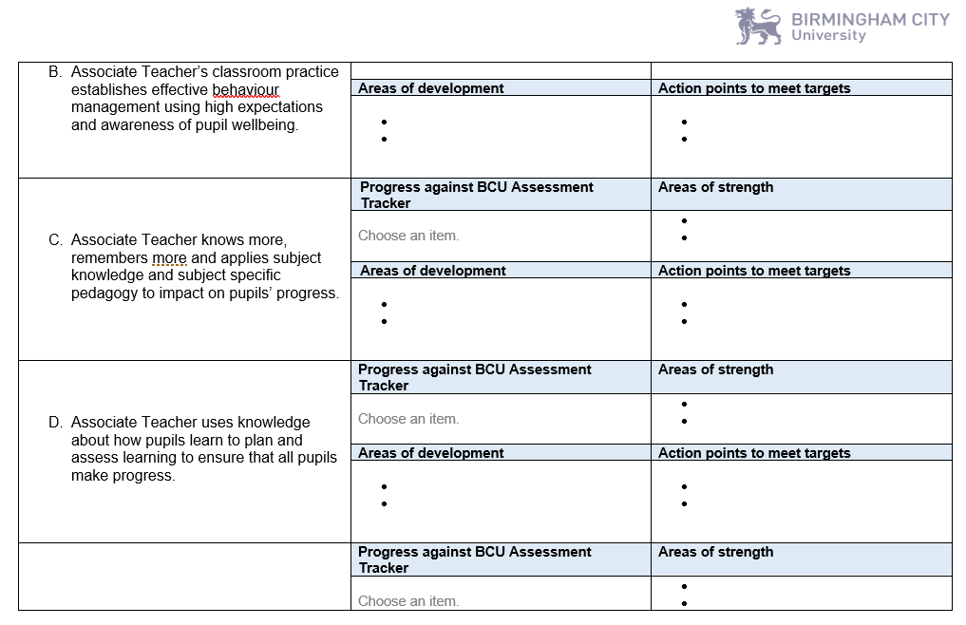

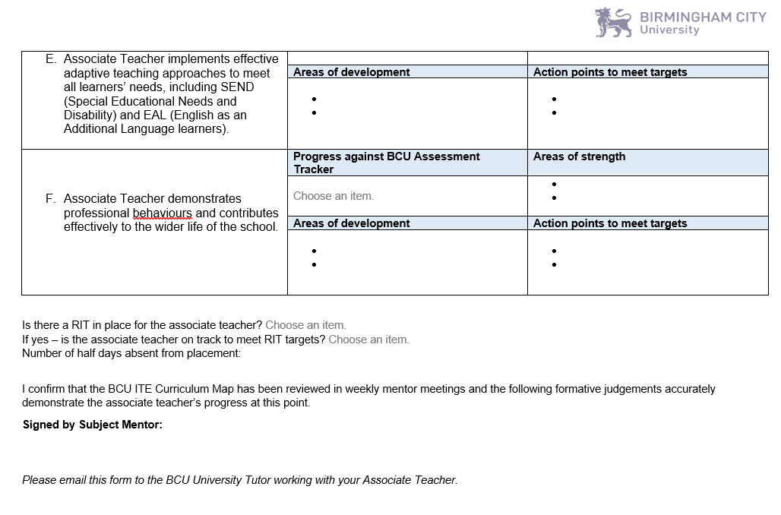

BCU ITE Curriculum Themes and links with Teachers’ Standards and ITT Core Content framework
Teachers’ Standards – used to summatively assess Associate Teachers at the end of the course for the award of QTS | BCU ITE Curriculum Themes and ITT Core Content Framework
PREAMBLE: Teachers make the education of their pupils their first concern and are accountable for achieving the highest possible standards in work and conduct. Teachers act with honesty and integrity; have strong subject knowledge, keep their knowledge and skills as teachers up-to-date and are self-critical; forge positive professional relationships; and work with parents in the best interests of their pupils.  It is important to see the Teachers’ Standards through the lens of the impact they have on pupil progress. | The BCU ITE Curriculum Key Themes will signpost the complex and interconnected learning through a coherent teacher education programme.  The ITT Core Content Framework has been designed to support Associate Teacher development in 5 core areas – behaviour management, pedagogy, curriculum, assessment, and professional behaviours. It is presented in 8 sections: High Expectations and Managing Behaviour; How Pupils Learn; Classroom Practice and Adaptive Teaching; Curriculum; Assessment; Professional Behaviours.
Standard 1: Set high expectations which inspire, motivate and challenge pupils  - establish a safe and stimulating environment for pupils, rooted in mutual respect  - set goals that stretch and challenge pupils of all backgrounds, abilities, and dispositions  - demonstrate consistently the positive attitudes, values and behaviour which are expected of pupils. | BCU ITE Curriculum Key Theme B  Associate Teachers’ classroom practice establishes effective behaviour management through the use of high expectations and awareness of pupil wellbeing.  ITT Core Content Framework  High Expectations  Managing Behaviour
Standard 2: Promote good progress and outcomes by pupil be accountable for pupils’ attainment, progress and outcomes  - be aware of pupils’ capabilities and their prior knowledge, and plan teaching to build on these  - guide pupils to reflect on the progress they have made and their emerging needs  - demonstrate knowledge and understanding of how pupils learn and how these impacts on teaching  - encourage pupils to take a responsible and conscientious attitude to their own work and study. | BCU ITE Curriculum Key Theme C  Associate Teachers’ knowledge and understanding of the curriculum, subject knowledge, pedagogy and how pupils learn impact on pupils’ progress and well-being.  ITT Core Content Framework  How Pupils Learn  Classroom Practice  Adaptive teaching

Standard 3: Demonstrate good subject and curriculum knowledge  - have a secure knowledge of the relevant subject(s) and curriculum areas, foster and maintain pupils’ interest in the subject, and address misunderstandings  - demonstrate a critical understanding of developments in the subject and curriculum areas, and promote the value of scholarship  - demonstrate an understanding of and take responsibility for promoting high standards of literacy, articulacy and the correct use of standard English, whatever the teacher’s specialist subject  - if teaching early reading, demonstrate a clear understanding of systematic synthetic phonics  - if teaching early mathematics, demonstrate a clear understanding of appropriate teaching strategies. | BCU ITE Curriculum Key Theme C  Associate Teachers’ knowledge and understanding of the curriculum, subject knowledge, pedagogy and how pupils learn impact on pupils’ progress and well-being.  BCU ITE Curriculum Key Theme E Associate Teachers implement effective adaptive teaching approaches to support all learners, including SEND (Special Educational Needs and Disability) and EAL (English as an Additional Language learners)  ITT Core Content Framework  How Pupils Learn  Curriculum
Standard 4: Plan and teach well-structured lessons  - impart knowledge and develop understanding through effective use of lesson time  - promote a love of learning and children’s intellectual curiosity  - set homework and plan other out-of-class activities to consolidate and extend the knowledge and understanding pupils have acquired  - reflect systematically on the effectiveness of lessons and approaches to teaching  - contribute to the design and provision of an engaging curriculum within the relevant subject area(s). | BCU ITE Curriculum Key Theme D  Associate Teachers plan and assess learning to ensure that all pupils make progress.  ITT Core Content Framework  Classroom Practice  Adaptive Teaching  Assessment
Standard 5: Adapt teaching to respond to the strengths and needs of all pupils  - know when and how to differentiate appropriately, using approaches which enable pupils to be taught effectively  - have a secure understanding of how a range of factors can inhibit pupils’ ability to learn, and how best to overcome these  - demonstrate an awareness of the physical, social and intellectual development of children, and know how to adapt teaching to support pupils’ education at different stages of development  - have a clear understanding of the needs of all pupils, including those with special educational needs; those of high ability; those with English as an additional language; those with disabilities; and be able to use and evaluate distinctive teaching approaches to engage and support them. | BCU ITE Curriculum Key Theme E  Associate Teachers implement effective adaptive teaching approaches to support all learners, including SEND (Special Educational Needs and Disability) and EAL (English as an Additional Language learners)  ITT Core Content Framework  How Pupils Learn  Classroom Practice a  Adaptive Teaching
Standard 6: Make accurate and productive use of assessment  - know and understand how to assess the relevant subject and curriculum areas, including statutory assessment requirements  - make use of formative and summative assessment to secure pupils’ progress  - use relevant data to monitor progress, set targets, and plan subsequent lessons  - give pupils regular feedback, both orally and through accurate marking, and encourage pupils to respond to the feedback. | BCU ITE Curriculum Key Theme D  Associate Teachers plan and assess learning to ensure that all pupils make progress  ITT Core Content Framework  Assessment  Curriculum
Standard 7: Manage behaviour effectively to ensure a good and safe learning environment  - have clear rules and routines for behaviour in classrooms, and take responsibility for promoting good and courteous behaviour both in classrooms and around the school, in accordance with the school’s behaviour policy  - have high expectations of behaviour, and establish a framework for discipline with a range of strategies, using praise, sanctions and rewards consistently and fairly  - manage classes effectively, using approaches which are appropriate to pupils’ needs in order to involve and motivate them  - maintain good relationships with pupils, exercise appropriate authority, and act decisively when necessary | BCU ITE Curriculum Key Theme B  Associate Teachers’ classroom practice establishes effective behaviour management through the use of high expectations and awareness of pupil wellbeing.  ITT Core Content Framework  High Expectations  Managing Behaviour
Standard 8: Fulfil wider professional responsibilities  - make a positive contribution to the wider life and ethos of the school  - develop effective professional relationships with colleagues, knowing how and when to draw on advice and specialist support  - deploy support staff effectively  - take responsibility for improving teaching through appropriate professional development, responding to advice and feedback from colleagues  - communicate effectively with parents with regard to pupils’ achievements and well-being. | BCU ITE Curriculum Key Theme A  Associate Teachers use critical enquiry and research informed practice to develop their understanding of effective teaching and learning.  BCU ITE Curriculum Key Theme F  Associate Teacher develops professional behaviours and contributes effectively to the wider life of the school.  ITT Core Content Framework  Professional Behaviours
PART TWO: PERSONAL AND PROFESSIONAL CONDUCT  A teacher is expected to demonstrate consistently high standards of personal and professional conduct. The following statements define the behaviour and attitudes, which set the required standard for, conduct throughout a teacher’s career.  - Teachers uphold public trust in the profession and maintain high standards of ethics and behaviour, within and outside school, by:  - treating pupils with dignity, building relationships rooted in mutual respect, and at all times observing proper boundaries appropriate to a teacher’s professional position  - having regard for the need to safeguard pupils’ well-being, in accordance with statutory provisions  - showing tolerance of and respect for the rights of others  - not undermining fundamental British values, including democracy, the rule of law, individual liberty and mutual respect, and tolerance of those with different faiths and beliefs  - ensuring that personal beliefs are not expressed in ways which exploit pupils’ vulnerability or might lead them to break the law.  - Teachers must have proper and professional regard for the ethos, policies, and practices of the school in which they teach and maintain high standards in their own attendance and punctuality.  - Teachers must have an understanding of, and always act within, the statutory frameworks, which set out their professional duties and responsibilities. | BCU ITE Curriculum Key Theme A  Associate Teachers use critical enquiry and research informed practice to develop their understanding of effective teaching and learning  BCU ITE Curriculum Key Theme F  Associate Teacher develops professional behaviours and contributes effectively to the wider life of the school.  ITT Core Content Framework  Professional Behaviours

RAPID IMPROVEMENT TARGETS (RIT) PROCESS 2023 24

Aims of the Rapid Improvement Targets Process

The Rapid Improvement Targets Process is initiated after a discussion between a mentor/tutor and the associate teacher. A RIT will ensure that all associate teachers are supported and offered intervention where necessary to make satisfactory progress on the course.

Rapid Improvement Targets can be initiated at any stage of the ITE programme and:
- Can relate to an associate teacher’s engagement with, and attendance, at the taught elements of the programme
- Can be initiated if an associate teacher fails to demonstrate high standards of personal or professional conduct. (See Appendix 1 for examples)
- Can relate to specific aspects of the associate teacher’s teaching and be characterised by a lack of expected progress by the pupils (See Appendix 1 for examples)
- Can identify gaps in performance aligned against the BCU ITE Assessment Tracker and/ or the ITT Core Content Framework (DfE, 2019)
- Can be initiated if associate teacher’s teaching, for any reason, is not developing as expected; for example, if an associate teacher ‘plateaus’ and there is no evidence of further progress or development in the impact of their teaching
- Can be initiated if associate teacher has not received the necessary support from the placement school, at which point the university will intervene and offer additional support
- Can be initiated if an associate teacher needs support with well-being or workload management.

Rapid Improvement Targets can only be initiated by a BCU tutor. Subject and Professional Mentors can and should raise concerns aligned to the process with the link tutor and will share specific areas of weakness ahead of any formal meeting.

Rapid Improvement Targets will:
- outline the concerns,
- set clearly articulated and precise targets aligned to the BCU ITE Curriculum,
- outline concrete actions for the associate teacher to achieve,
- identify which stakeholder is responsible for monitoring each target,
- identify intervention strategies,
- signpost training needs,
- explain existing support strategies, and
- agree review deadlines.

In Rapid Improvement Target meetings:
- the associate teacher must attend
- the SBT subject and/or professional mentor will attend
- targets will be monitored by the BCU tutor responsible for quality assuring the associate teacher’s progress
- be overseen by BCU Senior Tutor on the associate teacher’s course

The Rapid Improvement Target Process is an intervention strategy and will result in an agreed increase in school and / or university support and monitoring to ensure the associate teacher has an opportunity to address the targets requiring immediate action.

If a placement breaks down within a RIT period the lead mentor will be required to complete the RIT review and the Placement Review Process.

Rapid Improvement Target Process

The Rapid Improvement Target Process (RIT) has been simplified into a flow chart and can be found on the following page:
Issues or areas to be discussed by subject/professional mentor and tutor.
Have these issues or areas been discussed with the associate teacher to correct the identified issue?
Yes
No
Issue of RIT1: Associate teacher is placed on a RIT for up to 10 working days * to provide opportunity to demonstrate progress/change in performance. RIT is written and implemented by tutor, with subject/professional mentor supporting the monitoring of progress. RIT should be discussed during weekly review meeting in school.
No
Yes
No
Successful completion of RIT—normal training resumes.
No
Yes
Issue of RIT2: Associate teacher is placed on a RIT for up to 5 working days* to provide opportunity to demonstrate progress/change in performance. RIT is written and implemented by tutor, with subject/professional mentor supporting the monitoring of progress.
Yes
Successful completion of RIT—normal training resumes.
No
Contact Course Leadership to refer
associate teacher to the Placement Review Process (PRP)
No
No
Successful completion of RIT—normal training resumes.

Discussion to take place to ensure the associate teacher is aware of the issues or areas for development.

Has the associate teacher been on a RIT for this issue/area before?
Has the associate teacher demonstrated satisfactory progress within the timeframe?

Yes

Is the associate teacher at risk of failing the placement or the placement terminated ?

Has the associate teacher demonstrated satisfactory progress within the timeframe?

Is the associate teacher at risk of failing the placement or the placement terminated ?

Issue of RIT3: Associate teacher is placed on a RIT for up to 5 working* days to provide opportunity to demonstrate progress/change in performance. RIT targets should be overseen by a senior tutor before RIT is implemented. Associate teacher should be informed of the risk of failed placement.
Contact Course Leadership to refer
associate teacher to the Placement Review Process (PRP)
Yes

Is the associate teacher at risk of failing the placement or the placement terminated?

Contact Course Leadership
to refer associate teacher to the Placement Review Process (PRP)

Yes

Appendix 1- RIT form

Examples:
Rapid Improvement Targets will be issued when:
- An associate teacher does not make the expected progress – e.g.:
  - Not establishing purposeful learning relationships with pupils
  - Not using Behaviour for Learning policy appropriately
  - Inadequate subject knowledge
  - Inadequate pedagogical knowledge
  - Inadequate lesson planning practices
  - Inadequate resource creation within teaching contexts
  - Poor pace within a lesson
  - Inadequate assessment practices
  - Failure to use pupil data appropriately to plan lessons
  - Failure to adapt school lesson plans to meet the needs of pupils in their classroom
  - Insufficient knowledge of adaptive teaching strategies

- An associate teacher fails to demonstrate high standards of personal and professional conduct -e.g.:
  - Poor punctuality
  - Poor attendance
  - Inability to use identified absence procedures appropriately
  - Unprofessional dress
  - Failure to engage in set independent learning tasks
  - Plagiarism
  - Inability to meet deadlines aligned to BCU ITE expectations – such as submitting lesson plans 48 working hours ahead of lessons to be observed
  - Failure to complete set tasks within the course – such as Progress Journal completion and meeting assignment deadlines
  - Failure to respond to feedback from expert colleagues
  - Dis-respectful behaviour in any training context
  - Discriminatory comments in any training context
  - Poor email communication etiquette
  - Poor organisation which impacts on personal and pupils’ progress

* number of days as specified by professional judgement depending on target area

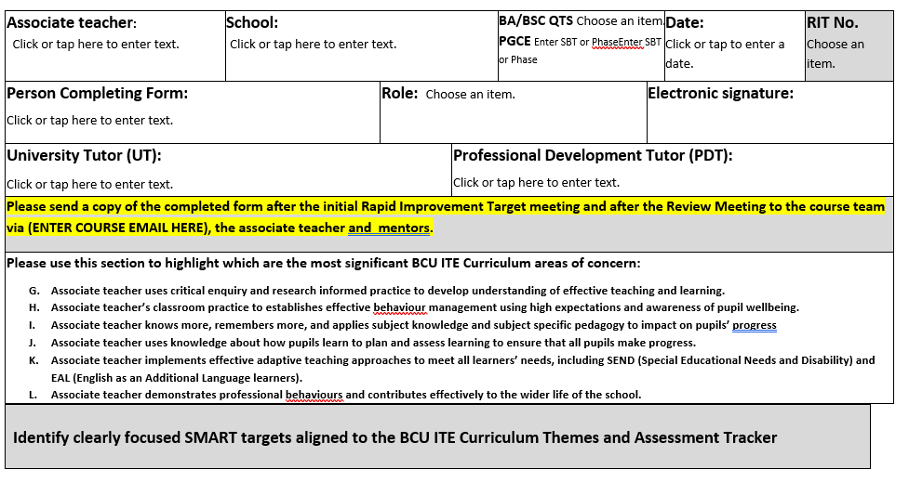
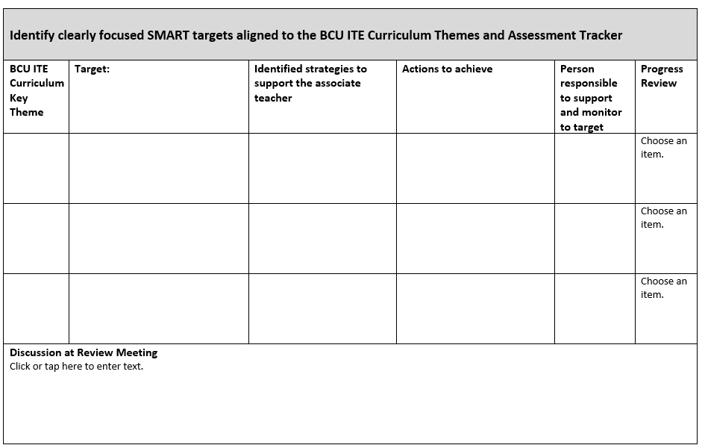
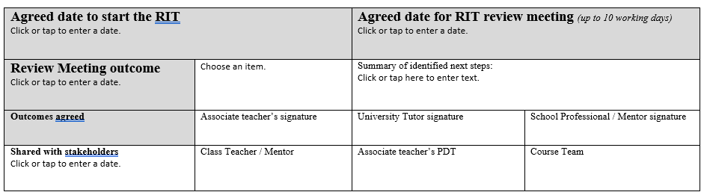

Placement Review Process 2022 23
Associate teacher is at risk of failing a placement or
A placement is discontinued before the end date or
Associate teacher demonstrates unprofessional conduct.

University tutor informs Course Leaders
Course Leader emails Placement Review Report Forms to associate teacher, mentor, university tutor.

Associate teacher, mentor, university tutor complete Placement Review Report forms.
Completed forms, observation forms Progress Journal and RITs to be emailed to Course Leaders to collate information.

Collated information sent to the Head of Department for review
Head of Department reviews all evidence against BCU ITE Assessment Tracker, DfE ITT Criteria, Keeping Children Safe in Education, Teachers’ Standards Parts 1 and 2.

Head of Department recommends:
Associate teacher has passed the placement
A resit placement as a first attempt
A resit placement as a first attempt with a RIT in place
A failed placement to be presented to Module Assessment Board (MAB) with the right to resit with a RIT in place
A failed placement to be presented to the MAB and a referral to Student Governance for Fitness to Practice, Fitness to Train or Fitness to Study
A failed resit placement presented to MAB, the module is recorded as failed. If all other modules are passed PG Cert without QTS awarded
Failed placement to be presented to the MAB and the associate teacher is charged £1125 for resit.

Head of Department to email a letter with the decision to the associate teacher and the course leaders
Course Team to support Associate teacher with actions resulting from decision
Course leaders to collate information and complete Student Governance referral forms and send to Head of Department for approval.
Course leaders or link tutor contact school to share decision letter and discuss any implications for mentor training.

Mentor Interaction Flowchart
Subject Mentor to work closely with the University Subject Tutor to ensure that the Associate Teacher is making progress against the BCU ITE Assessment Tracker and monitor the tracking of their subject knowledge development using subject specific prompts within Review and Progress Meetings.

All Mentors to attend a one compulsory Core CPD session to support their development each term. Subject Mentors engage with 1 Subject CPD sessions per term. Professional mentors attend Enhanced CPD sessions each term by invitation. Attendance to all CPD is confirmed with Professional mentor who will liaise with the Placement Link Tutor to monitor attendance and measure impact.
University ITE Integrated Curriculum: Subject Mentor to engage with the University ‘learn that’ statements and use School-Based-Training ‘learn how’ to support the training of the Associate Teacher in their subject – confirmed by Subject Tutors

Subject Mentors to sign the Mentor Agreement in the BCU Mentor Partnership Guide. Signed contracts are then collated by the Professional Mentor as evidence of compliance - confirmed by Placement Link Tutor

Professional Mentor/ Subject Mentor to attend the Mentor Induction CPD and review the Mentor Calendar and BCU Mentor Partnership Guide via the Secondary Partnership Website – confirmed by Placement Link Tutor

*Suggested Subject Mentor subject specific actions to support Associate Teacher development:
- Associate Teacher to co-plan lessons or sequence of lessons with subject specialist
- Associate Teacher to carry out a work scrutiny or marking
- Associate Teacher to observe a colleague teaching a specific subject that the AT is not confident in
- Associate Teacher to complete their subject specific audit/tracker

Roles and Responsibilities:

Professional Mentors:
- Review and adhere to the BCU Mentor Policy,
- Identify an experienced colleague in the Associate Teacher’s specialist subject who will be their Subject Mentor over the training year
- Meet with the Lead Tutor to termly to ensure the subject specific BCU ITE Curriculum is being used by mentors to underpin planning, support, weekly meetings, discussion and targets
- Quality assures all individual Subject Mentor observations and assessments at least once in the academic year – we suggest a paired observation or observed mentor meeting as a strategy to do this and supply a QA form to be submitted and reviewed with your PLT,
- Undertake other activities relevant to the role

Subject Mentor

- Use the subject specific BCU ITE Curriculum to underpin support, inform weekly meetings and discussions and to set subject specific targets
- Provide day to day support for the Associate Teacher including guidance on teaching, planning, accessing resources and other responsibilities
- Arrange which classes the Associate Teacher will be working with (e.g. groups/ whole class)
- Advise on classroom systems and procedures
- Discuss targets for placement with the Associate Teacher
- Support the Associate Teacher with arrangements to observe other colleagues
- Host weekly meetings with the Associate Teacher to discuss the Associate Teacher’s reflections on their week of teaching
- Set subject specific targets for the week ahead with the Associate Teacher
- Review the previous week’s targets with the Associate Teacher
- Observe the Associate Teacher twice each week and provide written formative feedback
- Undertake joint observations with the BCU Tutor
- Work with the BCU tutor to undertake Review/ Progress meeting or stand-alone visit.
- Work with the BCU tutor if the Associate Teacher requires a Rapid Improvement Target (RIT) this will be completed by the BCU Tutor.
- Support with school induction. Liaise with other colleagues where applicable
- Guide and support the Associate Teacher’s professional development and subject specific pedagogical knowledge in line with the subject specific BCU ITE Curriculum – using the BCU Weekly Learn How Plans to record targets and review progress,
- Attend BCU Mentor Core CPD and the recorded and live Subject Mentor CPD sessions termly.
- Read and act on weekly BCU Subject Bulletins to keep up to date with the subject specific foci identified within the BCU ITE Curriculum.
- Undertake other activities relevant to the role.

BCU Tutor

- Communication with the mentor through email and through Microsoft Teams. A phone call may be requested by the school
- Act as a first point of contact for the Associate Teacher’s placement
- Contact school before Associate Teacher begins block placement to discuss arrangements and offer guidance, as required
- Meet online with Associate Teacher before placement begins.
- Attend Review/Progress Meetings
- Provide any additional online support such as support with RIT
- Carry out a school visit to observe the Associate Teacher. This may be in conjunction with a Review or Progress Meeting or as a stand-alone visit
- Moderate the placement outcome
- Undertake other activities relevant to the role

Associate Teacher

- Maintain a high level of professionalism whilst on placement including following school policy and procedures
- Follow absence-reporting procedures for placement
- Keep documents up to date (these should be saved as a OneDrive file) and ensure it is shared relevant colleagues
- For formal observations, provide a copy of the planning for the observer/s
- Ensure that lessons to be taught are planned for a prepared for in a timely manner
- Complete weekly reflection on your curriculum and complete the weekly mentor meeting form, in readiness to discuss at the weekly meeting
- Gather supporting evidence and complete proforma for Critical Incident in readiness for Review/Progress Meetings
- Meet with the mentor and BCU tutor at the end of placement in order to discuss outcomes, achievements, targets for development
- Undertake other relevant activities

Where can the Class Teachers/ School Mentors get further help and guidance?

Please contact the University Tutor/ Personal Development Tutor via email as soon as any issue arises or if you have a query regarding the placement.

Online meetings can be arranged via Microsoft Teams.

Course Team contact details:

Partnership Lead
- Helen Lowther: Helen.Lowther@bcu.ac.uk

BA & BSc (Hons) Secondary PE / Biology / Computing with QTS
- General Enquiries/Questions: UGSecondarySLT@BCU.ac.uk
- Course Leader and PE Lead Grant.Huddleston@bcu.ac.uk
- School Based Placement Lead Gemma.Taylor@bcu.ac.uk
- Biology Lead and SKE Course Lead Kerry.Taylor@bcu.ac.uk
- Computing Lead Christine.Swan@bcu.ac.uk

PGCE Secondary Education

- PGCE Course Leader Kelly.DaveyNicklin@bcu.ac.uk
- Deputy PGCE Course Leader Kerry.Taylor@bcu.ac.uk
- Deputy PGCE Course Leader Jennifer.Whitford@bcu.ac.uk
- Partnership Administrator education.partnerships@bcu.ac.uk
- Course Coordinator/Administrator Nathan.Hawkins@bcu.ac.uk

Mentor CPD Events 2023/24

Timings

PGCE - Wednesday 27th September or Tuesday 3rd October
Please only attend one. The link below is for both days.
Click here to join the PGCE Mentor Training
- 4pm is only for new mentors to BCU.
- 4:30pm - Please could all Subject and Professional mentors join here.
- 5pm - Separate links will be given on the day professional and subject mentor sessions.

PGCE Mentor Training School B
Date TBC

Undergrad Mentor Training
Year 1 - Subject Mentors - Tuesday, 14th November - 4-5pm
Click here to join Year 1 mentor training
Year 2 - Subject mentors - Tuesday, 30th April - 4-5pm
Click here to join Year 2 Mentor Training
Year 3 Subject mentors - Tuesday, 5th December - 4-5pm
Click here to join Year 3 mentor training

Code of Conduct

College of Education and Social Work
Associate Teacher Learning Agreement and Code of Conduct 2023 24

Agreement between the College of Education and Social Work and [insert Associate Teacher’s name].

ITT Equal Opportunities and Race Equality Policies
- BCU is committed to equal opportunities and the fair and consistent treatment for all regardless of their age, disability, gender, race, ethnic or national origins, colour, marital status, sexual orientation, age (subject to entry requirements), parental status, political belief, socio-economic background or religious beliefs.
- BCU is committed to an equal opportunities and diversity policy which ensures that all applicants / students are treated fairly and on their merits and are given opportunity to succeed. There is equal commitment to the personal and professional development of its entire staff.
- As an associate teacher you will be expected to abide by the regulations and requirements detailed in the Course Handbook and by the following Code of Conduct:

CODE OF PROFESSIONAL CONDUCT AND FITNESS TO TEACH INCLUDING REGARD TO CHILD PROTECTION & SAFEGUARDING

- Statutory professional expectations

- I understand that, as successful completion of this course leads to admission to a professional body, I am required, during my studies, to adhere to the expectations of conduct endorsed by the teaching profession, as set out in Part 2 of The Teachers’ Standards. I understand that breaches of these expectations may lead to early termination of school placements, referral to Placement Review Panel, referral to Student Governance and/or Fitness to Practice, this could lead to my exclusion from the course and/or the inability of the BCU ITE Partnership to provide me with a supportive professional reference.
- I understand that by signing the Teaching Regulation Agency’s ‘Suitability to Teach’ document that I am registering with the Teaching Regulation Agency and will therefore be subject not only to BCU policies and procedures but also to those of the Teaching Agency.
- I understand that if I need reasonable adjustments to be made to enable me to fulfil the expectations of the teaching profession, I will make these needs known to the course team and if appropriate I will meet a Disability Support Advisor to create a Disability Support Plan, and when applicable a Placement Action Plan will be created which must be approved by the course leadership team and I will then share with mentors in school.

- Conduct
- I undertake to behave in a manner appropriate to my position as an associate teacher and understand that behaviour including, for example, dishonesty, indecency, harassment, bullying, violence, abuse of drugs or alcohol will lead to referral to a Placement Review Panel and/or referral to Student Governance and/or Fitness to Practice, this could lead to my exclusion from the course and/or the inability of the BCU ITE Partnership to provide me with a supportive professional reference and may include consideration of any criminal conviction, where the offence(s) are directly related to my studies.
- I understand that if I behave dishonestly during the assessment process (including plagiarism or other forms of cheating, including when applying for extenuating circumstances), or in relation to my attendance or the attendance of others by falsifying signatures or other means I will be subject to the Fitness to Practice procedure and may be removed as an associate teacher from my course. For further information see https://icity.bcu.ac.uk/Student-Affairs/Appeals-and-Resolutions/Fitness-to-Practise
- I will follow the appropriate university processes for raising concerns.

- Disclosure of Criminal Convictions and Cautions
- I am not disqualified under the terms of the 2018 Childcare Disqualification requirements.
- I undertake to inform my Course Leader, without delay, should I be subject to a criminal investigation, conviction, or caution after the submission of my application for DBS Enhanced Disclosure - which in effect includes any time during my training. I understand that a criminal investigation, conviction, or caution may lead to my suspension or expulsion from some or all aspects of the course and that this may lead to the need for my studies to be extended or terminated.
- I also understand that the Rehabilitation of Offenders Act (1975) does not apply to the teaching profession and that should I be subject to a criminal conviction or caution it will never be considered “spent”.
- I recognise that during my studies I will be placed in a position of trust and that as such I am subject to the requirements of the Sexual Offences (Amendment) Act 2000.

- Child Protection and Safeguarding
- I will always treat pupils, colleagues, staff, and any other members of the BCU ITE Partnership with due respect and conduct myself in a professional, honest, decent, and courteous manner. I will use language appropriate to the situation and people involved. I will accept my responsibility to ensure that pupils are treated with respect and are free from abuse. In schools I will always work in a place which is accessible to others and in which I can be observed working. I will not take or agree to meet a pupil outside school premises without another responsible adult present. I will not make unnecessary physical contact with a pupil. I undertake to ensure that my communication with pupils, including electronic communication, is appropriate and through partnership school approved systems. I will report any suspicion that a pupil is being abused to the school’s named safeguarding lead. I will acquire an understanding of working with diversity, including gender, race, and culture, to work with pupils, staff, and parents appropriately. I will be mindful of the difficulties some groups may face and ensure personal prejudices and stereotypical views do not influence my judgements or actions.
- I will ensure that I investigate and note my responsibilities as an associate teacher in training at each of my placement schools regarding safeguarding.
- I will ensure I know and adhere to the school behaviour management policy and consistently apply rewards and sanctions, recognising that it is illegal to use physical means of punishment.

- Health and Safety
- All associate teachers have responsibilities for safety at their place of study under Health and Safety legislation. I will follow the Health and Safety at Work Act, which requires me to take care for your own safety and health and that of others, including a responsibility in loco parentis for the safety of pupils in my care. I will follow the Health and Safety Policy of each school/setting in which I am placed.
- I will have due regard to the safety of pupils at all times as outlined by Section 7 of the Health and Safety at Work Act (1974) and the extension of the regulations to trainee teachers for employment (1994) which place a duty on me to take reasonable care for the health and safety of myself and anyone else who may be affected by my acts or omissions, and to co-operate as much as necessary in full compliance with the obligations imposed on my employer by health and safety legislation.

- Personal information and Data Protection
- I understand that I will have access to confidential personal information and that I am required to comply with the Data Protection Act. I understand that I may not disclose this information to any third party, other than in accordance with the conventions regarding use of personal information for use in research for the purposes of completing assignments or in accordance with the law. Any personal information used in assignments or tasks will have all means of identifying the subject removed.

- Dress Code
- I will ensure that I maintain, both in training environments and in schools, a standard of dress that will be perceived as professional by such persons as I may encounter in the pursuit of my studies.

- Absence from the Course
- The content of the course meets the requirements of Qualified Teacher Status accreditation, and I will pursue my studies with due diligence, ensuring that I avail myself of the educational opportunities made available.
- I will take responsibility for my own learning through 100% attendance at all sessions, workshops, including self-directed learning and periods of school-based training and through being suitably prepared for them.
- I will only be absent from university teaching sessions or school-based training due to ill health, or an absence authorised by the course team. I will notify my UT/PDT, the tutor leading the session and notify MySRS. For further guidance see Student Engagement Policy.
- If I am absent from any part of the course, due to ill health or authorised absence, e.g. medical appointment. I will make up the lost learning opportunities. I understand my attendance will be monitored.
- If I am absent from my school placement due to ill health or authorised absence, I will contact the school in accordance with school policy for staff. I will notify my absence to MySRS by 08:30am at the very latest on each day of absence, stating my name, school, stage of course and reason for absence. I will keep the school and university including UT and PDT, informed about continuing absence daily.
- I understand that taking holidays during term time is prohibited and could jeopardise my completion of the course in line with my peers. I understand that this could result in returning in the following academic year to complete any missed component of the course.
- I understand that I will need to follow the Extenuating Circumstances policy and procedure. This is with reference to absence from the course or in anticipation of failing to meet deadlines. I understand that I must meet ALL deadlines. For more detailed guidance visit Extenuating Circumstances Procedure: Birmingham City University (bcu.ac.uk)

- IT / Internet / Telephone usage
- Use of the placement school telephone, the school monitors IT equipment, email, and internet systems, and you therefore do not have any expectation of privacy. Such monitoring will be for legitimate purposes in accordance with the Data Protection Act 1998 and the Telecommunications (lawful Business Practice) (Interception of Communications) Regulations Act 2000.
- My on-line presence will maintain proper and professional regard for the ethos and high standards of the profession, including of social media.
- Use of university and placement school internet: I understand that the internet is to be used to support my studies as a teacher in training. I will ensure that I do not infringe any copyright restrictions on materials accessed or transmitted via the internet.
- I understand that all use of the internet is logged and that these logs are periodically inspected.
- I will avoid deliberately accessing any material that might be considered offensive or inappropriate. This includes all racist and sexist information, together with any material that might be pornographic. It also includes sites promoting violence, offensive language, and unlawful conduct.
- I will report any accidental accessing of such material to the BCU IT Help Desk or my mentor in school so that it may be noted, and the fact recorded.
- I will ensure that files downloaded from the internet are checked for viruses before being used and ensure that appropriate action is taken if a virus is detected.
- I will ensure that any use I make of email facilities will not contain illegal, lewd, or offensive materials or language, or be used to send bulk emails apart from those which may be considered to be necessary to support my work as a teacher in training.
- I will ensure that I do not send emails that are defamatory or libellous in nature and acknowledge that could result in legal action being taken against me.
- I will not allow access to the internet facility to external users.
- I understand that abuse of the internet facilities available to teachers in training will be managed under the provisions of Fitness to Practice procedure and the circumstances encountered will be fully investigated by senior BCU staff. Such abuse is viewed as a very serious violation of the BCU disciplinary code which may, subject to the circumstances, be categorised as acts of gross misconduct, i.e., the misconduct is deemed to be of such a nature that it fundamentally breaches the contractual relationship between the teacher in training and BCU and in such situations the teacher in training will be dismissed without notice. Some circumstances could further lead to criminal proceedings being taken against the associate teacher.
- I will not misuse the use of personal e-mails and/or e-mail attachments by down-loading information onto BCU or school owned equipment.

- Partnership School Property
- I will take due care and attention to look after any equipment and resources loaned to me and report any damage to the equipment or software issues immediately to the relevant IT support team. No attempt to repair the equipment should be attempted, and any damage deemed to be caused by negligence or miss use will be charged to the associate teacher. I will return ALL loaned equipment and resources as provided by the partnership school.
- On termination of my course/placement for any reason (or earlier if requested) I acknowledge that I must immediately return to the school or BCU:
- All originals and copies of any documents or information, however recorded and whether retained electronically or on paper or otherwise.
- All other property in my possession or control which belongs to, or relates to the BCU ITE Partnership, including, but not limited to, identity/security passes, keys, safety equipment, protective clothing, uniform, credit/charge cards, documents, tapes, laptops/computers and other computer hardware, memory sticks and similar, computer software, mobile phones, vehicle related documents/passes.

- Filming and Recording
- I understand that I am NOT allowed to record, using any mobile device, school lessons or BCU lectures/sessions without permission.

College of Education and Social Work
Student Learning Agreement and Code of Conduct

I have read, understood, and agree to abide by the BCU Associate Teacher Learning Agreement and Code of Conduct and will upload this signed agreement to Moodle submission point:

Signed: [Associate Teacher]
Date:
Print name:

Please mark with an X to indicate the course you are following:

BA (Hons) Primary Education with QTS
BA (Hons) Secondary Physical Education with QTS
BSc (Hons) Secondary Science (Biology) with QTS
PGCE Primary and Early Years – Core and School Direct
PGCE Secondary – Core and School Direct
PGCE Post-Compulsory Education and Training (PCET)

Signed: [staff]
Date:
Print name:
On behalf of the College of Education and Social Work

Enrichment Placements

Required Key Stage 2 Placement
To secure their knowledge of their subject / curriculum in Key Stage 2 BCU Associate Teachers must spend time in a primary school.
- BA / BSc (Hons) with QTS requirements
In Year 1, BCU Associate Teachers have a full week identified at the start of June to secure and complete an enrichment placement in a primary school. Although Associate Teachers are responsible for securing these placements independently, Lead / Professional Mentors could support by signposting local feeder schools and brokering contacts for the Associate Teacher.
During this placement Associate Teachers are required to fully explore the curriculum and support the delivery of their specialist subject.
- PGCE requirements
BCU Associate Teachers must complete a full day in a Key Stage 2 setting. to secure and complete an enrichment placement in a primary school. Although Associate Teachers are responsible for securing these placements independently, Professional Mentors in the Associate Teacher’s Home School could support Associate Teachers by signposting local feeder schools and brokering contacts for the Associate Teacher.
During this placement Associate Teachers are required to observe and discuss how the curriculum is designed and delivered in their specialist subject.

Required SEND Placement
To secure their knowledge of the factors and application of adaptive teaching pedagogies relevant to pupils with identified Special Educational needs and / or Disabilities all BCU Associate Teachers will complete a SEND placement as part of their School Based Training.
- BA / BSc (Hons) with QTS requirements
In Year 2, BCU Associate Teachers have full week identified immediately at the start of January to secure and complete an enrichment placement in a SEND school or provision. Associate Teachers are responsible for securing these placements independently.
- PGCE requirements
Most PGCE Associate Teachers will complete a 4 day SEND placement in their Home School during their PGCE School Based Training placement. The Professional Mentor is responsible for identifying time to complete this enrichment experience.
The placement could be conducted as a paired experience to support the time demands placed on the SEND team.
This placement will involve:
- A meeting with the SENDCo to discuss the SEND Code of Practice
- A review of a pupil’s EHCP with the SENDCo – outlining the plan – do – review process
- A review of SEND needs within their classes with a SEND colleague (SENDCo or LSA)
- A chance to conduct SEND shadowing with a SEND pupil from one of their classes
- LSA shadowing – with a chance to discuss their role in supporting the class teacher to develop adaptive practices to meet individual pupil’s needs
PGCE Associate Teachers in partner schools hosting more than 5 Associate Teachers.
Some partner schools generously offer multiple School Based Training placements across a range of subjects – in those cases it would be challenging to expect a SEND team to host SEND placements for all Associate Teachers.
In these instances, the Professional Mentor in the identified partner school will liaise with the BCU PLT and Strategic Lead for Partnerships to allocate Associate Teachers to an external SEND placement in a specialist school / resource base. These external placements will be held on identified week and will be signposted in the monthly Professional Mentor Bulletins once they are confirmed. The Professional Mentor and the BCU Strategic Lead for Partnerships will ensure that the Associate Teachers are given plenty of notice around when and where their placement will occur,
This placement may differ in structure to the suggestions listed above but will still provide a worthwhile contrasting experience and insight into the complexity of SEND provision within the region.
BCU are responsible for funding these additional external SEND placements.

Required Key Stage 5 Experience
In some regional schools Professional Mentors should allocate some Key Stage 5 teaching in the BCU Associate Teacher’s specialist subject.
This addition to the Associate Teacher’s timetable should be in
- Year 2 or 3 of the BA / BSc (Hons) with QTS School Based Training
- School A or B of the PGCE School Based Training placements
In schools without Key Stage 5 provision we ask Professional Mentors by signposting local feeder schools and brokering contacts for the BCU Associate Teacher so they can spend time observing and discussing how their subject is taught after Key Stage 4:
- BA / BSc (Hons) with QTS have an enrichment week available to them in year three to secure a Key Stage 5 experience if their placement schools have not yielded that opportunity before the end of the course.
- PGCE Associate Teachers can have a split timetable to accommodate spending time with a local provider of Key Stage 5 during their School A placements (if School B does also not offer this opportunity).

