Design for Performance 2018-19
Equipment List

The following list, which has been carefully drawn up to avoid unnecessary expenditure, describes the minimum provision we would expect you to have in your first year, of which only the items listed in bold type will be needed immediately:

- Sketchbook both A5 and A3
- Cutting Mat A3
- Metal ruler 300mm Minimum
- Dry media, a good range of charcoals, pencils, pastels etc
- Wet media, a good range of colour in either acrylic or gouache.
- A variety of paintbrushes
- 1 x scale ruler that has both 1:25 and 1:50 on it
- Swann Morton scalpel and spare blades or disposable craft knife
- A variety of pens (not ballpoint) for drawing
- 2 USB flash-drives: 2gb or above for saving and transferring digital work

We would suggest that you purchase the other items below as and when they are needed, taking the opportunity to talk to other students on the course for advice on cheap sources and websites. There is also a shop on campus at Parkside that sells art supplies at reasonable prices.

- A variety of black fine liner pens 0.5 & 0.7
- Constant line pencil .35mm
- Compass, minimum spread of 7”
- Good quality putty rubber for drawing, plastic eraser for technical drawing
- Masking Tape
- Stanley Knife
- Soldering Iron with a fine nib
- Can of spary mount
- Bottle of PVA glue
- Tube of UHU glue
- Hairdryer
- A lockable toolbox large enough to contain the above

Other:
Many students on the course find a laptop a useful individual item to have. However, there are computer suites on campus and you have the opportunity to loan out a laptop. If you already have your own laptop that’s fine but if you don’t then we would recommend that you wait until you are well into your first year before making this investment. As a School; we predominantly use Apple Macs but for some students a PC is a better choice. It will very much depend on the type of the practitioner you become and the software you wish to use.

Readers
Definition of A Reader – A literary anthology: a collection of literary works chosen by the compiler.

We would strongly advise that you purchase the following texts as they will underpin your three years of study. They will give you a key guide to the people, philosophies and general movements in the world of Design for Performance.

L4 – The Routledge Companion to Theatre and Performance
(Routledge Companions) Paul Allain (Author), Jen Harvie (Author)
L5 – The Cambridge Introduction to Scenography
(Cambridge Introductions to Literature) Joslin Mckinney (Author), Philip Butterworth (Author)
L6 – Theatre and Performance Design: A Reader in Scenography
Jane Collins (Author), Andrew Nisbet ( Author)

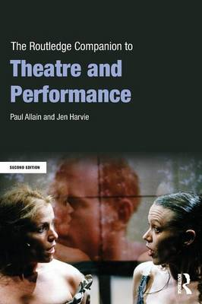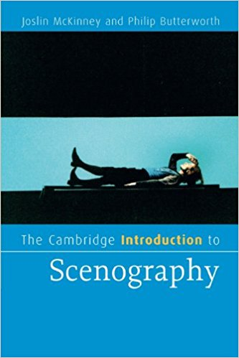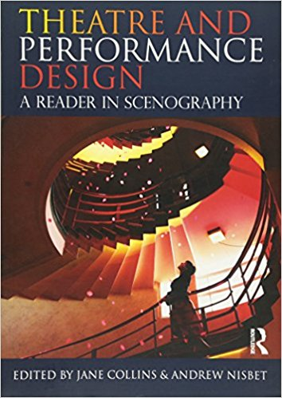
Level 4 Level 5 Level 6

