STUDENT ENGAGEMENT FUNDING (2019)

The Education Development Service offers opportunities for students to be paid to work in partnership with university staff on a range of projects that strengthen the student learning experience.

You can apply for funding under either of the University’s two schemes, Student Academic Partners (SAP) or the Student Academic Mentoring Programme (StAMP). More detail on these distinct offers is available on pages 4 and 5.

In 2019, projects can last up to 12 months with the funding period running from 1 January to 31 December 2019. The priorities for funding this year align with the University’s strategic targets of improving retention and student attainment. In particular, we invite well thought through proposals that address:

- the retention of students (through academic and/or wellbeing interventions);
- reducing disparities in student attainment across the entire student population.

Through removing barriers to learning we will enable all our students to achieve. Therefore, we encourage initiatives that focus on inclusivity and ensuring students from potentially disadvantaged backgrounds (e.g. disabled, black and minority ethnic, commuter, carers, mature, working, parents or those from low socio-economic backgrounds) have the opportunity to achieve.

Applicants might also wish to consider the place of assessment in delivering these targets. This is particularly pertinent in light of the development of the University’s new Assessment Centre. It is intended that this centre will be in operation from September 2019 and will include secure, proctored testing areas and more relaxed student development spaces. In the new year there will be a separate call for projects to design specific e-assessment activities that could be delivered through the centre.

EDS, in partnership with the Students’ Union, will embrace all projects that provide opportunities for student and staff partnerships and inter-disciplinary collaborations in an attempt to transform the way that students learn. Our scheme also aligns with the University’s Graduate+ initiative (https://graduateplus.bcu.ac.uk/ ), supporting projects that enhance students’ personal development and employability. This provides students with the opportunity to enhance their skills in an academic employment environment within a paid post at the University. Students will be encouraged to work towards their own individual Graduate+ Award as part of this process.

Those projects selected for funding will be required to present their progress at the University’s 2019 Learning and Teaching conference.

This call for projects is supported by Higher Education Funding Council for England (HEFCE) Catalyst B project funding. The University, through EDS, is a partner in a projects that focus on disparities in student attainment. DRIVER is a partnership project with Coventry, Staffordshire, Wolverhampton, Solihull 6th Form College, Halesowen College, Coventry University College and Staffordshire University College. The focus of the project is on the transition between colleges and universities where students from potentially disadvantaged backgrounds (e.g. Black and Minority Ethnic (BME), commuter, mature and those from low socio-economic backgrounds) are highly represented yet statistically less likely to achieve a good degree. DRIVER aims to address the student as an individual, rather than as someone who possesses certain demographic characteristics. The colleges and universities involved in the partnership will collectively create actions that will benefit all students and, in particular, address the intersectionality of factors affecting student success. The project provides a focus for the use of learner analytics to inform learning conversations between staff and students that can create responsive adjustments within programmes and each partner institution.

Application process

The application process aims to help you explain to us what you hope to achieve and will enable you to show the panel the real partnership between students and staff in addressing your issue. The process requires you to:

- Submit the title of your project and a 300-word overview of the project to Luke Millard in EDS by 23rd November 2018. This should be done through email. You are encouraged to consult your Head of School and/or Associate Dean for advice and support for your bid.

- Present your ideas to the Student Engagement Assessment Panel on 4th December 2018. Each project will deliver a 10-minute presentation which will be followed by questions from the panel.

Your presentation will require the use of data to evidence the need for change and clarity around how your project will be judged a success. You will be asked to select a suitable time on the day once all applications are received.

If you would like to discuss your planned proposal or have any other questions, please feel free to contact Elodie.Wakerley@bcu.ac.uk or Luke.Millard@bcu.ac.uk

Some useful resources to consider (and there are many more)
The Inclusive curriculum (HEA) https://www.heacademy.ac.uk/individuals/strategic-priorities/retention/bme-attainment-gap/inclusive-curriculum
Inclusive learning and teaching in higher education: a synthesis of research (HEA) https://www.heacademy.ac.uk/knowledge-hub/inclusive-learning-and-teaching-higher-education-synthesis-research
Mental Health in HE (UUK) http://www.universitiesuk.ac.uk/stepchange and http://www.universitiesuk.ac.uk/policy-and-analysis/reports/Pages/student-mental-wellbeing-in-higher-education.aspx or https://www.ippr.org/research/publications/not-by-degrees
Commuter students and LGBT research (TSEP & NUS) http://tsep.org.uk/inclusive-approaches-to-student-engagement/
Disability equality in HE (HEA) https://www.heacademy.ac.uk/resources/detail/evidencenet/disability_equality_synthesis
Student retention and success – What Works (HEA) – Final report and conference presentations https://www.heacademy.ac.uk/knowledge-hub/supporting-student-success-strategies-institutional-change and https://www.heacademy.ac.uk/knowledge-hub/what-works-student-retention-and-success-change-programme-final-conference-and
Student Academic Partners (SAP)
Student Academic Partners (SAP) provides an opportunity to integrate students into the academic community of the University. It generates a sense of ownership and pride in the institution and its programmes through a scheme that provides students and staff with a direct opportunity to work collaboratively to strengthen learning and teaching at the University for the benefit of all. Over the past nine years SAPs have delivered over 500 projects and have seen the employment of over 1500 students. These projects have substantially impacted upon the learning experience for our students and outcomes have become embedded across many schools and programmes.

On average, projects normally ask for funding to employ students for around 100 hours of time. Students will be employed through Manpower and EDS will manage that process. Projects normally have a small team of students collaboratively delivering the project with 1 or 2 members of staff providing guidance.
Applications will need to show the benefits of partnership with students and the potential for significant impact on the student learning experience through the provision of data explaining the reason for the project and how they will judge the project to be successful.

For further information on SAP and StAMP projects click here to see the JISC Student as Change Agents case study of BCU.

Student Academic Mentoring Programme (StAMP)
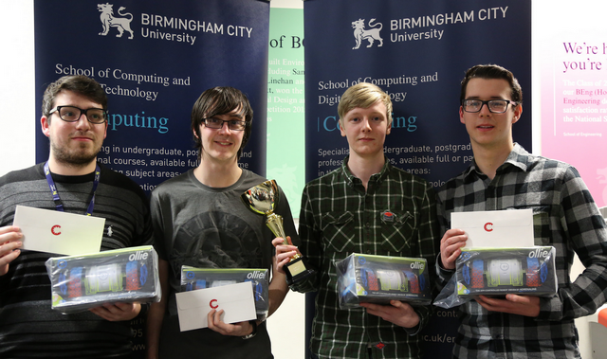
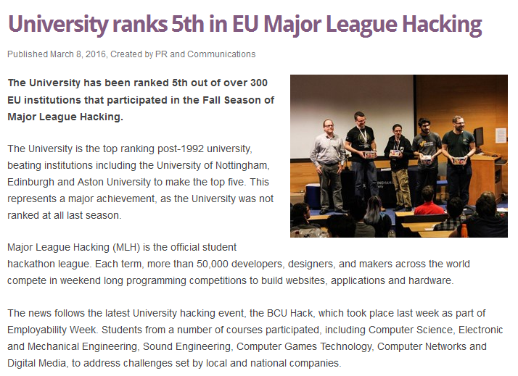
The Student Academic Mentoring Programme (StAMP) was designed through a collaboration with our colleagues at Northwest Missouri State University. It has the intention of creating student led interventions that would better support course teams seeking to improve the progression and achievement of their students. Projects can normally bid for up to 200 hours of student employment to develop mentoring initiatives.

The programme now enters its eighth year of operation and has supported over 200 projects in that time. Mentoring encourages students to take advantage of peer to peer support by offering them the opportunity to gain academic support from more experienced students, under the guidance of academic staff. We have supported many types of mentoring initiatives that support student success and would expect funding bids to comment on the mentoring model(s) they will employ.
In 2019 we would like to support mentoring activities that either:
- employ a supplemental instruction model. This sees senior students being employed to sit in on specific classes/modules/workshops, that they have already studied, with more junior students and to provide a bridge with staff or an alternative outlet for student questions. Colleagues at Northwest Missouri State University have often used this approach with ‘gatekeeper modules’ or those that students often find the most difficult to pass.

- provide professional mentoring opportunities for students alongside their studies. This could see the use of senior students or postgraduates, that reflect the diversity of our student population and are able to provide role models for more junior students.

This does not exclude other mentoring models or ideas, but we hope offers some inspiration.
For further information on SAP and StAMP projects click here to see the JISC Student as Change Agents case study of BCU.

