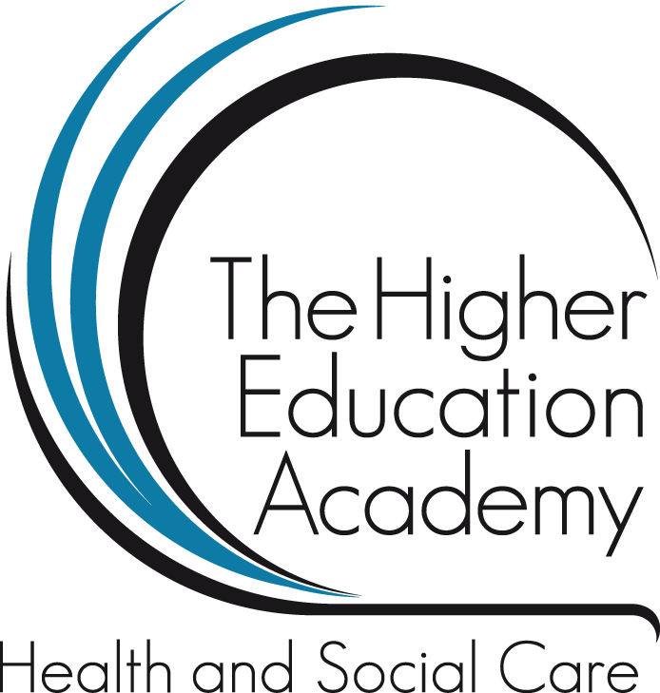

Vodcast Transcript 02/04/14
Workshop Theme: Students as Partners
Workshop Title: The journey of transition from a student nurse to a newly qualified nurse.
Speakers: Harriet Shaw-Roberts (HSR), BCU alumni, Children's Nurse (RN), Birmingham Children's Hospital and Ruth Cartwright (RC), BCU alumni Adult Nurse (RN), Birmingham Community, Healthcare NHS Trust.
Please note:
- This is a partial recording of the workshop hosted by Harriet and Ruth.
- The video footage of their personal blogs have not been captured within this film as un-edited versions were used.
- Additionally interaction and discussion with audience and delegate attendees was not recorded as footage.
- A PowerPoint presentation was not used.
- Therefore the transcript is a written record of communication and interaction. This will be outlined by each speaker’s initials throughout the recorded conversation.
- Although Harriet and Ruth took the time to introduce themselves and the project they are involved in (see event resource pack) those introductions do not feature at the start of the film.
HSR: So it actually started in May wasn’t it

RC: Yes

HSR: And we were approached by Lisa, Lindsay and Katie about this project. Basically we got an email, I think it was sent out to all of the students in the cohort that were coming up to qualifying. We were just in our last stages of university. We were starting our transitions module. And it was quite a worrying time for all of us because it was when it was all kind of coming to an end really with our course. So we got an email didn’t we?

RC: So we basically received this email and to be honest when I received this email I was actually just starting my PP1 (Practice Placement One) which is management placement. And we had a lot going on. We had mock interviews with Bridget Malkin, we had like mock job interviews which helped us a lot. We also had like the problems of findings jobs, starting to apply for jobs and things. And I received this email from Lisa and I was like ‘I don’t want to get involved in this, I’ve got enough on my plate as it is. You know I’ve got too much responsibility I’m not in the mood…you know’. But like I say I did apply for it, sent it and I didn’t actual think I would get it but I did.

RC: I was really interested in the project. I didn’t meet Harriet until then obviously as she’s a child branch student nurse and I’m adult. And we are from different cohorts; I wouldn’t have met this group of people otherwise.

RC: So like I say once we had all introduced ourselves we set up this collaborative agreement. Which basically said we had to think about things like what did we actually want to achieve? What are these video blogs trying to achieve? How are we going to do it? And how are we going to do it in a professional way whilst respecting confidentiality and obviously the University and the Trust that we now work for.

HSR: When we were sent out the email we actually had to apply and say why we wanted to do it and how we thought it would benefit other students in the future. So we had to write a short paragraph as I said saying why we wanted to apply. And it was quite interesting because it made me think how students in the future would benefit from you know being able to see our journeys. I thought that, for example, if that was me, if I had seen someone else’s journey of transition when I was at that stage before qualifying. I felt that that would really benefit me. Because you can relate to another student going through the same thing.

HSR: You know you can hear as much information as you want through lecturers and stuff who probably did it while ago.

Lisa Abbott: now, now! Audience laughs…

HSR: But for someone who’s done it in the past few years it’s still quite recent or relevant and I think it’s important that you can relate to that.

HSR: And something else that made me think this would be quite good is you know something that you could put on your CV, in your personal statement and talk about it at job interviews. I did actually put it in my personal statement and mentioned it as an extra-curricular thing that I was doing and that will always stay on my personal statement now and on my CV for future jobs and stuff.

RC: So other reasons why I wanted to apply for the project. Obviously I wanted to meet new people. I actually had a gap year during my university training so when I returned to university I didn’t know many people. So obviously I was in a new cohort. I made a few new colleagues and friends but like I say it was nice to meet a group of people who I knew were going through the same experiences as myself yet wouldn’t usually speak to on a day-to-day basis.

RC: I also wanted a virtual record to look through in future years. And I think, especially as I was brought up around technology like the internet and iPad’s and things and its now all digital. Like looking through a photo album is becoming a thing of the past. And it’s nice to have a virtual look back at things.

HSR: Like reflection as well

RC: Yes, like seeing the blogs today. It was nice to see going back to that stage. And that stage seems like years ago now yet it was months so that was really nice. And it was also really nice to look back and think of your achievements. Because you don’t actually realize how far you have come from being a student to a registered practitioner. I mean we only had graduation last month. And I think that’s made it really sink in that actually I am a registered nurse and I have that responsibility so that’s really nice.

HSR: It’s also good to kind of like keep a link with the university. You know if you want to go and do anything in the future. Because I am quite interested in maybe coming back to university and doing some further education so to keep the links. You know because when you leave university you’re kind of pushed out you know that’s it and you feel quite cut off from it. For me personally it’s quite a good thing to keep the links, keep in contact with the lecturers and things like that so that if the opportunity does arise in the future I can say you know I’ve still been in contact and things like that.

HSR: So going back to when it all first started. When we first started we had a few technical difficulties and stuff, as you do. We were given camera, like webcams from university but the first lot that we got were really quite rubbish. They were really grainy, the sound wasn’t that good so we had to test all of that out before. And we had a few meetings and things. And then we finally got a proper camera which was like HD so you could see all you spots and stuff as well!

HSR: Everyone’s was as the same level. And also just getting use to talking to a camera. And you have to keep looking at it. I felt really silly doing it. You know I had housemates in my house who could hear me talking to a camera and thinking I was crazy! But after the first few you kind of just got used to it.

RC: Yeah

HSR: You started to talk quite naturally and then obviously it’s all going to be edited when we finish it in October. All the blogs that we have done are going to be edited by the media students and all put into one big video aren’t they?

Lisa Abbott: Yes we are going to create, well there’s a few things we are going to create. Mantas and Algirdas actually are going to create some videos that we can create already for example the final parts of the course. So for example everyone’s experience of interviews, everyone’s experience of their last day, everyone’s experience of their first day so that you get that broad range. But we are also going to create short five minute movies, which I don’t know how on earth we are going to bunch all of that together into each student’s journey because they will all be different. So like we’ve got a mental health nurse, we’ve got military students doing this so it will showcase their journey throughout that twelve month period of what is or can be quite a rocky road sometimes. I am already fascinated by the things that are on the blogs and I can’t wait to see them actually articulated into something.

HSR: It will be interesting

Lisa Abbott: Yes it will be…and these guys have editing rights as well so that if there not happy with something…

HSR: So if something is really embarrassing on there we can just say cut that out.

RC: A few other things we had technical problems with and problems that arose were things like time. As we now all work full time obviously it was hard to get six or so nurses together and lecturers to come together all at the same time and that was proving quite difficult as some stages. Especially working around shifts as well. And also because my responsibilities have now changed. I work full time now and I’ve put my student days behind me so to get motivated to check your emails, to reply and to get things because obviously that sort of area of my life had gone really. And now working full time and not having as much time as you wanted so time to film really. And as well it was dark all the time through the winter so lighting as well…

HSR: You don’t think of all of these things until you actually have to do it and plan it properly. There was also at the beginning a bit of trouble in thinking about how we would share each other’s blogs. How many of us were there that started doing this?

Lisa Abbott: seven or eight
HSR: So we all wanted to kind of find like a network online where we could upload our blogs, our videos and see each other’s and see who is saying what and see how they present and things like that. So for a week or so we were kind of trying to find an online website or some way of doing that where it was private. Because obviously if you upload things onto you-tube and stuff you can’t then download and watch them without other people seeing them. So that was something that we personally didn’t have to sort out but the IT team at the university. So there are actually a lot more people involved in this project than just us and a camera. There’s actually a lot more people which we kind of forget about at times. Yes it’s on us because we are filming us but actually then end product is actually going to have had a lot of people having worked on it. Yeah I don’t know what else to…

RC: Yeah so we’ve got this thing, it’s like a hub called sky drive, which will spring up now. So this is like a private area. So we can watch everybody else’s blog and they can watch ours but it’s not actually shared publically. So it’s only the university that have access to this. And we also said that we would be able to watch each other’s because obviously if you are going to make a video and show it to other students we want to be able to feel comfortable. I know I would like to feel that my opinions are respected by other people and that my feelings and my emotions are respected by my colleagues. And that came into the collaborative agreement as well. That we could watch each other’s and feel supported by each other.
HSR: And what we did basically, this is quite an easy website that we use, but we have our video on our computer and then we just upload it. It does take forever because they are quite big files. I remember when I first did it something was wrong with my laptop and it wouldn’t upload. I would leave it for an hour to upload and it wouldn’t. And I would come back and find it really frustrating. But we finally sorted it out. And as I say you can just click on the blogs and then they download and you can watch them. So we will show you some little clips of ours. We were just saying earlier that it is horrible looking at them on such large screens in HD. So this is a bit of Ruth’s, what one was this called?

RC: This is the NMC so it’s when I had just registered with the NMC, registration and starting. So this is like I think two weeks before I started my job.
Please note the recording of this workshop ends here. Harriet and Ruth went onto show delegates ‘clips’ from their recorded blogs. Yet as the nature of the site is private and the blogs are currently in un-edited format it was only fair to end workshop footage here; emulating the arrangements as made with students within the jointly signed and co-created collaborative agreement.

