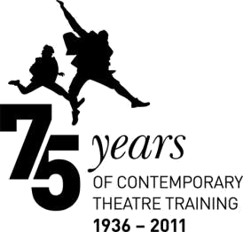

Guidance on how to complete your online application form for BA (Hons) Acting

Completing our online application form
You will need to create a username and password before you can apply online. You can apply on our website under the ‘How to Apply’ tab within your selected course page. You can work through the form at your own pace, saving as you go along. You will need to provide information on your previous and current education, employment and English language ability, as well as a personal statement and a referee. We recommend you write your personal statement offline and paste it into the application form.

What should I include in my personal statement?
Your personal statement should cover your interests, accomplishments and personal ambitions. You should discuss the relevance of any specialist training you have undertaken prior to your decision to apply for your chosen course. You should also tell us whether you have applied to any other CDS Drama Schools and/or Universities (and if so, which ones) and whether you have applied to Royal Birmingham Conservatoire Acting previously.

How long should my personal statement be?
Your personal statement should be about 500 words in length and written in essay style. You should give your personal statement the same amount of care an attention as your audition: be sure to cover all the elements requested above, proof-read it carefully and check your spelling before submitting it with your application.

What does my reference need to include?
Your referee should be someone who is not a family member. Your referee should focus on commenting on your stamina and character – in particular, your ability to sustain rigorous training. He or she should also comment on your suitability for study at degree level and your suitability to pursue a specialised course in acting.

Will I be auditioned?
Admission to the BA (Hons) Acting is via audition. We will contact you to discuss the process and to arrange an audition after we have received and read your application. Before completing your application you should ensure that you have read all of the guidance on our website regarding

the audition process. You will need to pay the appropriate audition fee before you are offered an audition.

Auditioning is a two-stage process – Initial and Recall. This helps to ensure that each applicant is given a fair opportunity and that we have the best information on which to base our choice of candidates. We receive hundreds of applications each year and less than seven per cent of those applying gain a place. However, if you pass your Initial Audition and attend a Recall Audition, you have roughly a one in six chance of being offered a place. In addition to the guidance below, you may wish to read Auditions: Frequently Asked Questions.

We recognise that you will inevitably be nervous about your audition; much rides upon the outcome. We work hard to ensure that your audition is a positive experience. Members of both academic and admissions staff will be available to answer questions at all stages of auditioning. All auditions – Initial and Recall – are stewarded by full- time students who are there to support and guide you through the process.

