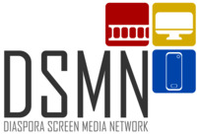  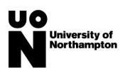

**DSMN Symposium, University of Northampton, Morley Room (Senate), 5 February 2020**

5th February 2020 will see the first of a series of exciting events run as part of the AHRC -funded Diaspora Screen Media Network. Led by Professor Janet Wilson and Professor Rajinder Dudrah, and with the support of research coordinator of Dr David Simmons, the network intends to act as a platform for those interested in Black British and British Asian screen media, bringing together scholars, students and creative personnel.

The research question, ‘What is the impact of social media on consumption patterns of diasporic cinematic and media culture in modifying its themes and issues’?, will be debated during the day through presentations, round table discussion and workshop sessions.

Several short films of Black British/British cinema will be made available in advance, for potential attendees and participants to view, and to serve as a discussion point in the sessions.

Refreshments and a lunch will be provided. The event runs from 9.00 a.m. to 5.00 p.m. and is open to anyone with an interest in Diaspora Screen Media.

The network leaders and coordinator are encouraging all creative practitioners, community arts organisers, consultants, researchers and members of the public interested in attending to write to us with short 300 word profiles (with optional photo) on their interest and work in Black British and British Asian screen media, for loading onto the network website, and if they wish a 500-800 word blog on their experience in this area.

The website address is <https://mypad.northampton.ac.uk/dsmn/>

Contact: [David.Simmons@Northampton.ac.uk](mailto:David.Simmons@Northampton.ac.uk) for further details.