Covid-19 Contractor and Visitor Management Form

To help keep you safe during your visit and to protect BCU staff and students, please read the information below.
Complete your details and return this form to your host before you arrive on campus.
Your host will store this information for 21 days following your visit to campus. Your information will be deleted after this time.
In the event of a positive coronavirus test, your details may be shared with Public Health England, if requested, to assist in the national Covid-19 contact-tracing program.

What to expect when you arrive on campus
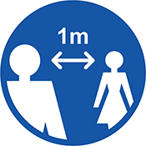 | 1m+ social distance  All entrances, foyers and circulation spaces operate with at least 1m social distance in place, but you should maintain 2m social distance where it is achievable.  Please follow any directional signs and instructions whilst you are on campus.
Face coverings
You will be required to wear a face covering, please ensure you bring one with you and put it on before you enter the building.

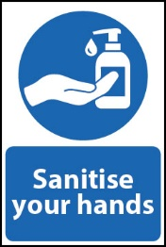 | Hand gel  Please use the hand gel provided at the building entrance/reception area.
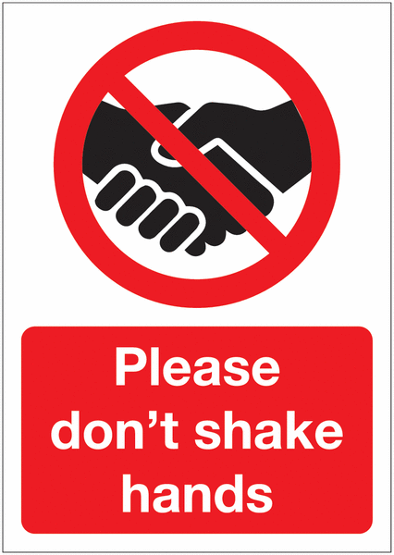 | Don’t shake hands  Please do not shake hands when greeting your host.

Visitor/Contractor Information
Your name | Click or tap here to enter text. | Your telephone no. | Click or tap here to enter text.
Host’s name | Click or tap here to enter text. | Date of planned visit | Click or tap here to enter text.
Please answer the following questions. If your status or circumstances change prior to your intended visit date, please cancel your appointment and do not come to campus.
Covid-19 Question |  |  |  | Yes | No
Do you currently have any of the following symptoms, or had them in the last 10 days?  - New and persistent cough  - High temperature/fever  - Sudden loss/change in sense of smell or taste |  |  |  | ☐ | ☐
Have you received a positive coronavirus test within the last 10 days? |  |  |  | ☐ | ☐
Does anyone you live with currently have symptoms or received a positive coronavirus test within the last 10 days? |  |  |  | ☐ | ☐
You must not visit campus if you have answered ‘yes’ to any of these questions.

To be completed by the BCU host
Your name | Click or tap here to enter text. | Date of actual visit | Click or tap here to enter text.
Building | Click or tap here to enter text. | Room location | Click or tap here to enter text.
Workstation ref.  (where applicable) | Click or tap here to enter text. | Class/activity  (where applicable) | Click or tap here to enter text.
As BCU host you are responsible for ensuring the form is stored securely ie; OneDrive/SharePoint with access restricted to a needs only basis. The form must be securely destroyed following 21 days after the visit
If a BCU contact tracer contacts you, please follow the instructions given.

