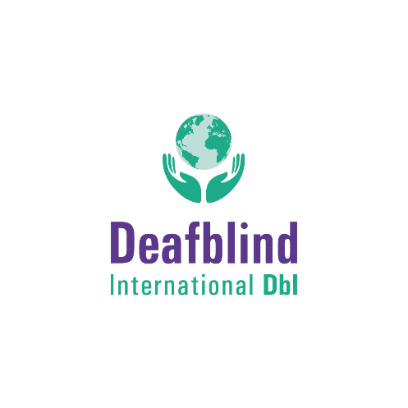
The Acquired Deafblindness Network (ADBN) invites YOU to join us in
Celebrating Your Everyday Contributions

What is ADBN?
ADBN is an international network of over 180 members, who all share an interest in acquired deafblindness. We work together to enhance our understanding of acquired deafblindness, bringing together different perspectives, and valuing lived experience, practice wisdom and theoretical and research based knowledge.

What is ADBN celebrating?
We are celebrating YOU! As we launch our renewed network, we want to celebrate the contributions made every day by people living with acquired deafblindness. We know that acquired deafblindness comes with challenges, but we also know that those living with acquired deafblindness contribute to the lives of their families, their friends, their communities and society in general, in many ways. And we want you to share your contributions with us!

What do you mean ‘contributions in everyday life’?
It can be anything. We want to celebrate the ordinary things that make a difference. For example, are you working or volunteering? Perhaps you’re a good friend, a great partner, a loving parent. Maybe your talents lie elsewhere - you’re a good cook, an artist, a musician, a writer or have a fabulous sense of humour. Do you run, climb, play football or swim? Do you help raise awareness about deafblindness or educate others? All of these are contributions and we want to know about them!

I’ve not done anything extraordinary, why are you celebrating these contributions?
Often, people who are deafblind are not seen as contributing, but are instead seen as incapable, incompetent or simply as those needing and receiving support from others. We need to hear about you and your contributions to challenge that perception!

OK! So how do I tell you about my contributions?
- You can write about them – in your own language – and email us!
- You can take photos or create pictures and email these to us!
- You can make a video and send us the link!
- You can email us photos or examples of your work such as paintings, poems and writing
Anything that works for you!

What will you do with my contribution?
We will be collecting what you share with us throughout June (Deafblind Awareness Month) and will then launch the celebration on 30th June 2021 with an online presentation. We will then be sharing your contributions on our website, and through various Deafblind international social media channels over the coming weeks, months, and who knows….!

Sounds great! Can I get more information?
Yes! For more information, please go to our website and see the ‘Celebrating Everyday Contributions’ section and/or email ADBN Chair Peter Simcock: peter.simcock@bcu.ac.uk

We are excited to hear from you!

