Mentor Newsletter October 2011 (Full Time Trainees)
This electronic newsletter is designed to assist you in your role as mentor to a PGCE PCET Trainee. Thank you for agreeing to become a mentor to our trainee. We do value the contribution that you are making towards the training of your mentee whilst they are placed at your institution.
This newsletter is the first of a number that will be produced and dispatched to you throughout the present academic year. The aim of the newsletter is keep you informed of the activities trainees may be participating in and to acquaint you with information regarding the content and topic areas that make up the modules and assignments that your mentee is currently covering throughout their course at the University.
Helpful tips will also be included in the newsletter particularly concerning documentation and/or processes that need to be addressed during the mentoring process. You are all busy people and so the plan is to keep the newsletters ‘brief’. I would welcome any contributions to the newsletter and feedback from you, particularly if there are any improvements that can be made.
Modules Covered during September-October 2010 (Full-time Group)
Module Code Module Name Level Credits
EDU6116 Preparing to Teach in the Lifelong 6 10
Learning Sector
or
EDU6117 Preparing to Teach in the Lifelong 6 10
Learning Sector (ESOL)
The trainees will need to carry out an analysis and evaluation of an aspect of their subject specialist teaching and collect documentary evidence of the SVUK/Minimum Core standards required. They will also need to discuss their roles and responsibilities within their placement. As a summative assessment the trainee will need to produce a portfolio of professional evidence which will need to be submitted online by December 12th 2011.
EDU6118 Principles and Practice of Assessment 6 10
And Evaluation
The trainee will need to produce a formative assessment tool for use in their teaching and evaluate its effectiveness. They will also be reflecting on formative feedback to learners. Summative assessment of this module will be by the production of a 2,000 word assignment to be submitted online by December 5th 2011.
Your mentee may well approach you for information or guidance concerning:
- the management structure of your institution
- the lecturing role
- aspects of professionalism
You may even be asked by your mentee to complete a questionnaire or caste your eye over a rough draft of a document. Hopefully the above information will put it all into context.

Subject Specialist Workshops and Audits
During their time on the course the trainees will be constantly revisiting and updating their subject specialist audit. This document is particularly significant as it helps them to identify any gaps they may have in the subject specialist knowledge, so your input in helping them update their audit is valuable. Trainees will also be participating in a wide range of subject specialist workshops, held here at BCU. If you feel you could contribute to, or run, a workshop then let us know.
For example, last year the Art trainees partook in a printmaking workshop.

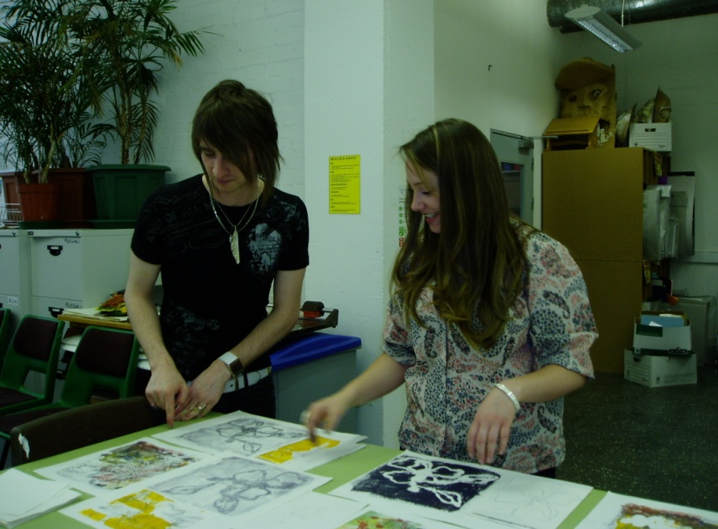

Useful Tips!
- Ensure that your trainee is keeping their teaching log up to date and, when you are satisfied that the content is correct, you can countersign it.
Trainees should be teaching across a range of groups and levels.
- Encourage your mentee to bring along their formative record of SVUK/Minimum Core standards to your regular target interviews so that you can check that it is being regularly updated.
- Ensure your trainee has targets to work towards and is uploading them into the e-portfolio.
- Your mentee has carried out a subject specialist audit which highlighted any areas for development. Ask to see this document and check how they are progressing. These first four points should be regular features of your target setting meetings
- Your mentee is the main conduit between you and the University. Make sure that they have supplied you with all of the documentation that you need (Observation Grids, Post-Observation Summary & Targets, Targets for Development)
- You can obtain electronic versions of all of these documents on the Post-Compulsory Partnership website at: http://www.bcu.ac.uk/elss/school-of-education/partnerships-collaborations/pcet-partnerships
Please feel free to contact me with your comments.
Phil Bate Professional Development Tutor
Email: Philip.Bate@bcu.ac.uk

