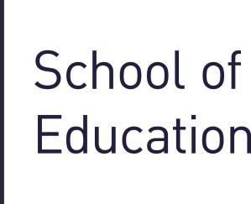

PGCE Post Compulsory
Education & Training

Partnership Opportunities Pack

2017 – 2018

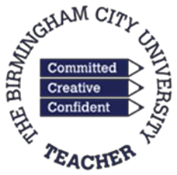
Find out more
Visit our Partnership website: www.bcu.ac.uk/education/partnerships
Call our Partnership Team on: 0121 331 6591

Partnership in Initial Teacher Training 2017/2018

Thank you for your continued involvement in our Partnership and for your support of our trainee teachers. Please find enclosed the documents that form our ‘Partnership Opportunities Pack 2017/2018’. This will also include the information required from your institution to make offers of placements for our PGCE Post Compulsory Education and Training (PCET) trainee teachers during the academic year 2017/2018.

For information, our full-time PGCE PCET trainees will undertake their teaching placements in settings from approximately (or as soon as settings are ready to trainees) the week beginning 30th October onwards and will be expected to finish at around Friday 25th May

Trainees will be required to attend their placement for 3 days per week and teach a minimum of 150 hours in total over the academic year.

Institution Details and Placement Offers Form

We ask you to complete this form to ensure that we have the correct and most up to date contact details for your institution as well as the details of the main contact dealing with placements at your organisation.

This second part of this form asks you to provide us with the details of the trainee teacher placements you are able to offer, and the name and email address of the contact in each subject area offering placements. We would appreciate your help in circulating this document amongst colleagues and would advise keeping a copy of the completed form for your own records. We ask that you include email addresses wherever possible.

We realise that making offers at this stage in the year can be difficult and subject to all sorts of variables. We would, however, appreciate it if you could give the matter your consideration and return the relevant information to us as soon as possible. In particular, we would welcome early offers to take trainees during the autumn term since this helps with our planning, although you will appreciate that we are unable to confirm these placements until this new cohort has formally enrolled in September.

Partners’ Handbook

In addition to the enclosed documents, detailed below, our Post Compulsory Education and Training Partners’ Handbook will give details of the roles and responsibilities for each member of the partnership: trainee teacher, institution and University.

The Partners’ Handbook is available to mentors at the following link:

www.bcu.ac.uk/elss/school-of-education/partnerships-collaborations/secondary-partnerships/handbook.

Please be aware that, currently, the Partners’ Handbook available to view or download from this link is for the current academic year, 2017/2018.

Why Mentor?

In addition to the benefits experienced by the trainee teacher we also know that there are many benefits for the mentor and their organisation of fulfilling this rewarding role. Please see “Why should I become a Mentor?” for ideas and further information.

Initial Online Mentor Training

Please also find enclosed a flyer relating to Birmingham City University’s Initial Online Mentor Training. We hope that this training will encourage you not only to work with our trainees and share your knowledge and experience, but also help you to think about your own professional development.

Documents to be returned

We would be grateful if you could please return electronic versions of the ‘Institution Details Form’ and
‘Placement Offers Form’ to Craig Davis, Partnership Administrator, at the following email address:

education.partnerships@bcu.ac.uk .

Alternatively, if you wish to print these documents and return them by post, please send to the following address – Craig Davis, Partnership Office, School of Education, Attwood Building, City North Campus, Birmingham City University, Perry Barr, Birmingham, B42 2SU.

This letter and the attached documents are available on our Post Compulsory Education and Training partnership website at the following link should you require them:

http://www.bcu.ac.uk/elss/school-of-education/partnerships-collaborations/pcet-partnerships/partnership- pack

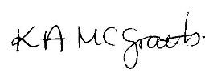
Thank you for your consideration and we look forward to working with you in the near future. Yours sincerely

Karen McGrath
PGCE Post Compulsory Education & Training Programme Director

