How to find the ISSN/ISBN Number.

- When completing an inter library loan request you will be required to enter the ISSN/ISBN number.

- To find this you will need to visit your search result on the library catalogue.
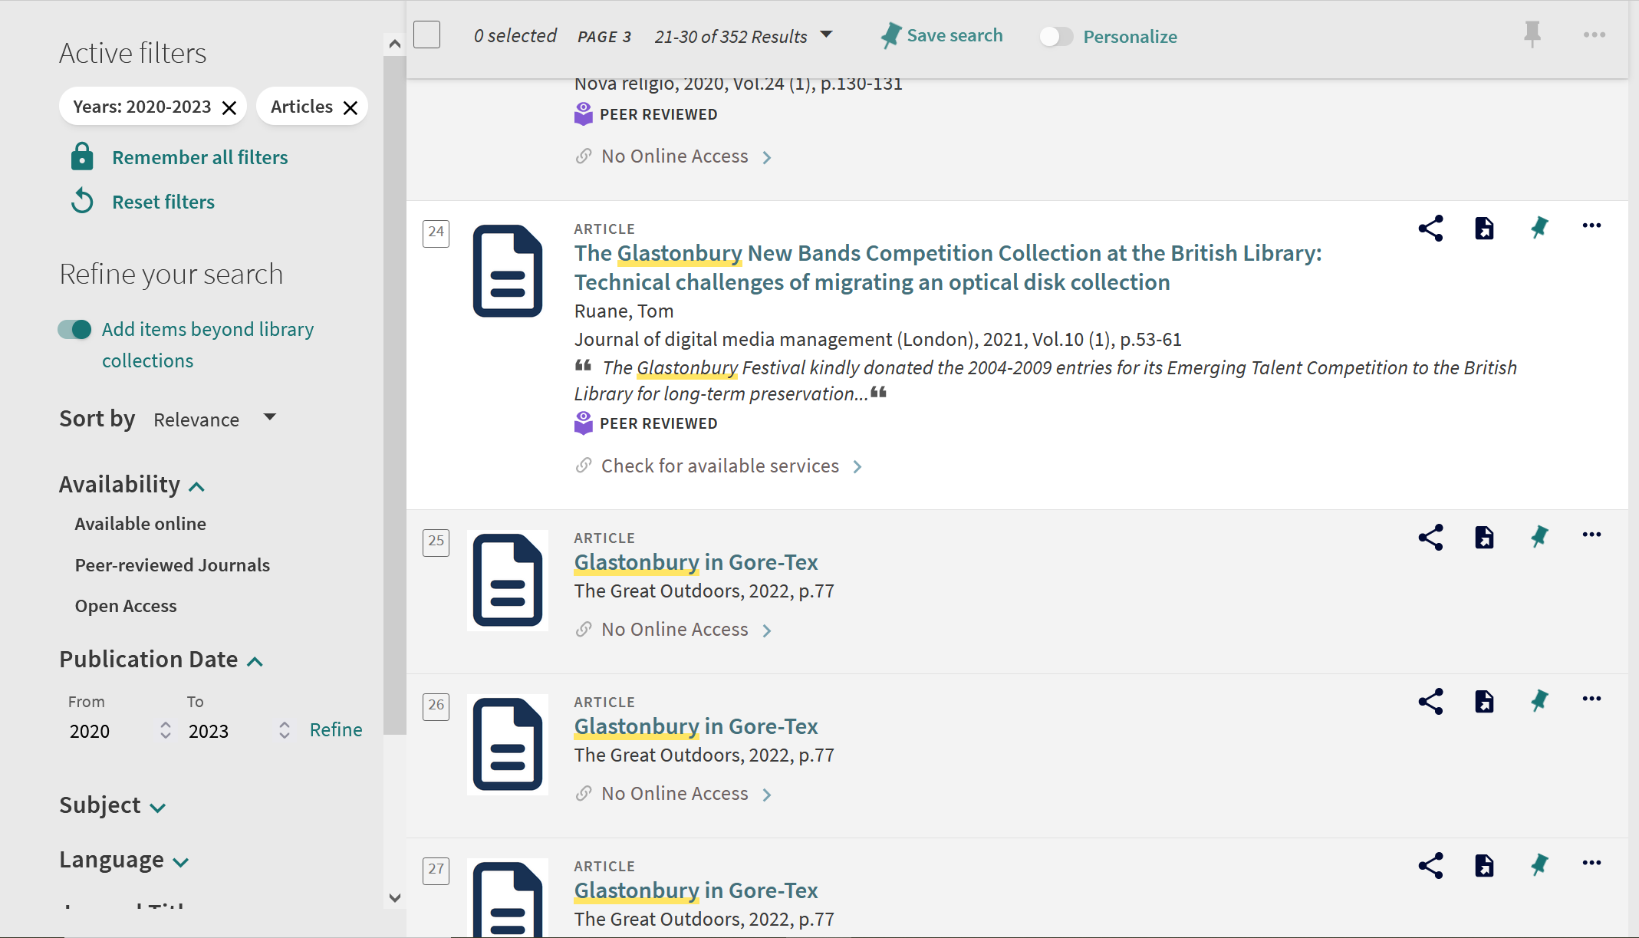
- Click to open the search result.

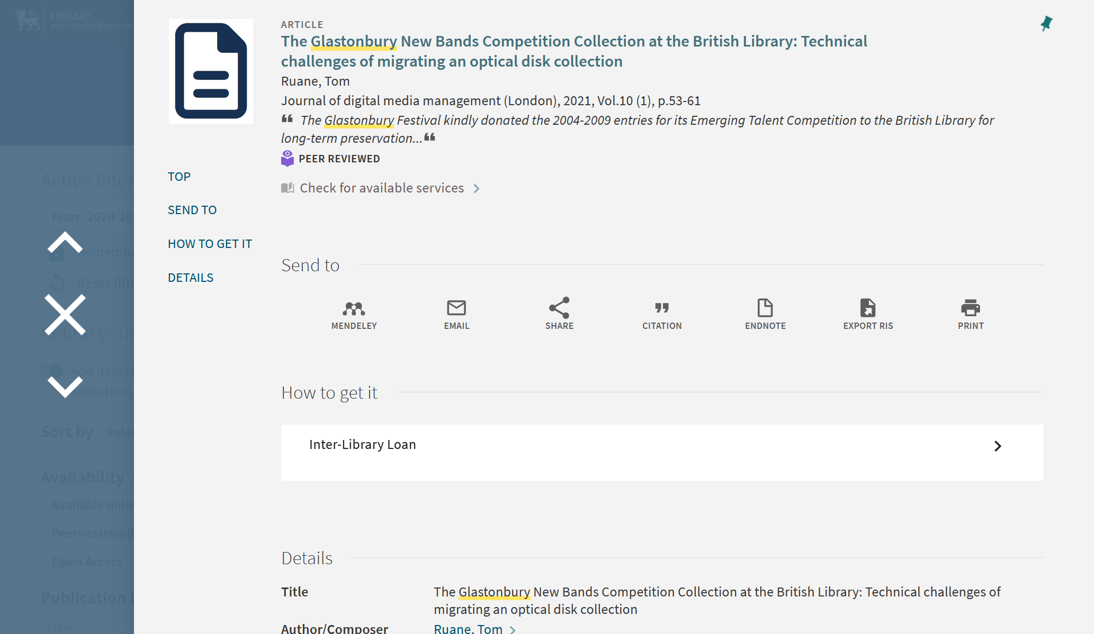

- Scroll further down the page and you should find the ISSN/ISBN number under the ‘Details’ section.

- This can then be copied and pasted into the inter library loan request form.
- Please ensure that you only enter numbers in the ISSN/ISBN field.

- You can then complete and send your request.

