Mentor Newsletter Autumn 2012
This electronic briefing document is designed to assist you in your role as mentor to a PGCE PCET Trainee. Thank you for agreeing to become a mentor to our trainees. We do value the contribution that you are making towards the training of your mentee whilst they are placed at your institution.
If you have not yet received training as a mentor then you can book into one of the sessions taking place at BCU, the details of which are shown below. Alternatively, if you are unable to attend any of these group training sessions, it may be possible that one of our staff can come out to your institution to deliver the training to a group or an individual.
Current Mentor Training Dates and times at BCU:
Wednesday 17th October 14.00-16.30
Wednesday 31st October 14.00-16.30
Wednesday 14th November 14.00-16.30
Wednesday 21st November 14.00-16.30
To book a place on any of these training sessions please contact Saiqa Andleeb at Saiqa.andleeb@bcu.ac.uk
This briefing is the first of a number that will be produced and dispatched to you throughout the present academic year. The aim of the briefings is to acquaint you with information regarding the content and topic areas that make up the modules and assignments that your trainee is currently covering as part of their PGCE PCET course at the University. You may be asked by your trainee to help them in the acquisition of information that they need to successfully complete their modules (e.g. institution policies)
Helpful tips will also be included in the briefings particularly concerning documentation and/or processes that need to be addressed during the mentoring process. You are all busy people and so the plan is to keep the briefings ‘brief’. I would welcome any contributions to the briefing and feedback from you, particularly if there are any improvements that can be made.
Modules Covered during September-October 2012
Module Code Module Name Level Credits
EDU6116 Preparing to Teach in the Lifelong 6 10
Learning Sector or:
EDU6118 Principles and Practice of Assessment 6 10
And Evaluation

Learning Outcomes
EDU6116
- Analysis of teaching in relation to subject specific skill/ESOL/Literacy and Language using academic literature and the SVUK/Minimum Core standards to inform the work
- Critical evaluation of in the an aspect of teaching the trainee’s subject specialism/ESOL/Literacy/Language
- Critical evaluation of trainee’s roles and responsibilities within the learning and teaching context
- Collation and organisation of appropriate documentary evidence to support trainee’s claim to meet SVUK/Minimum Core standards required at this stage
EDU6118
- Evaluation of key concepts in assessment as they relate to trainee’s curriculum area
- Evaluation of the application of a typical assessment strategy in trainee’s curriculum area
- Reflection on use of formative feedback to learners as part of the typical assessment strategy
- Use of academic literature and other information sources on assessment to inform trainee’s work

Formative Assessment
EDU6116
Sharing findings and observations with peers on University Moodle; peer assessment of learning & teaching strategies; principles of planning and participation in a range of speaking and listening activities; completion of Practice of Teaching Workbook 1 Tasks A-D.
EDU6118
Sharing findings and observations on Moodle; peer assessment of inclusive resources and participation in a range of presentations; speaking and listening activities

Summative Assessment
EDU6116
Production of a portfolio of professional practice. To be submitted online.
Hand in deadline: 10th December 2012
EDU6118
Production of a 2000 word assignment discussing and evaluating an assessment strategy. To be submitted online.
Hand in deadline: 3rd December 2012
Useful Tips!
- Ensure that your trainee is keeping their teaching log up to date and, when you are satisfied that the content is correct you can countersign it.
- Check with your trainee whether they need help in delivering any subject topics and check that they are maintaining and updating their Subject Specific Audit.
- Electronic copies of all the documentation that you will need for your mentoring role can be obtained by accessing the following address:
http://www.bcu.ac.uk/elss/school-of-education/partnerships-collaborations/pcet-partnerships

Please feel free to contact me with any comments as to how we can improve this briefing.
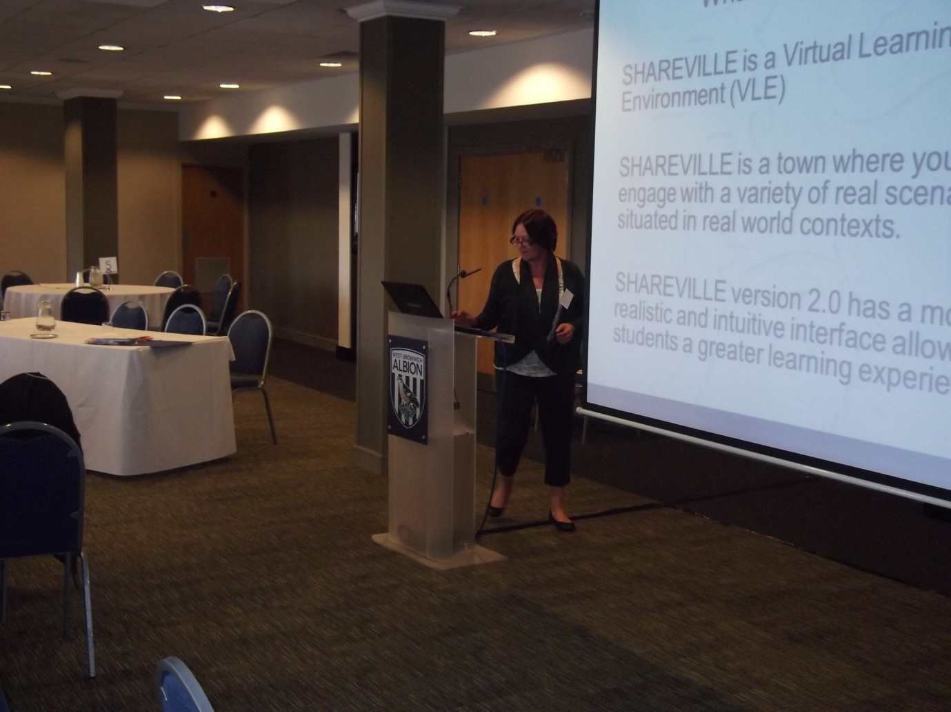
Karen McGrath (BCU PGCE PCET Programme Director) delivering a presentation about the University Shareville to the Mentor Conference held at the Hawthorns Conference Centre in July 2012

Phil Bate Professional Development Tutor
Email: Philip.Bate@bcu.ac.uk

