Notes from a Year of STEAMhouse
By Rajinder Dudrah, Professor of Cultural Studies and Creative Industries in the Faculty of Arts, Design and Media
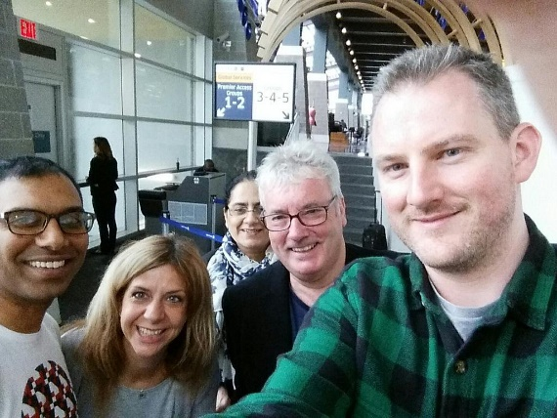
When STEM based subjects and ideas meet with those in the Arts that’s STEAM, and STEAMhouse will be the University’s new facility to locate a range of activities (academic research and innovation-led, while working with external partners in the region and beyond) all under one roof. STEAMhouse will allow university colleagues and their partners to use Science, Technology, Engineering, Arts and Maths in interdisciplinary ways to test and provide solutions to some of today's pressing challenges.
The BCU team about to catch a flight to New York City for their tour of STEAM-based institutions.

STEAMhouse is developing apace at the University with an academic year’s worth of meetings, visits and activities with external partners already having taken place. More events are planned for the forthcoming year, including the phase 1 launch of the STEAMhouse building in Digbeth at the end of 2017 which will house future events.
At the outset of the 2016/17’s academic year, a team of five from BCU visited Rhode Island and New York City as part of a fact finding and networking trip with STEAM-based institutions in the States. Our group consisted of Joanna Birch (Director of Innovation & Enterprise), Tom Cahill-Jones (Development Manager in the Institute for Creative Innovation), Dr Steve Harding (Director of Creative Innovation), Professor Hanifa Shah (Associate Dean for Research and Enterprise, Faculty of Computing, Engineering and the Built Environment) and myself. Between us we visited Rhode Island School of Design in Providence, Startup52 in Harlem, The Pratt Institute’s Fashion and Design Accelerator in Brooklyn, New School’s Parsons Lab in Manhattan, and the Staten Island Maker Space.
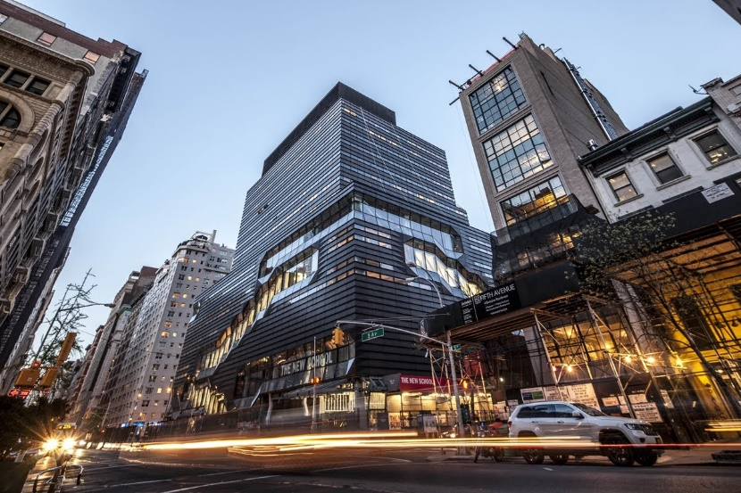
Visiting New School’s Parsons Lab on 5th Avenue in Manhattan, New York City

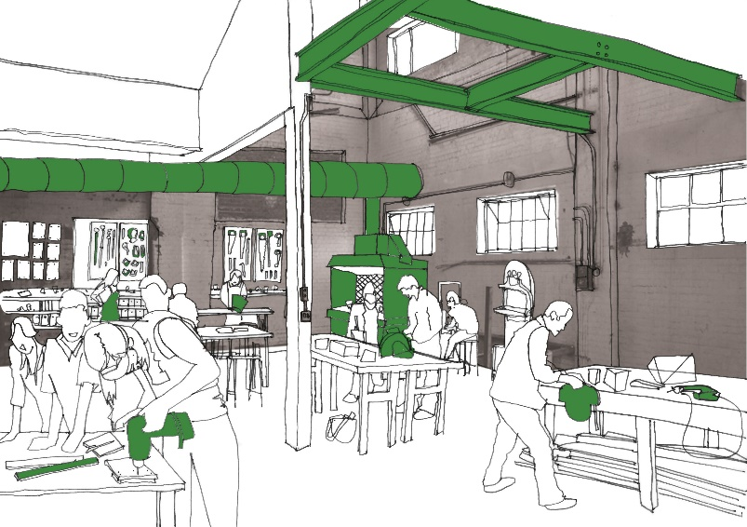
STEAM education and programmes have been formally embedded to varying degrees in America’s education curriculum from secondary through to tertiary levels since at least the mid to late 2000s. This trip was invaluable for us, then, not only to meet with new colleagues, see and learn varied ways of working in and with STEAM, as well as to consider what might a STEAMhouse facility and culture look and feel like for BCU?
An artist’s depiction of the proposed STEAMhouse maker spaces
“WE WILL NEED TO FOSTER A CULTURE OF cOLLABORATION – tHERE IS NO RIGHT WAY OF DOING ‘steam’.”

The University has devised two phases through which our STEAMhouse facilities and activities will begin to materialise. The first phase will be located on the Digbeth High Street from late 2017. Through a University enterprise and partnership model it will enable businesses to develop innovative ideas and creative products in a collaborative setting. The building will have specially designed spaces to encourage businesses to incubate new ideas, and prototype new creative products and services over a three year period.

Phase two will see the development of the STEAMhouse project with over £20 million being invested in a large-scale collaborative centre made up of mixed incubation, collaboration and maker space in the centre of Birmingham. A new STEAMhouse education facility called STEAM Academy will create interdisciplinary courses with industry input.
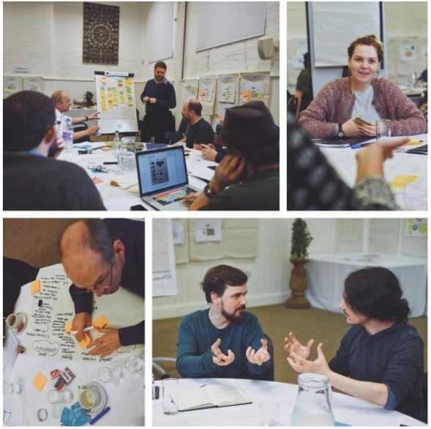
As with any new major venture BCUs STEAMhouse project will require all parts of the University coming together, learning, discussing, developing and creating from existing and new ways of thinking and doing, as well as working alongside our external partners - one of the existing strengths of the University. The list of our partners will include artists, activists, scientists, teachers, students, makers from various trades, SMEs, local and national government etc.
STEAM thinking in action at BCU’s STEAMlabs – a workshop precursor to STEAMhouse
For some, including myself, STEAMhouse as an idea, as a University project, might also be somewhat overwhelming, albeit even if only initially. How might we collectively begin to make sense of STEAMhouse and allow it to work for us?
Reflecting back on our group trip to the States at the outset of the academic year, and having attended a few of the events and meetings across the University related to STEAMhouse, a few points and questions remain with me over the course of the year. They are worth mentioning here as I think they speak to a culture of open enquiry around STEAM that many at the University are already very good at.
- How can interdisciplinarity work best for us? A good number of us are already working in interdisciplinary ways and STEAMhouse will also be an opportunity for us to take stock of how we are working within our main disciplinary area/s and how we are in dialogue with and use other disciplinary methodologies in our research enquiries.
- We will need to foster a culture of collaboration - there is no right way for doing STEAM. We might need to find a variety of approaches at BCU that could work well if there is a culture of collaboration grounded in intellectual and practice-based “curiosity”.
- STEAMhouse will be an interdisciplinary way of working for us, not only with our external partners but also with our students. Wherever possible we will need to help prepare our students for a world of work which will require them to think and act in this way. The STEAMhouse PhD scholarships that have been recruited for over the course of the past year are a good indicator of this approach.
- STEAMhouse could bring us a step change in our research culture, especially in terms of how we might form new relationships and consolidate existing ones at the intersection of STEAM disciplines. How best might these relationships be mediated at BCU?
As one academic year closes, and after a much deserved summer break, do look out for STEAMhouse related activities and ways of finding out more and getting involved in the new academic year.
Rajinder Dudrah is Professor of Cultural Studies and Creative Industries in the Faculty of Arts, Design and Media: http://www.bcu.ac.uk/media/research/research-staff/rajinder-dudrah
Interested in participating in STEAMhouse? Drop us an enquiry here or find out more on our website.

