Do you want to embed a culture of innovation to foster creative solutions and achieve competitive advantage?
What you get out of it
- Staged free consultancy to achieve defined organisational goal based on research.
- Free structured training delivered on Design Thinking tailor-made to industry or sector.
- An innovatively-oriented culture and engagement in activities that create value.
- The opportunity to work with leaders on the field from Birmingham City University.
The offer
- A consultant to guide your organisation through great challenges or obstacles.
- Unique solutions for your organisation using a mixture of academia and consultancy.
- A safe environment to try, test, fail and succeed in tackling complex problems.
- A transferable set of skills that aids the organisation, management and employees.
‘Innovation has become nothing less than a survival strategy’ (Brown and Katz, 2011).
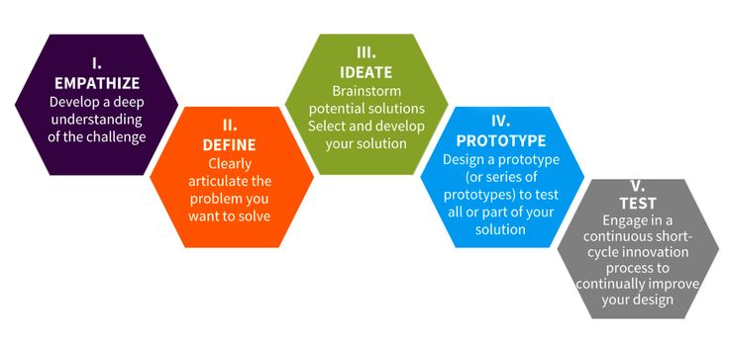
‘
An overview of the Design Thinking process

What to expect from the research consultant
- Specific development of design solutions that meets your users’ and organisational needs.
- In depth analytical research of users’ needs including interviews and conducting focus groups if required.
- Hands-on practical involvement in the project, an active participant, and an extra pair of hands.
- The latest contemporary techniques, practical solutions and theoretical knowledge to meet your organisational goals.
Co.Design
CO.develop
Collaborate
Innovate

How to take part and submit a project proposal
For an online version of the application form please click here or visit: https://goo.gl/forms/VtESqo3Ykh5jO6Vn1
Alternatively, further ‘Information and Guidance Notes’ can be found at: www.bcu.ac.uk/business-school/research/design-thinking
For further information please contact the project team: Carey Burke, Research Consultant e: carey.burke@mail.bcu.ac.uk, Dr. Margarita Nyfoudi e: margarita.nyfoudi@bcu.ac.uk, Dr. Martin Eley e: martin.eley@bcu.ac.uk
Expectations for the client
- To take an active part in the co.design of the project including planning, delivery to implementation.
- To ensure support for the project throughout the organisation and assemble an interdisciplinary cross-functional team to engage with and work through the design thinking process.
- To commit to a holistic approach that may challenge existing perceptions and offer radical alternatives.
- Committal to exploring and embedding innovative practices in order to achieve cultural change.
Design thinking is perfect for identifying missing parts of the puzzle.
Using induction and abduction, inventive solutions are created through empathy, reasoning and analysis, which leads to observable results and added value.

What is Design Thinking?
Design Thinking is an interdisciplinary human-centric approach to innovatively solving problems and creating value. By using techniques more commonly associated with designers such as co.design and collaboration, Design Thinking enables organisations creatively to enhance their users’ experience. As a result Design Thinking provides a multifaceted and holistic approach that can increase growth, differentiation or offer a competitive advantage. The universal nature of Design Thinking means it is often used to tackle complex problems, develop or create new processes, products, services and policies for example. Design Thinking continuously seeks to improve whilst focusing on ‘what’ and ‘how’ can lead to aspirational values.

