C:\Program Files\Microsoft Office\MEDIA\CAGCAT10\j0335112.wmf**INCOMING STUDENTS**

There are hundreds of reasons to study at the [Birmingham City University](http://www.bcu.ac.uk/) (BCU).

Birmingham City University is a modern and dynamic university with 25.000 students from over 80 countries, more than 2.000 staff, and four faculties throughout the University.

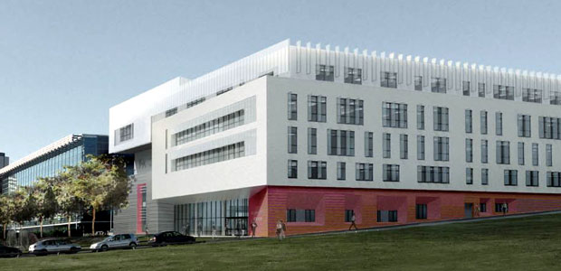The Faculty of Art, Design and Media has a growing and enviable reputation for excellence in both the traditional and digital arts. You will find a thriving community here, with students from our various faculties and institutions.

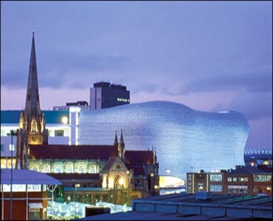

Birmingham is in the middle of England, and the second largest city in the UK. Birmingham is a vibrant and multicultural city, and a large number of amenities, cultural activities, shops, and opportunities will be available to you. Please find out more about Birmingham here: <http://www.visitbirmingham.com/student_birmingham/>

As an Erasmus student you will be welcomed by a professional team of lecturers and staff. BCU and have a large number of partner institutions worldwide and across Europe, and a strong experience in liaising with international students. We welcome our Erasmus students and we do our best to provide them with all they need to make the most of their time while studying here.

On your arrival you will be provided with support for anything concerning courses, student services, and student life. University accommodation is available to students; you can find further information here <http://www.bcu.ac.uk/student-info/accommodation> .

If you are thinking about coming to Birmingham on an Erasmus scheme, please do not hesitate to contact us. **We look forward to hearing from you!**

**CONTACT DETAILS:**

**ERASMUS FACULTY CO-ORDINATOR**

Professor John Butler, Head of the Department of Art

**ERASMUS FACULTY CO-ORDINATOR for Staff and MA/MPHIL students**

Professor Johnny Golding, Prof of Philosophy & Fine Art, School of Art

**STUDENT EXPERIENCE OFFICER**

Michela Reghellin

+44 (0)121 331 5804

[Michela.Reghellin@bcu.ac.uk](mailto:Michela.Reghellin@bcu.ac.uk)