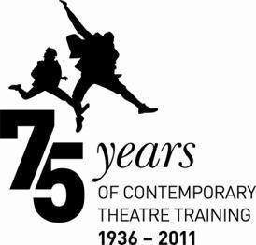

MA ACTING: GUIDANCE FOR APPLICANTS (FEMALE)

Your Audition

PUNCTUALITY
You should make sure you arrive in plenty of time for your audition; if for any reason you will be late please let us know. Punctuality is essential during the course, as it is when working in the profession. We are aware that sometimes transport is delayed – however, we will expect you to have arranged your travel to arrive on time even if there is a reasonable delay.

WARM-UP SESSION
At the audition you will be given a short vocal and movement warm up with one of our current students.
These warm ups do not form part of the audition process they are just an opportunity for you to prepare yourself.
Please note: Street shoes and stilettos are not allowed in any of our studios, but jazz and character shoes are.

SPEECHES
You must prepare and memorise two contrasting speeches from different plays, one of which must have been written in the last 20 years and one of which must be from an Elizabethan / Jacobean play.

Each selection should be no more than two minutes in length and suitable for your gender, age and experience (you may be stopped if a speech exceeds two minutes in length).

All speeches should be from published plays. Excerpts from film script, television dramas and unpublished plays are not acceptable unless you can provide at audition, and leave with us, a copy of the actual and complete script with the speech used clearly marked.

You should have read the whole of the play from which a speech is taken and be able to provide the correct title, name of the author if relevant and translator. You may be asked questions about the play and your character’s journey within it (i.e. their motives etc.).

It is preferred that the content of the speeches should be something to which you can relate and understand. It is not advised that you attempt an accent unless you are entirely confident of its accuracy and only if it is appropriate to the speech.

Any performance choices you make should be justifiable within the text. The performance should reveal an understanding of the scene and character and an ability to create and share appropriate emotions and atmosphere. Try to make sure that any vocal and physical interpretation you do is strictly relevant.

Criteria for Speeches
- Energy Achievement of contrast
- Choice of speeches
- Creation of environment
- Spatial awareness
- Use / handling of language
- Suitability of physicalisation
- Power to hold an audience
- Identification with character
- Potential for development through training

THE SONG
Your song will be performed alone to a senior singing tutor. As with your acting selections, your song should be a published work with piano accompaniment. We will provide a pianist but you must provide sheet music in a suitable format for the pianist to use.

We are interested to see how you interpret a song and its content. We appreciate that some candidates are not experienced singers but we do not believe that this stops anyone from expressing the style and content of a song. It is important that you choose a song suitable for your voice, gender and age.

Song Criteria
- Qualities
- Technique: including breathing, body alignment
- Story Telling: journey of the song

SIGHTREADING
You will be asked to sight read a short selection, which you will be given upon your arrival on the audition day.

INTERVIEW / MEETING
In certain instances, the Course Director or his/her representative may interview you, to gain a better understanding of you and your motives for wishing to attend a drama school.

A voice tutor may wish to see you individually to assess more fully your vocal potential.

CRITERIA FOR AUDITION ASSESSMENT
The assessment of each candidate is based upon a set of criteria used consistently by staff, who comment on and mark the work shown.

Speeches to Avoid
There is plenty of advice available on how to select speeches for your Drama School Audition. To assist in that process, we would like to give you a short list of speeches which for various reasons we would prefer you to avoid when coming to audition at Birmingham School of Acting. These pieces are:

Shakespeare
- Lady Macbeth
- Queen Margaret (Henry VI Part III & Richard III)
- Phoebe (As You Like It)
- Juliet (Romeo and Juliet)
- Tamora (Titus Andronicus)

Contemporary
Plays for one person are generally not a good idea; we advise you to avoid extended monologues by:

- Victoria Wood
- Alan Bennett
- Claire Dowie
- Eric Bogosian

We strongly recommend that you avoid speeches from plays by:
- John Godber
- Sarah Kane
- Samuel Beckett
- Harold Pinter
- Steven Berkoff

Individual speeches which we ask you to avoid are:
- Angela from Like a Virgin
- Presley from Pitchfork Disney

Finally, may we remind you that the contemporary speech should have been written within the last 20 years; ‘Road’, by Jim Cartwright, was written in 1986. The idea is for you to be able to demonstrate your knowledge of contemporary repertoire.

What happens next?

OFFER OF A PLACE
Following an audition and/or interview, one of the following outcomes is possible:

- You are offered an unconditional place
This means that you have a place on the course for which you applied. This offer is only for the year in which you apply.
- You are offered a conditional place
This means that you will have a place on the course for which you applied if you attain the required academic qualifications. This offer is only for the year in which you apply.
- You are offered a reserve place on the course.
This is the most common outcome. It indicates that you have reached an acceptable standard, but because applications and auditions/interviews happen throughout the year we cannot allocate all places on a course until the auditions/interviews have been completed.
- You are not offered a place on the course

You cannot re-apply for a place on the same course in the same academic year.

APPEALING AGAINST AN UNSUCCESSFUL AUDITION
If you wish to appeal against a decision you should contact the Admissions team at admissions@bcu.ac.uk, within 14 days of notification to receive a copy of the Appeals Policy. An appeals panel, led by a senior member of staff who was not involved in your audition, will investigate thoroughly any grounds for appeal and will notify you of the outcome.

Directions to Birmingham School Conservatoire Acting at Millennium Point by Road
Millennium Point is clearly signposted from all main routes into the city – simply follow the brown tourist signs. Currently, there are major road works in the vicinity of Millennium Point and access routes may change on a regular basis. You may need to follow diversion routes where indicated.

From M6, Junction 6 (Aston Expressway)
Follow signs to City Centre on the A38(M). After the first exit follow signs for Ring Road and Convention Centre. You immediately come to Dartmouth Circus roundabout. Take the first exit (Dartmouth Middleway, A4540). At the next roundabout take the third exit onto Jennens Road.

From M5, Junction 3 (Hagley Road)
Follow the A456 into Birmingham for approximately 6 miles, through the tunnel at Five Ways, onto Broad Street.
Follow signs for the A38 (Aston Expressway) onto Great Charles Queensway. Proceed under the tunnel at St Chad's Queensway. Indicate left as you exit and go down to the island at the bottom.
Take the third exit onto James Watt Queensway. Continue onto Chapel Street, then turn left at the traffic lights onto Jennens Road. Go all the way round the next roundabout to return along Jennens Road

From M42, Junction 6 (Coventry Road)
Follow A45 City Centre for approximately 7 miles. You will then reach a large traffic roundabout (Bordesley Circus). Follow signs for the M6 into Watery Lane Middleway. At the first roundabout, follow signs for the M6. At the second roundabout, take the second exit into Lawley Middleway. At the third roundabout (Ashted Circus) take the first left onto Jennens Road.

Car Parking at Millennium Point
There is a multi-storey car park owned and managed by Birmingham City Council situated adjacent to Millennium Point. The car park entrance is on Howe Street off Jennens Road. If you are using a sat nav please use the postcode B4 7AP.

Charges at the time of writing are:
Up to 1hr - £1.50 | Up to 3hrs - £3.70 | Up to 6hrs - £5.00
Up to 2hrs - £2.80 | Up to 4hrs - £4.50 | Over 6hrs (up to 24hrs) - £6.00

Please retain your entry ticket on entering the Car Park. Payment is via machines located inside the car park building at the end of your visit. This car park accepts cash and card payments.

Walking from Birmingham New Street Station or Birmingham Moor Street Station
If you have arrived into Birmingham New Street, leave the station via the main entrance, exit to the left of the escalators and follow the path around to the Rotunda building and continue following the signs for Moor St Station. Moor Street Station is situated on Moor Street Ringway. (If you have arrived into Birmingham Moor Street, turn right out of the station and continue as follows.) Walk along Moor Street Ringway over the set of traffic lights; Birmingham Metropolitan College-Mathew Boulton Campus is on your left. After the traffic lights

Moor Street Ringway becomes Jennens Road. Walk a further 400m and Millennium Point is located on your right.

Other directions, including directions from buses etc, are available on the Millennium Point website.
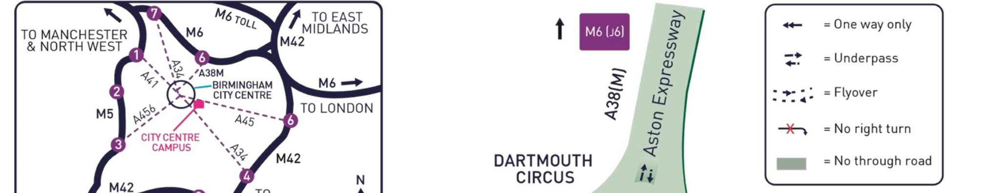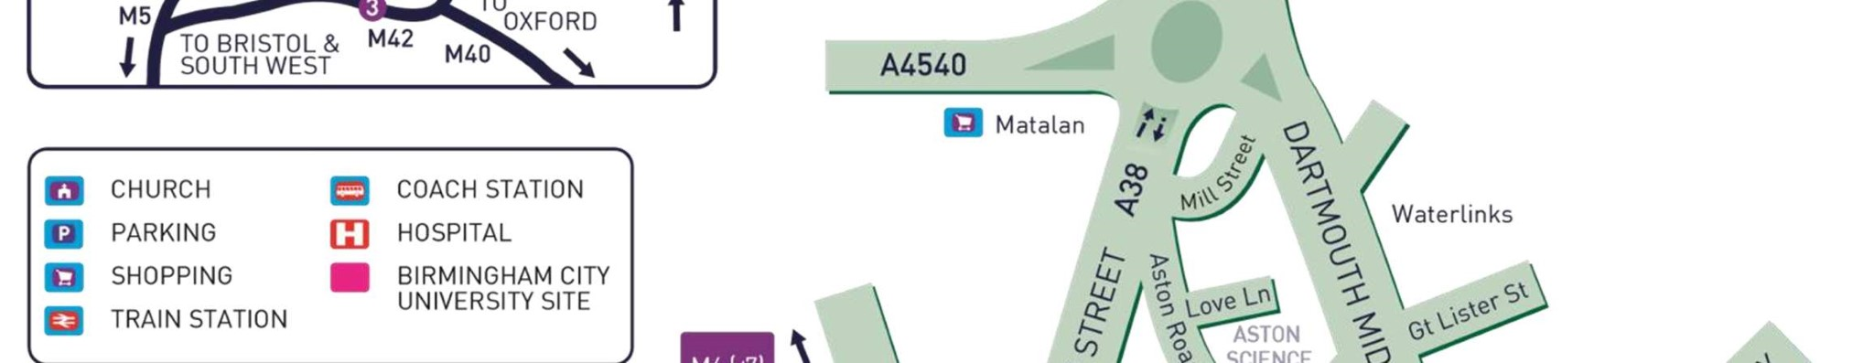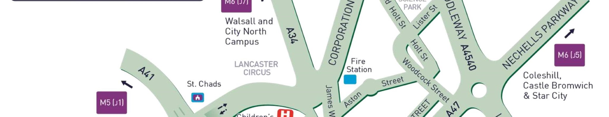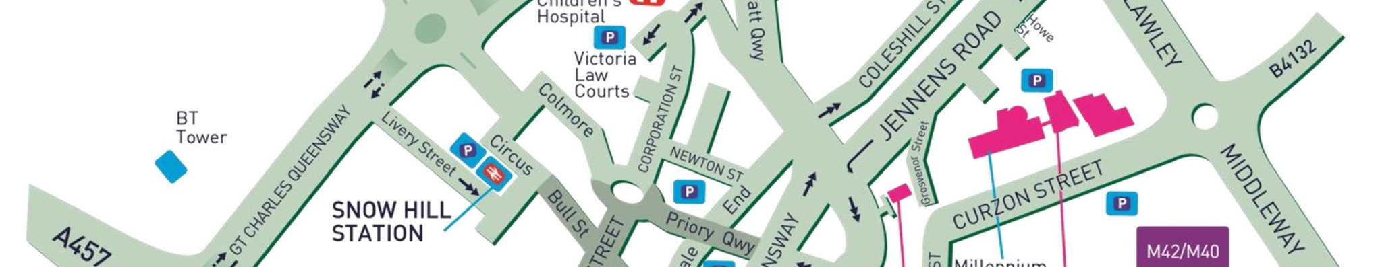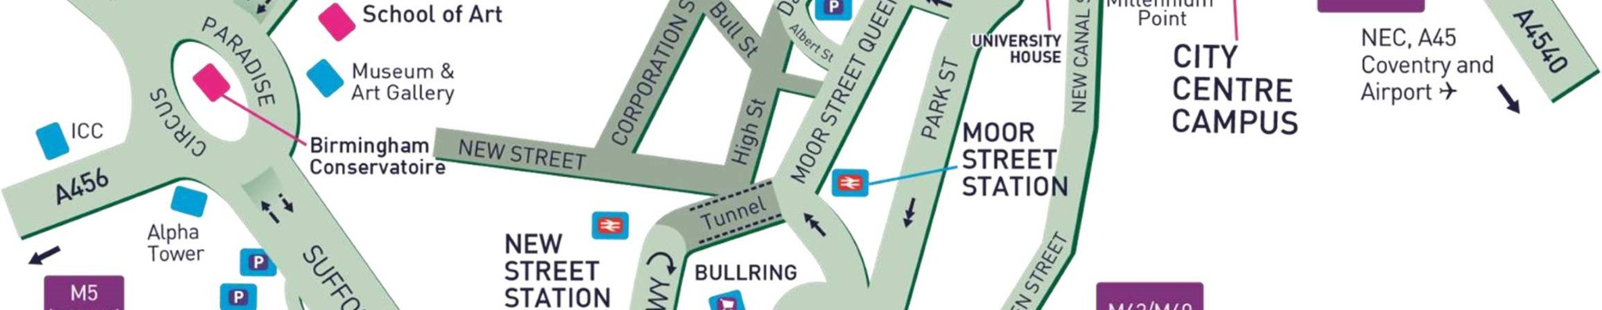

City Centre Campus
Millennium Point,
Curzon Street
Birmingham
B4 7XG
T: 0121 331 5000 W: www.bcu.ac.uk

