Mentor Newsletter December 2011
This is the second newsletter of the academic year, which is designed to keep you informed of events that have occurred recently that may be of interest to you. We also aim to keep you up-to-date with the activities that your trainees will be involved with in the coming New Year’s term. By now your trainee should be settled in at your institution and hopefully undertaking a planned programme of teaching.
It is important that trainees experience a wide range of teaching experiences during their placement involving different levels, course types and age ranges.

Successful Ofsted Inspection
We have just completed an Ofsted inspection, which involved numerous observations and discussions with our staff, trainees and mentors. The inspectors spoke of the quality of trainees and mentors they met and this was a characteristic in all of the evidence gathered during the week. Trainees were “benefitting from good training and mentoring” and inspectors noted that trainees were making “good progress”. Trainees were described as “reflective and articulate”. The outcome of the inspection has yet to be confirmed officially but, following moderation, we are likely to receive a “good” grade. As soon as the report is published, we will let you know.
This is very much an assessment of the partnership between the University, our trainees and our partner Colleges and other organisations and we trust you will share this sense of achievement. We look forward to our continuing collaboration in seeking to maintain and improve the quality of provision in teacher education. We would like to take the opportunity to pass on our sincere thanks to all mentors and placement staff who agreed to contribute to the inspection process and gave up their time to do this.

Mentor Training
Two Mentor Training sessions were offered in October and November to a total of 20 mentors. A number of one to one training sessions were also carried out by our staff at placement institutions. A third Mentor Training session is planned for Tuesday 13th December 2011 at the university. If you would like to attend this please contact Chris Markwell at Chris.Markwell@bcu.ac.uk .

More helpful tips are also included in this newsletter and are designed to help you in your role as a mentor. I would welcome any contributions to the newsletter and feedback from you, particularly if there are any improvements that can be made. This month sees two assignment deadlines that the trainees need to make and the following information covers work that they will be involved with next term. The levels of the modules that they will follow are dependent on their performance in their current assignments.

Modules Covered during January-April 2011 (Full-time Group)
1
Module Code Module Name Level Credits
EDU6119 Resources for Inclusive Learning 6 20
This module requires trainees to look at the concepts of Diversity and inclusivity from a professional and practical perspective, with an emphasis on developing skills and resources for teaching their subject specialism. This module also requires them to consider aspects of curriculum models. The module will be investigative and reflective, providing the opportunity for the trainee to develop and use inclusive teaching and learning resources linked to an understanding of the related pedagogy in their chosen specialist subject.
Or
EDU6117 Analysis of Inclusive Learning 7 20
This module will explore the notions of Inclusivity and Diversity. Trainees are required to produce a range of resources for inclusive learning, particularly those using blended learning methods. With their critical friend (trainee from same curriculum area) they will critically analyse learning theories and curriculum models and consider the implications of these in their own teaching context.
In both cases assessment will be by the production of an academic poster that they will present to their peers. (3000 word equivalent). The deadline for this is 16th April 2012

2
EDU6120 Continuing Personal and Professional 6 20
Development
The module will introduce and explore the notion of CPD and its place within the Post-Compulsory Education and Training (PCET) context. Trainees will be expected to research, analyse and critique theories, principles and models of reflective practice and CPD. The focus of the module will be the development of their own CPD plan for the future and reflections on their CPD experience to date.

Or

EDU7103 Continuing Personal and Professional 7 20
Development and Wider Professional
Practice
Trainees will:
- undertake research, analyse and critique theories, principles and models of reflective practice
- investigate and plan for their own professional development
- share and debate their findings with others.
Assessment of these modules involves the presentation of a CPD plan to their peers. The date for these presentations is 14th May 2012

3
EDU6121 Teaching in the Lifelong Learning 6 60
Sector
Assessment of this module is by production of a portfolio of the trainee’s professional practice as outlined in the *Practice of Teaching Workbook 2. (6000 word equivalent). *This can be accessed on the Partnership website (see below)

Subject Specialist Workshops and Audits
We mentioned these in our last newsletter. These are sessions that we offer regularly throughout the course to assist trainees to build on their subject specialist skills. The workshops that took place in November were in Sport, Art, IT, Literacy, Media, Maths, Social Sciences, Music and Drama. These were well attended and very successful. More workshops are planned for December and January.
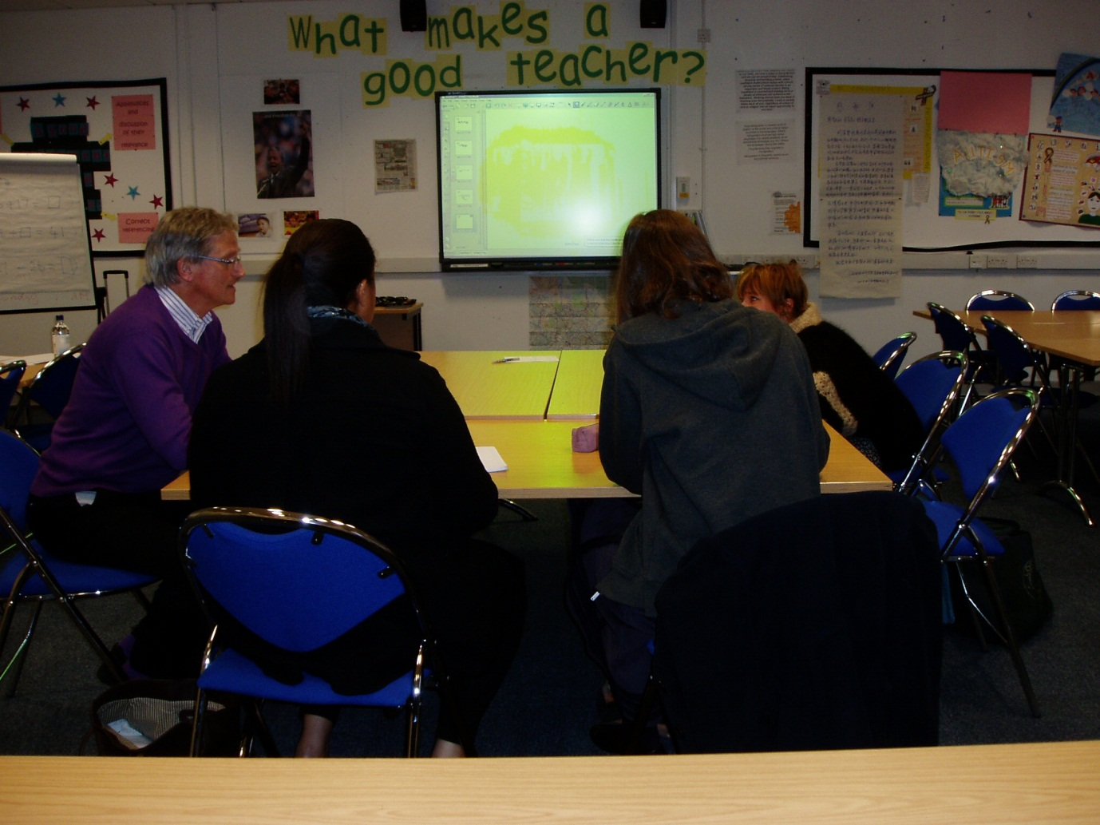
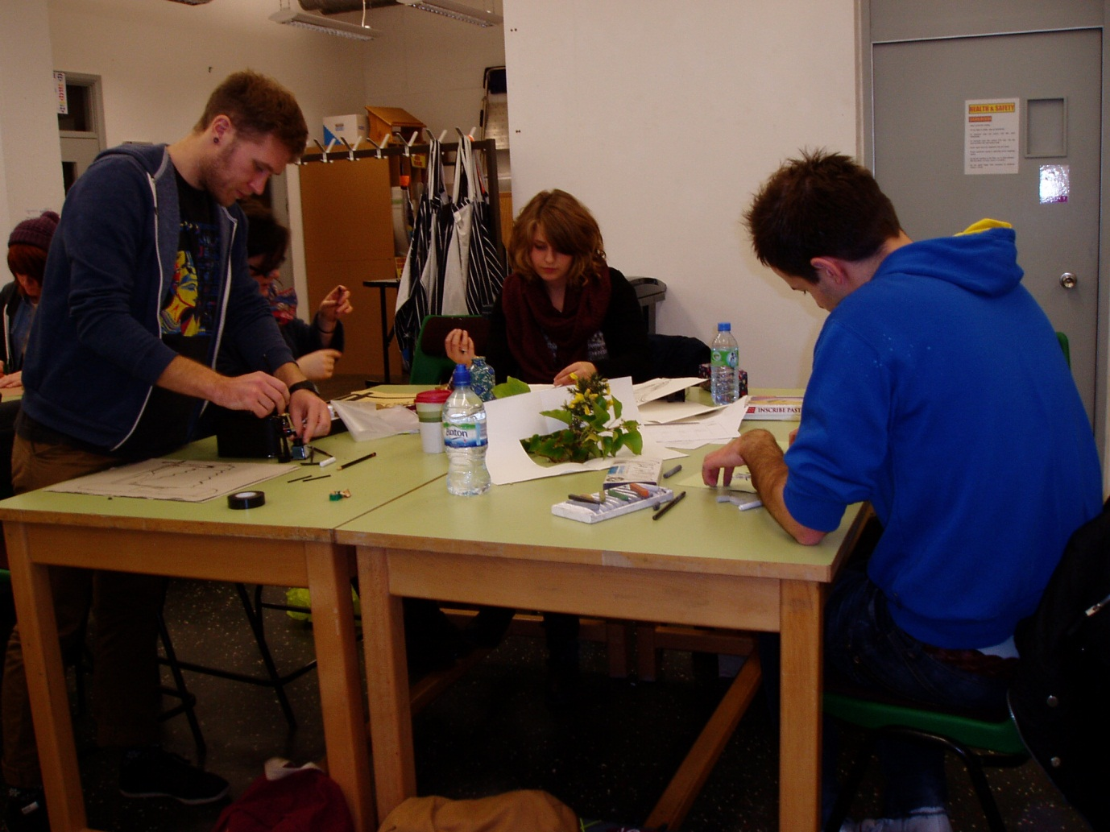
Useful Tips!
- Make sure that your trainee supplies you with all the university mentor documentation
- Prior to doing an observation, request copies of the trainee’s lesson plan and rationale a day or two before the observation
- Take a copy of the SVUK/Minimum Core Standards into the observation. If you have obtained an advance copy of the lesson plan you can familiarise yourself with the standards that the trainee plans to evidence in the lesson
- Continue to check on the development of the trainee’s subject specialist skills during your regular target setting meetings
- You can obtain electronic versions of all of these documents on the Post-Compulsory Partnership website at: http://www.bcu.ac.uk/elss/school-of-education/partnerships-collaborations/pcet-partnerships
Please feel free to contact me with your comments.
Phil Bate Professional Development Tutor
Email: Philip.Bate@bcu.ac.uk

