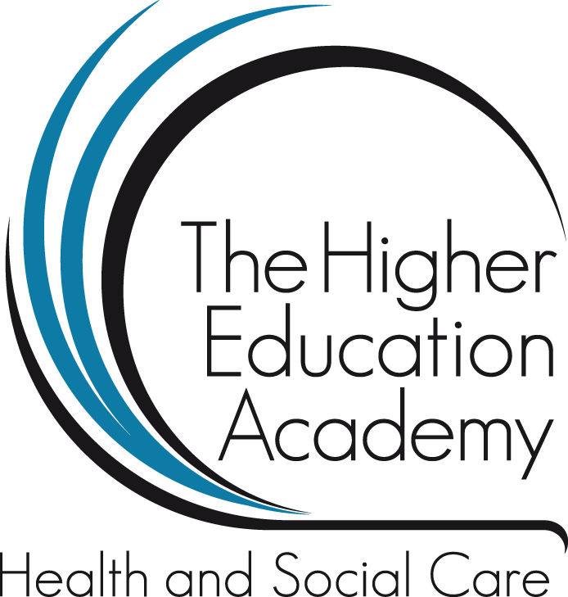

Enhancing holistic healthcare employability for successful student transition – how do we measure its success?
Birmingham City University, City South Campus, 109:30-16:00 2nd April 2014
Bite-size workshop summary
Hello There!
We are really looking forward to welcoming you to Birmingham City University, City South Campus for the Seminar Event on 2nd April 2014.
On being welcomed to campus you will be asked to choose which bite-size workshops you will attend via signing up to a workshop register. The workshops are in addition to the two keynote speaker sessions on ‘Impact: lots of questions, some answers’ by Ruth Lawton (Learning & Teaching Fellow for Employability, Birmingham City University) and ‘Graduate Employability, Measuring Success’ by Dr Lorraine Dacre-Pool, Senior Lecturer, University of Central Lancashire.
To assist you in making a choice (in advance of the event itself) we thought it may be helpful to send you a synopsis of the bite-size workshop options on offer; please see pages 2-4.
You will be asked to sign-up to two workshops each lasting 25 minutes. There are 20 places per workshop and five minutes in between workshop activities to move from your first to second choice.
Have a read of the information below and then on the day you can decide which two workshops you will attend. Until then don’t forget about the option to submit your own abstract sharing your employability story – abstract deadline date 31/03/14; see www.bcu.ac.uk/measure-success for more details.
Bite-size Workshop Option 1

Title: The journey of transition from a student nurse to a newly qualified nurse.

Presenters: Harriet Shaw-Roberts (Children’s Nurse (RN) Birmingham Children’s Hospital) & Ruth Cartwright (adult Nurse (RN) Birmingham Community Healthcare NHS Trust) & BCU alumni.
Workshop Summary: This workshop will explore the transition from student to newly qualified nurse through the personal journeys of two new clinically registered nursing graduates; discussing their thoughts feelings and experiences as captured through video blog diaries.

Bite-Size Workshop Option 2

Title: Academic and career partnerships; benefits, challenges and aspirations

Presenters: Katie Whitehouse, Careers Consultant and Lindsay Yardley, Senior Academic, Birmingham City University (BCU).
Workshop Summary: This workshop will explore collaborative approaches to academic and careers staff working together for the benefit of the student experience. The benefits and challenges of partnership work will be discussed as will the aspirations of mutually shared outcomes.

Bite-Size Workshop Option 3

Title: Smoothing the Transition to Enhance Graduate Employability.

Presenters: Bridget Malkin, Senior Lecturer, Birmingham City University (BCU) & Kay Wilson, Heart of England NHS Foundation Trust; Good Hope Hospital.
Workshop Summary: Research indicates that the 'transition process' should start prior to registration. There is a wealth of data in relation to the transitional experience of the newly qualified nurse that indicate key areas for development prior to registration. In the U.K. the lack of preparedness, feeling overwhelmed and under confident remains problematic issues for third year nursing students entering transition. This can result in unsuccessful achievement of clinical competencies necessary for registration.

Education and practice require a cohesive approach to address these issues as both have an equivalent level of responsibility in facilitating the student successfully through the process. This collaborative research project introduced targeted, confidence enhancing activities during clinical practice so as to support third year nursing student development and enhance integration during their transition practice prior to registration. The workshop will outline strategies and activities undertaken in the project to facilitate student success and enhance their employability that delegates may wish to share in their respective organisations supporting the ripple effect.

