PORTFOLIO
OF EVIDENCE

EVIDENCE OF PRIOR
ACADEMIC STUDY AND PRACTICE LEARNING (RPL)

Your Name:

Application Number:

TABLE OF CONTENTS

E-Learning for Health Certificate Equality and Diversity and Human Rights 3

E-Learning for Heath Equality and Diversity and Human Rights course content 4

Professional Values and Academic Skills Module Guide Screen Grabs 5

Academic and Practice Enquiry Module Guide Screen Grabs 6

Safeguarding Training Screen Grabs of Complete. 7

Introduction of Leadership and Teamworking Module Guide Screen Grabs 8

GCSE Certificate 9

Health Care Support Worker Job Description 10

Health Care Support Worker Offer Letter 11

EQUALITY AND DIVERSITY AND
EQUAL RIGHTS TRAINING CERTIFICATE

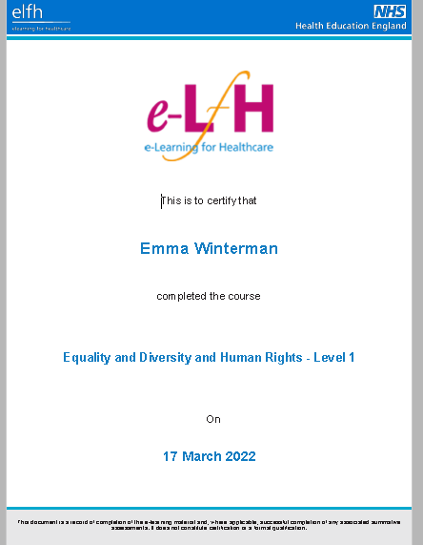

E-LEARNING FOR HEATH EQUALITY AND DIVERSITY
AND HUMAN RIGHTS COURSE CONTENT

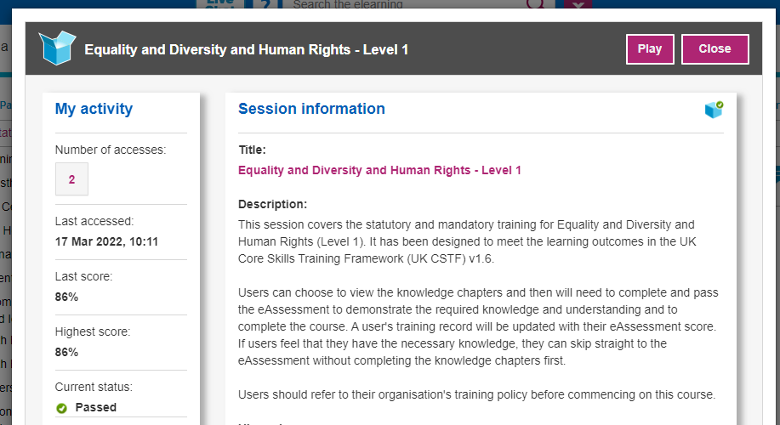

PROFESSIONAL VALUES AND ACADEMIC SKILLS MODULE LEARNING OVERVIEW AND OUTCOMES.

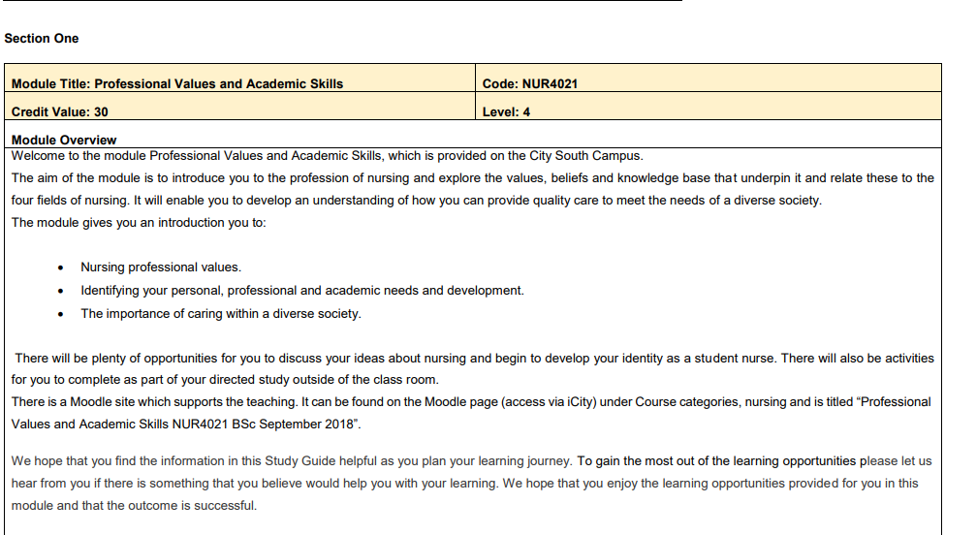
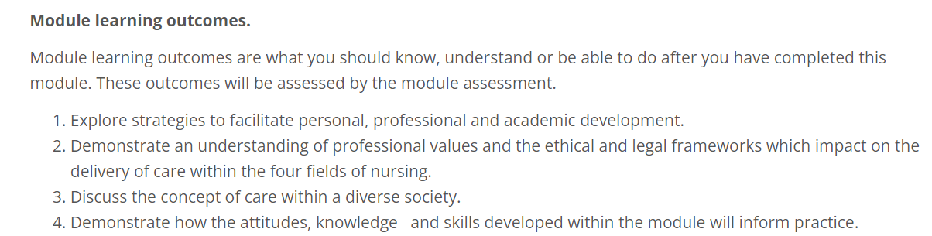

ACADEMIC AND PRACTICE ENQUIRY MODULE LEARNING OVERVIEW AND OUTCOMES.

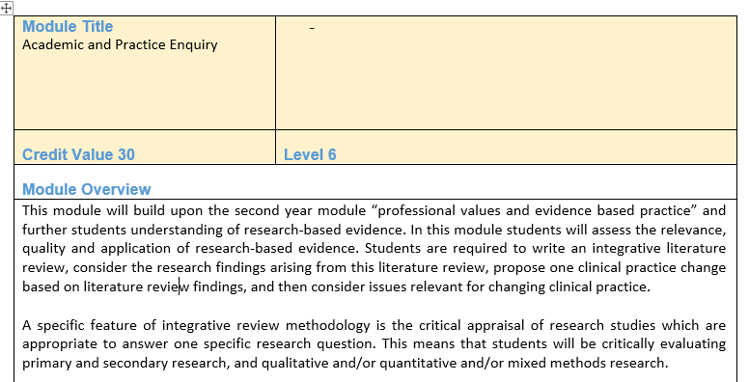
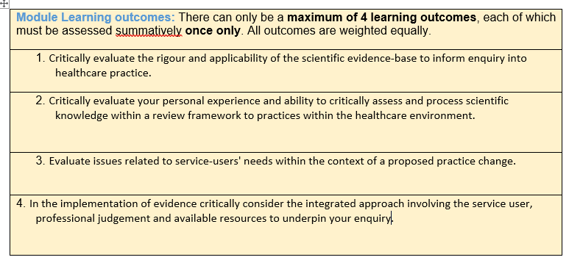

SAFEGUARDING TRAINING

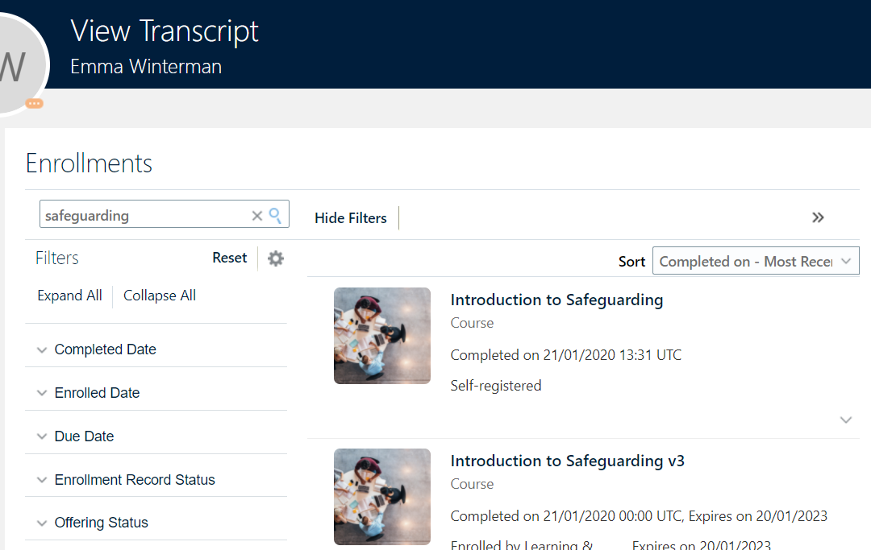
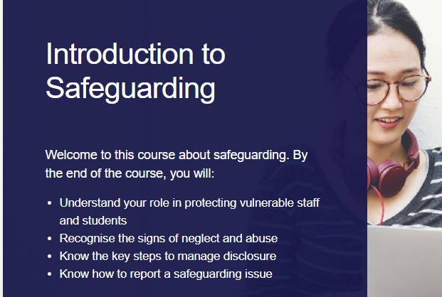

INTRODUCTION TO LEADERSHIP AND TEAMWORK MODULE LEARNING OVERVIEW AND OUTCOMES.

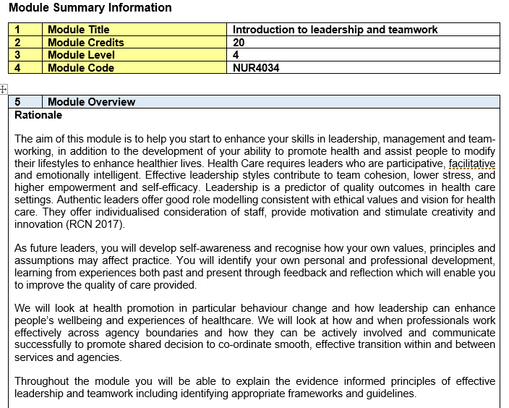
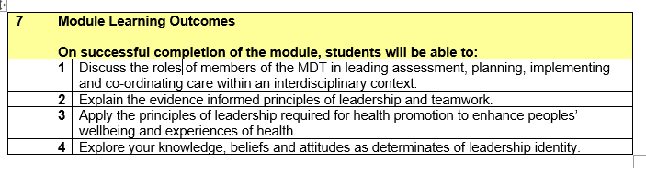

CERTIFICATE OF GCSES WOULD BE
INCLUDED ON THIS PAGE.

COPY OF HEALTH CARE SUPPORT WORKER JOB DESCRIPTION WOULD BE INCLUDED ON THIS PAGE

ALONGSIDE EVIDENCE THAT YOU WORKED IN THE ROLE SUCH AS AN OFFER LETTER, CONTRACT OR PAYSLIP.

